Ramah Repertoire Lists
(Not in any order)

New Shira
- Ivdu (Razel)
- Hariu
- Heyo/Od Yavo Shalom
- Kol B’Ramah (Warshawsky)
- Ana El Na (Jaffa Road/Aviva Chernick)
- Anachnu Ma’aminim
- Ozi (Kline)
- V’hi Sh’amdah (Shwekey)
- Esa Einai (Nichols)
- V’ahavta (Warshawskys)

Camp Hits
- Salaam/Ki Va Moed
- Shiru (Rogow)
- Im Tirtzu
- Adama V’shamayim
- Abanibi
- Ivdu/Hinei
- Hinei Bah HaShalom
- Yachad
- Hoshia (Nichols)
- Ameh (Katz)
- David Melekh/Am Yisrael (Trad. minor)
- Hava Nashira (Nelson)
- Al Shlosha (Recht)
- Kum Kum Lay Lay
- V’Ahavta
- V’Yerushalayim Ircha

Tefillah
- Modeh Ani (Wake Me Up)
- Mah Tovu (Besamim)
- Elohai Neshama (Warshawsky)
- Va’anachnu (Dumb Ways to Die)
- Psalm 147 (Warshawsky)
- Psalm 148 (Sykes)
- Mah Rabu (Warshawsky)
- El Barukh (Warshawsky)
- Or Chadash
- Barchu/Am I Awake (Aronson)
- Mi Chamocha (Pizmon?)
- Elohai Netzor (Warshawsky)
- Oseh Shalom (Sykes)
- Oseh Shalom (Ochs)
- Al Kein (Katz)

Shabbat
- Hachamah Merosh (Warshawsky)
- Tzur Mishelo
- Yom Zeh Mechubad (Bumblebee)
- El Hama’ayan
- Kol Ha’olam Kulo
- Mipi El
- V’haeir
- Acheinu
- Hamalakh Hago’el
- Eileh Chamba/V’nomar L’fanav
- Od Yishama (call and response)

Niggunim
1. Bina’s Niggun/Windshield Wiper (Weisenberg)
2. Lekha Dodi Niggun (Carlebach)
3. Anim Zemirot Niggun (Ma’aleh Gilboa)
4. Niggun Mitzpe
5. Ki Etzok Niggun (Warshawsky)
6. Motzi Niggun (Indiana Aish)
7. China Camp Niggun
8. Yaba baba bim bam (a la Boxt)
9. Ki Eshmera Shabbat (Nichols)
10. Krakow Niggun – both parts (Carlebach)
11. Niggun Ya Ribon
12. Or Zarua (Nichols)

1. Ivdu et Hashem (Yonatan Razel)

D C
Ivdu et Hashem B’simcha Bo’u L’fanav Birnana
D C D
Ivdu et Hashem B’simcha Bo’u l’fanav (X2)

Chorus
Bm A G
Woahhh De’u Ki Hashem Hu Ha’Elohim
Bm A C#m D
Hu Asanu V’lo Anachnu
Bm A G
Woahhh De’u Ki Hashem Hu Ha’Elohim
Bm A D
Anachnu Amo V’tzon Mar’ito…. Ivdu…

2. Hariu

Em Cmaj7 D Bm Em
Hariu Ladonai Kol Ha’aretz (X2)
D Em
Pitzchu V’ranenu V’ranenu V’zameru (X2)
D Cmaj7 D Bm Em
Pitzchu V’ranenu V’ranenu V’zameru ooo ooo
Em
Ki Tov Adonai L’olam Chasdo
G
Ki Tov Adonai L’olam Chasdo
A
Ki Tov Adonai L’olam Chasdo
C
Ki Tov Adonai L’olam
3. Salaam/Heyo/Od Yavo Shalom (in canon)
Capo: 3
Am C F
Heyo Heyo Heyo Heyyyyyyooo
Am C F
Heyo Heyo OOOOOOOOOOOO
Am C F
Od Yavo Shalom Aleinu Od Yavo Shalom Aleinu
Am C F
Od Yavo Shalom Aleinu V’al Kulam
Am C F Am C F
Salaam Aleinu V’al Kol Ha’olam, Salaam Salaam

4. Kol B’Ramah (Warshawsky)
Usually played Capo 2 using a partial capo, but doesn’t have to be
D C9 B/C9 C9 B/C9 D
Kol B’Ramah Nishma Sof Sof Higati L’veiti
D C9 B/C9 C9 B/C9 D
Rak Po Chofshi Lihyot Ata V’ani, Ta’aminu Li, Hakol Zeh Amiti

Verse
F# Bm
Az Horai Hayekarim Ta’asu Li Tova
F# Bm
Ki Kvar Pagashti Chaverim V’ein Li Shum B’reira
F# Bm
Omrim Kulam Simcha Tamid Hi Mitzvah Gedolah
E A Asus A
Az Tein Li L’hisha’er Po Im Ha’eidah (Back to chorus)

Ending chorus:
D C9 B/C9
Az Shiru Na B’yachad B’Shituf Peulah
C9 B/C9 D
Ein Od Makom K’machaneh Ramah (X3)
5. Ana El Na (Jaffa Road/Aviva Chernick)

Em A
Hey-ey-ey-eyyyy Hey-ey-eyyy (X2)
C G B7 Em C G B7
Ana El Na Refa Na La
C G B7 Em C G B7
Ana El Naaa Refa Na La!

Chorus
C G B7 Em
Ana El Na Refa Na La Ana!
C G B7
Ana El Na Refa Na La (X2)

6. Anachnu Ma’aminim

Am Dm Am Dm
Yisrael Yisrael B’tach Ba’shem Ezram U’maginam Hu
Am Dm F G Am
Yisrael Yisrael B’tach Ba’shem Ezram U’maginam Hu!

Chorus
Am G Am
Anachnu Ma’aminim B’nei Ma’aminim
Am G C
V’ein Lanu Al Mi Lehisha’en!
Dm G Dm E7 Am
Elah Elah El Avinu, Avinu SheBashamayim

7. Ozi (Kline)

8. V’hi She’amda (Shwekey)
Intro is Bridge II then Bridge I
Part I
Am F G Am G Dm G
Vehi Sheamda lavoseynou, Vehi Sheamda lavoseynou velanu
Am F C Dm
Shelo echad bilvad omad aleinou lechaloseynu,
F E7 Am
omad aleinou lechaloseinou X2

Part II
F C
VeHakadosh baruch hu matzileynu,
Dm Am
oy matzileynou miyadam X2 (second time-to part III)

Bridge I
F C G Dm F
Ta da da da Ta da Ta da da da Ta da Ta da da da da
G Dm G Am
Ta da da da Ta da da da da (First time - back to part I)

9. Esa Einai (Nichols)
PART 1
E A E
Esa ei-nai el he-ha-rim X2

PART 2
A E A E
Mei-ayin ya-vo, ya-vo ez-ri Mei-ayin ya-vo, ya-vo ez-ri

PART 3
Bm A E
Where will my help come from?

PART 4
E
My help will come from God,
A E
Maker of heaven and earth

10. V’ahavta (Warshawsky)
Capo 3
D A C G (whole song)

Part 1:
D A C G D A C G
V’ahavta L’rei’echa Kamocha

Part 2:
D A C G D A C G
Im lo Achshav Eimatai? Im Lo Achshav Eimatai

Part 3: (… indicates repeat)
D A C G D A C G
B’chol Levavcha… V’nafshecha… Me’odecha… V’ahavta
(last time through hold out V’ahavta)
1. Modeh Ani (Wake Me Up-Avicii)
Em C G Em C G D
Modeh Ani Lefanecha Melekh Chai Vekayam
Em C G D
She’hechezarta Bi Nishmati B’chemla
Em C G
Rabah Emunatecha

2. Mah Tovu (Besamim)
D E G D D E G D
Mah Tovu Ohalecha Ya’akov Mishkenotecha Yisrael
Em G D A
V’ani B’rov Chasdecha Avo Beitecha
Em G D A
Estachaveh El Heichal Kodshecha B’yiratecha

3. Elohai Neshama (Warshawsky)
First E chord is an E5 open chord on 7th fret, then sliding down all open chords
Add harmonies (especially to chorus) at will.
Chorus:
E5 E/D# C# A/D B
Elohai Neshama shenatata bi, tehora hi
E E/D# C# A/D B E
Elohai Neshama shenatata bi, teho - ra hi (X2)

Verse:
A/D B E E/D# C# B
Ata b’rata, ata yatzarta ata nefachta bi
A/D B E E/D# C# B E---(Back to chorus)
Ata b’rata, ata yatzarta ata nefachta bi

4. Va’anachnu (Dumb Ways to Die)
Melody based on the Youtube video “Dumb Ways to Die” and arranged for liturgy by Josh Warshawsky
Verse:
C F C F C F C F
V’anachnu nevarech yah, Me’ata ve’ad olam
C F C F C F C F
V’anachnu nevarech yah, Me’ata ve’ad olam

Chorus:
C C/B Am Am/G F G
Halleluyah, Halleluyah
C C/B Am Am/G F G C---(Back to verse)
Halleluya -ah -ah -ah, Haaaa lleluyah

5. Psalm 147 (Warshawsky)
Capo 3
Am G C F Am G C F
Halleluyah Halleluyah
Am G C F Am G C
Halleluyah Halle- Halleluyah
Am G C F Am G C F
Ki Tov Zamra Eloheinu Ki Na’im Nava Tehila
Am G C F Am G C
Ki Tov Zamra Eloheinu Ki Na’im Nava Tehila

6. Psalm 148 (Sykes/Nava Tehilah)
Am C G F
Haleluyah
Am C G F
Hal'lu et Adonai min hashamayim hal'luhu bam'romim
Am C G F
Hal'luhu khol mal'akhav hal'luhu kol ts'va'av
Am C G F
Hal'luhu shemesh v'yare'akh hal'luhu kol kokhvei or
Am C G Am
Hal'luhu shmey hashamayim V'hamayim asher m'al hashmayim
Am C G F
Y'hal'lu et shem Adonai Ki hu tsiva v'nivra'u
Am C G F
Vaya'amidem la'ad l'olam, Chok natan v'lo ya'avor

7. Mah Rabu (Warshawsky)
Capo 3, 4, or 5 (I play it on 4 usually)
C G
Mah Rabu (Mah Rabu!)
C G
Mah Rabu (Mah Rabu!)
C G C D G
Mah Rabu Ma’asecha Adonai
C G
Mah Rabu (Mah Rabu!)
C G
Mah Rabu (Mah Rabu!)
C G C D G
Mah Rabu Ma’asecha Adonai
Em D C D
Kulam B’chochma Asita
Em D C D
Kulam B’chochma Asita
Em D C D
Kulam B’chochma Asita
Em C D
Mah Ra-buuuu

8. El Barukh (Warshawsky)
F#/D G A D
El Barukh G’dol De’ah
F#/D G A D
Heichin U’fa’al Za’arei Chamah
F#/D G A Bm
Tov Yatzar K’vod Lishmo
G F#/G Em--A--D
Me’orot Natan S’vivot Uzo

G D A D
Pinot Tzeva’av Kedoshim
G D A Asus A
Romemei Shaddai
G D F#7 Bm
Tamid Mesaprim K’vod El
G F#/G Em--A--D
K’vod El U’k’dushato

9. Or Chadash
C F F G C
Or Chadash Al Tzion Ta’ir V’nizkeh Chulanu Meheirah L’oro (oh baby) (X2)
C F C C F G
Barukh Ata Adonai Yotzer Hame’orot, Yotzeir Hame’orot!
C F C C F C
Barukh Ata Adonai Yotzer Hame’orot, Yotzeir Hame’orot

10. Barchu/Am I Awake (Aronson)
Yai da [Am]dai dai [G]dai, yai da [F]dai dai [C]dai,
Yai da [Am]dai dai [G]dai, yai la [F]dai dai [C]dai x2

Am [Am]I a[G]wake, am [F]I pre[C]pared,
Are you [Am]liste[G]ning [F]to my [C]prayer, Can you [Am]hear my [G]voice, can you [F]under[C]stand,
Am [Am]I a[G]wake, am [F]I pre[C]pared

[C]Ba-r'[G]chu et [Am]Ado[Em]nai, [F]ha-m'[C]vo-[Gsus]rach [G]
[C]Ba-ruch Ado[G]nai [Am]ha-m'vo-[Em]rach, [F]l'olam [G]va-[Am]ed [G] [F]
[F]L'olam [G]va-ed [Am]
11. Mi Chamocha (Pizmon?)
Capo 3
Am Em Am
Do do do do do do do dododododododo do do do do do do do (Huh!) (X2)
Am G F F G Am
Mi Chamocha Mi Chamocha Mi Chamocha Ba’eilim Adonai Do do dodo do
Am G F F G Am
Mi Kamocha Mi Kamocha Mi Kamocha Ne’edar Bakodesh
F G Em Am F G Am
Nora Tehilot Oseh Fe - leh Nora Tehilot Oseh Feleh!
F G Em Am F G Am
Nora Tehilot Oseh Fe - leh Nora Tehilot Oseh Fe-

12. Elohai Netzor (Warshawsky)
E A
Elohai Netzor Leshoni Meirah Us’fatai Midaber Mirma
E A B E
Elohai Netzor Leshoni Meirah Us’fatai Midaber Mirma
C#m G#m A E
V’limkalelai Nafshi Tidom, V’nafshi K’afar L’kol Tihyeh
C#m G#m A B-Bsus-B
P’tach Libi B’toratecha, U’v’mitzvotecha Tirdof Nafshi

13. Oseh Shalom (Sykes)

Niggun: Am G G Dm-E7-Am (x2)
Am G Dm Am
Oseh Shalom Bimromav Hu Ya’aseh Shalom Aleinu
G Am G Dm
V’al Kol Yisrael V’al Kol Yoshvei Teivel
F G Am –back to niggun
V’imru Amen

14. Oseh Shalom (Ochs)
G F C G F C
Oseh Shalom Bimromav Hu Ya’aseh Shalom Aleinu
G F C G F C
Oseh Shalom Bimromav Hu Ya’aseh Shalom Aleinu
G F C D
Oseh Shalom Bimromav Hu Ya’aseh Shalom Aleinu
C D G C D Em
Ya’aseh Shalom, Ya’aseh Shalom, Shalom Aleinu V’al Kol Yisrael
C D Bm Em C D G
Ya’aseh Shalom, Ya’aseh Shalom, Shalom Aleinu V’al Kol Yisrael
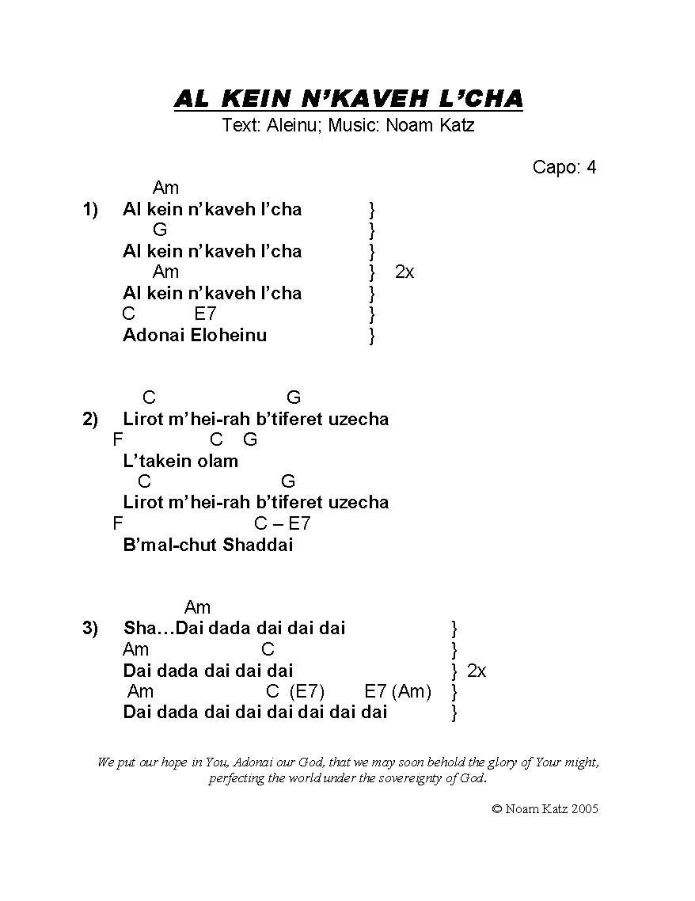
15. Al Kein (Katz)

Shabbat
1. Hachamah Meirosh (Warshawsky)
G/B D A Bm
Bo’i Hamalkah Bo’i Kalah
G/B D Asus A
Shalom Aleichem Mal’achei Hashalom
G/B D A Bm
Bo’i Hamalkah Bo’i Kalah
G/B A D
Shalom Aleichem Mal’achei Hashalom

Bm A G D
Hachamah Meirosh Ha’ilanot Nistalkah
Bm A G D
Bo’u V’neitzeh Likrat Shabbat Hamalkah
Bm A G D
Hinei Hi Yoredet Hakedoshah Haberuchah
Bm A G D
V’ima Mal’achim Tzevah Shalom U’menucha

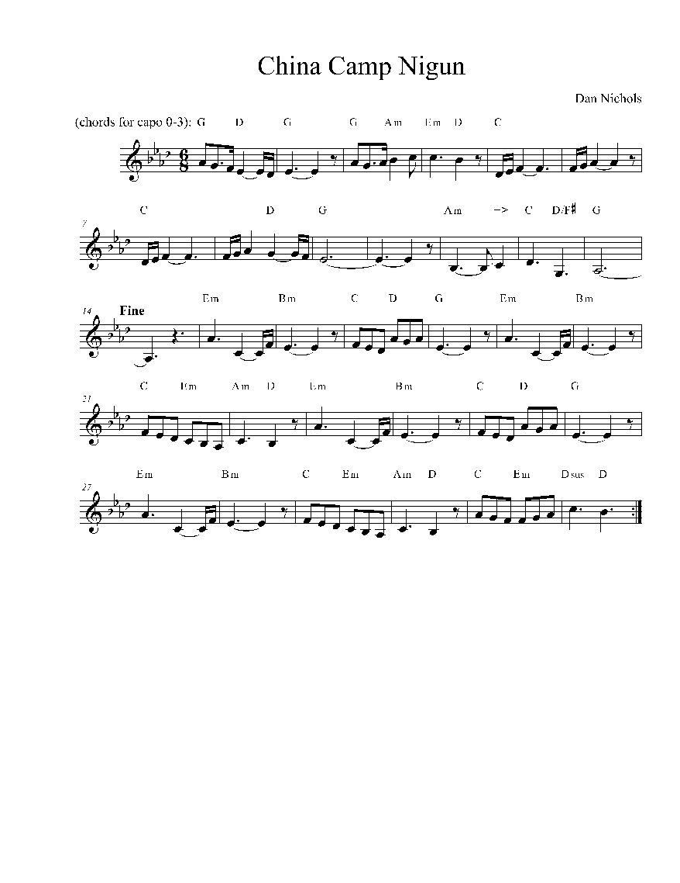
China Camp Niggun (Nichols)

Chords for Misc. Camp Hits:

Adamah V’shamayim (Sagol)
Em Bm
Heya Heya Heya Heya Heya Heya Heya Ho (X2)
G D C D Em
Heya Heya Heya Heya Heya Heya Heya Ho!
Em Bm
Adamah… V’shamayim…
Em Bm
Chom Ha’eish… Tzlil Hamayim…
G D
Ani Margish Zot B’gufi
C D Em
B’ruchi B’nishmati

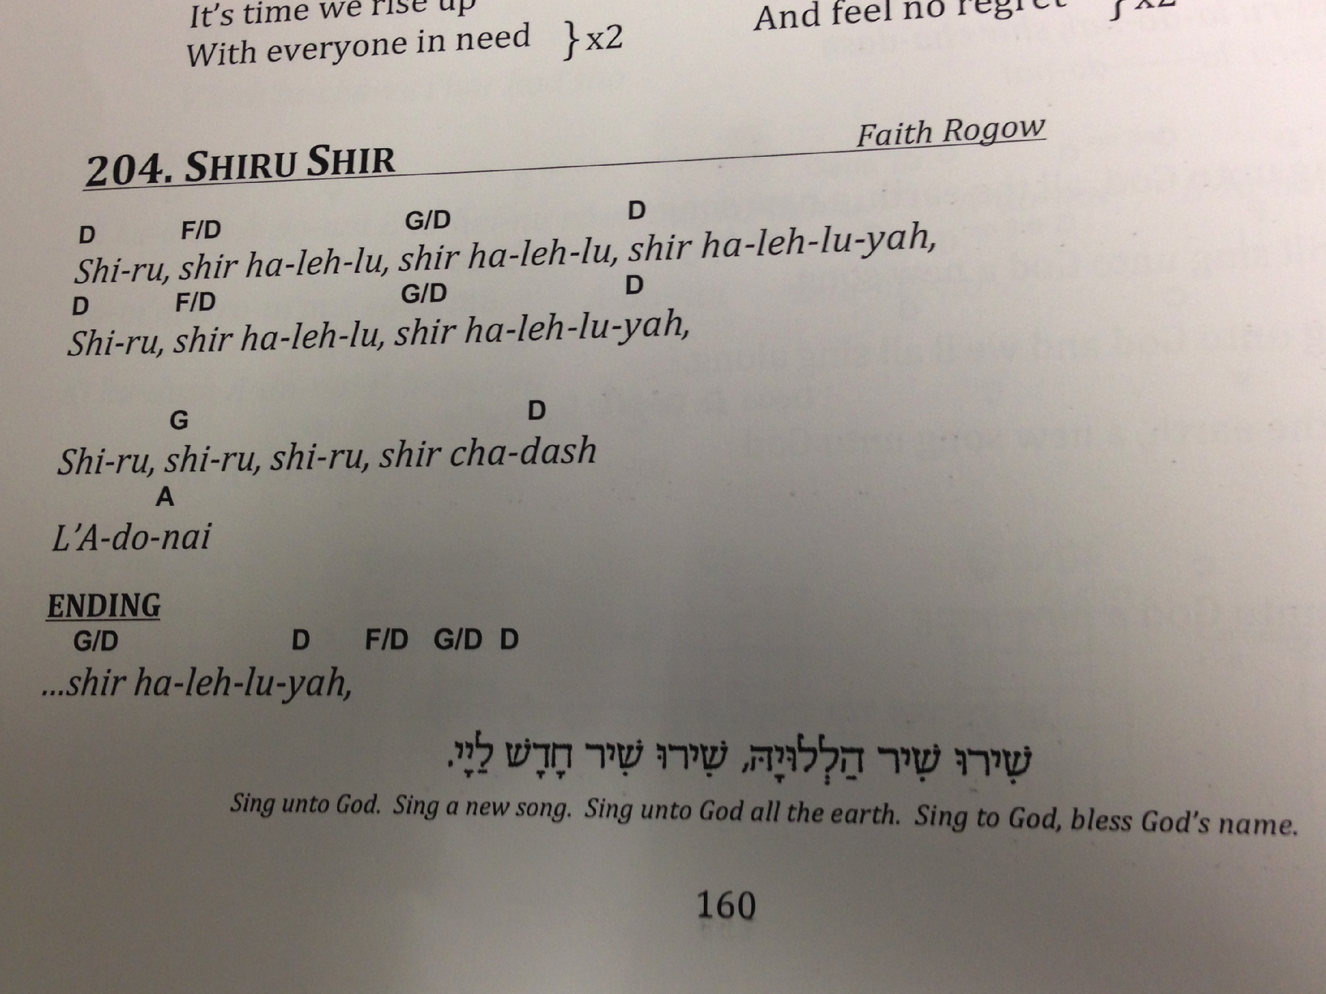
Shiru (Rogow)

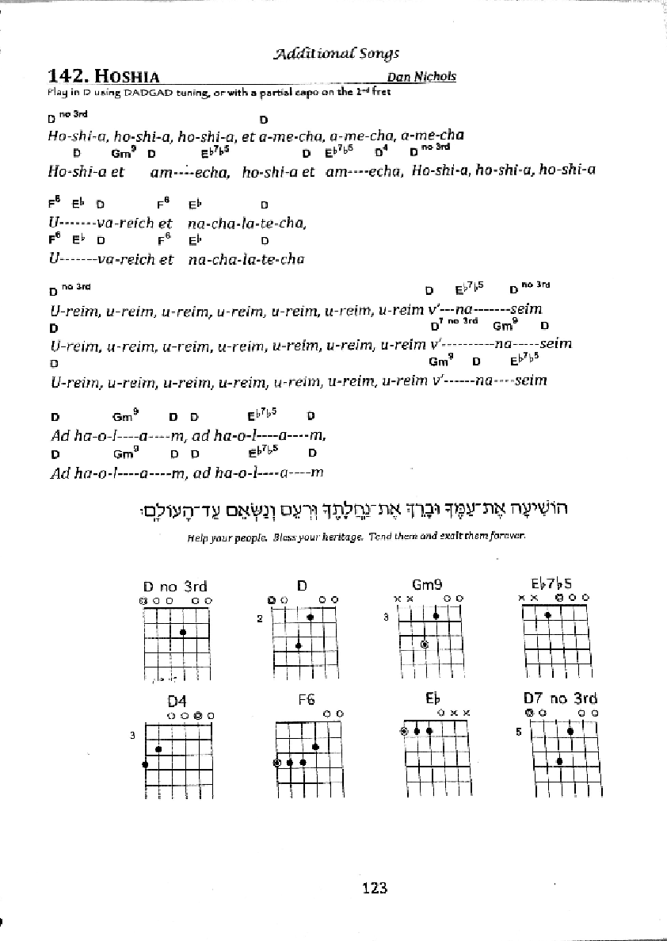
Hoshia (Nichols)

