SLBC 2016 New Repertoire
- Hashem Melekh (Gad Elbaz)
- Tzion (Zusha)
- Niggun
- Yihyu L’Ratzon (Elana Arian)
- Eileh Chamda Libi (Aronson)
- Brikh Rachamanah (Aronson)
- Yavo Shalom (Recht)
- Uzi [Psalm 59] (Warshawsky)
- Ashira (Razel)
- What Makes You Glow (Kraus)
- Ra’u Vanav (Yonatan Razel)
- Bayom Hahu (Allard)
- Shiru La’Adonai (Nichols)
- Bo-Esh (Chesler)
- Yismechu (Sammy Rosenbaum and Sam Rotenberg)
- Oseh Shalom (Recht)

- Hashem Melekh (Gad Elbaz)
F C G Am
Hashem Melekh! Hashem Malakh! Hashem Yimlokh, L’olam Va’ed (x2)
F C G Am
Ahalel HaShem Elokim, V’agadleinu b’todahhhhh (x2)
Am F C G
Yud V’hey V’vav V’hey Hashem Elokeinu Hashem Echad (x2)

2. Tzion (Zusha)
Capo 3
Am Am Dm Am E7 Am
Tzion Temaleh! Tzion Temaleh! Yibaneh Hamikdash, Yibaneh Hamikdash (x2)
Am G G D
Woahhhh Woahhh Woahhh Woahhh (x2)

3. Niggun
Am G C
Ayyy yaii yaii yai yai yaiiiiiii
C G Am
Ay yaii yaii yaii yaii yaii yaiiiii [x2]
Am G C
ya na nai nai naii naii naii naii naii naiiiii
C G Am
ya na nai nai naii naii naii naii naii naiiiii [x2]

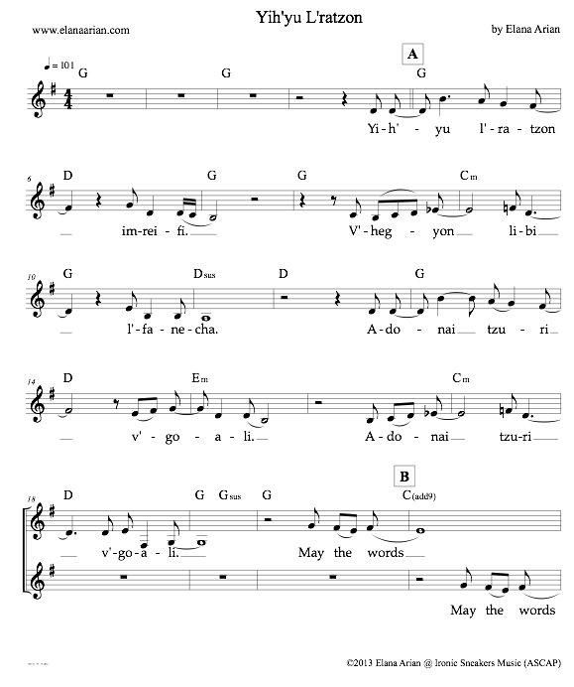

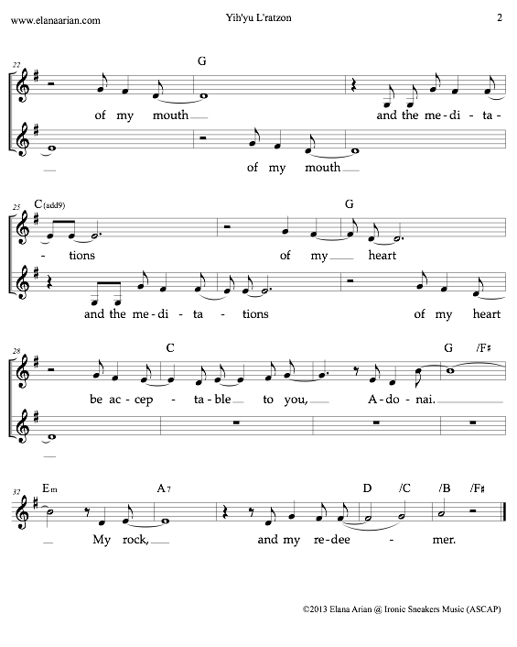

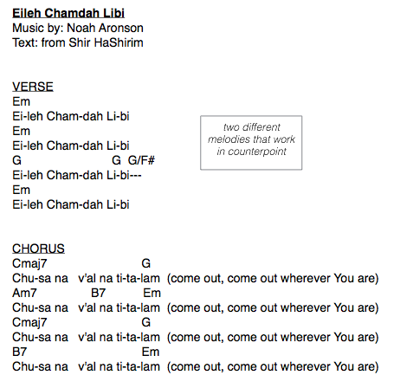hi
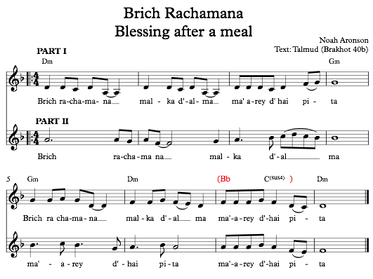
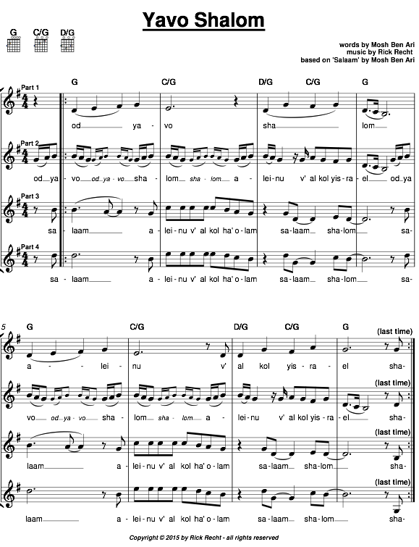

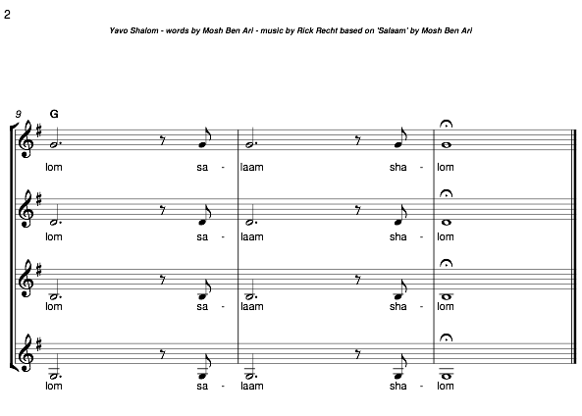
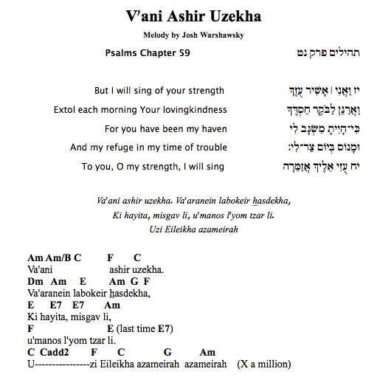

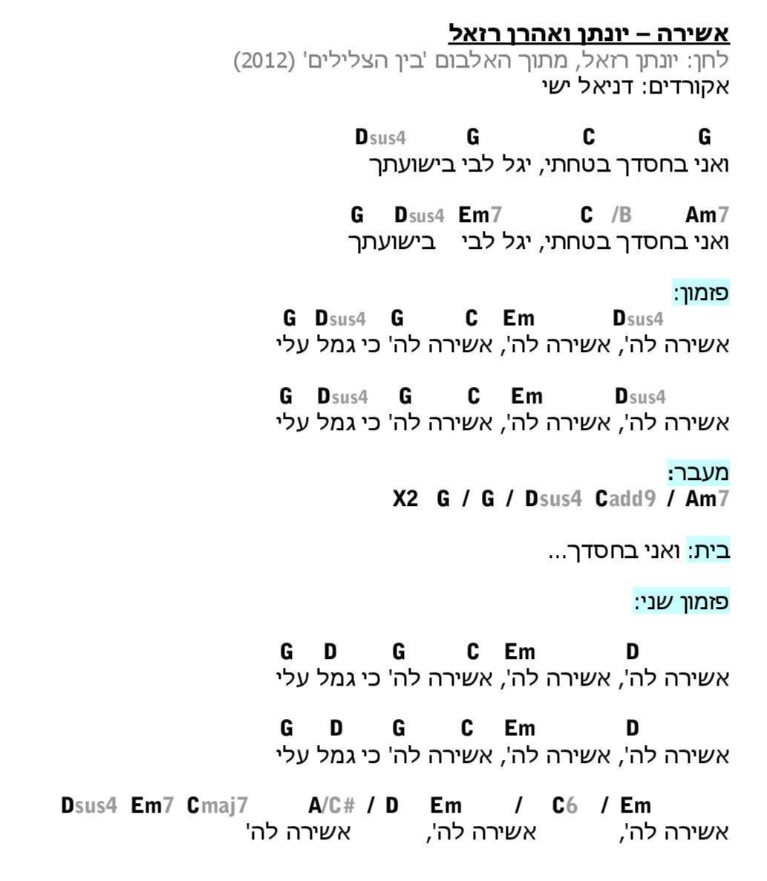
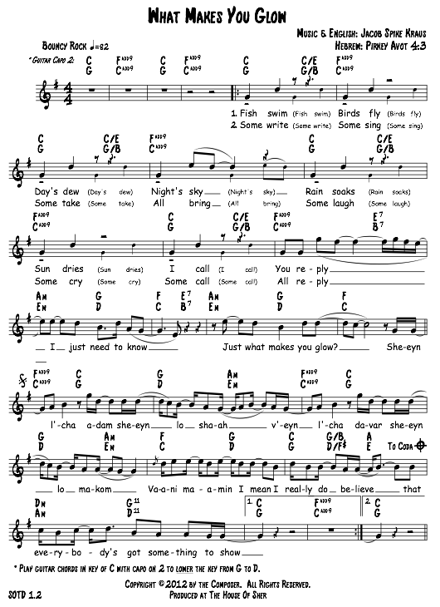
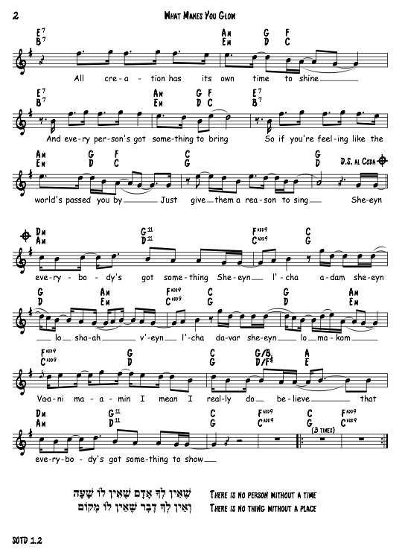

11. Ra-u vanav – Yonatan Razel
https://www.youtube.com/watch?v=XSIQiwi1YnQ
(play this key, capo II)

A D A E
Ra-u vanav g’vurato shib’chu v’hodu lishmo
D F#m – C#m
U-malchuto b’ratzon
D E A
kib’lu aleihem

Chorus:
A E f#m-D
Moshe u’v’nei Yisrael l’cha anu shira
A E A
B’simcha rabah v’amru chulam

Nigun:
A / E / D / E / A / E / A
A / F#m / C#m / D / E / A

12. Bayom Hahu – Ellen Allard
(play this key, capo II)

Am Dm Am
Bayom hahu y’hiyeh Adonai echad
Dm
U-sh’mo echad,
G Am
u-sh’mo echad. } 2x

Am
On that day God shall be one
Am E
And God’s name shall be one. } 2x

13. Shiru L’adonai – Dan Nichols
https://www.youtube.com/watch?v=68aGq6cAiXE

CHORUS:
G D A G
Shiru l’Adonai shiru shir chadash
G D A
Shiru l’Adonai kol ha-aretz
G D A G
Shiru l’Adonai bar’chu sh’mo
G D A
Basru miyom l’yom y’shu-ato

G D A G
1.) Come on sing a song, sing it all day long
G D A G
Sing it loud and clear, so the world can hear.
G D A G
What a gift you bring, when aloud you sing,
G D A G
Come on sing a song, sing a, sing a song

CHORUS

2.) Come on sing a song, sing it all night long,
Sing it soft and free so the world can see
How you’ve made each day sweet in every way
Come on sing a song, sing a, sing a song

CHORUS

14. בואש – Boesh By Carol Chesler
[Before beginning the song, start with “We will, we will rock you!” clap – tap knees twice, then clap]
Vamp on am/capo II

RAP: [done as call & response]
Shabbos Afternoon,
Eating good food,
Eating bunk food,

Eating junk food, Eating skunk food!
Saturday night, What a fright,
In plain sight, Black and white,
Takin' a bite!

CHORUS
2x {am G am G am G
?בואש! בואש! מה יש? בואש! בואש! מה יש

G am G am dm
מה יש על הרצפה? אשפה אשפה

G am G am dm
מה יש בקיקר? אשפה אשפה

G am G am dm
מה יש בחדר? אשפה אשפה

(silent) || E (silent) || E
מה צריך אכשיו? נקיון

CHORUS

מה יש בבית אם? אשפה אשפה
מה יש באולם? אשפה אשפה
מה יש באגם? אשפה אשפה
?מה צריך אכשיו

CHORUS
מה יש במועדון? אשפה אשפה
מה יש במתבחון? אשפה אשפה
מה יש באמפיתאתרון? אשפה אשפה
מה צריך אכשיו? נקיון
CHORUS

Note: Read Chords Right to left following the Hebrew!
All verse same as the first. With the refrain in between.

Vamp on am/capo II
(With the “We will Rock You” Clap --– tap knees twice, then clap] )

RAP: [done as call & response]

Shabbos Afternoon, Eating good food, Eating bunk food, Eating junk food, Eating skunk food! Saturday night, What a fright, In plain sight, Black and white, Takin' a bite!

CHORUS

G am G am G am G am G am G am
Bo-esh! Bo-esh! Mah Yesh? Bo-esh! Bo-esh! Mah Yesh?

Dm Am G Am G
Mah yesh al ha-ritzpah? Ash-pah ash-pah
Dm Am G Am G
Mah yesh ba-kikar? Ash-pah, ash-pah
Dm Am G Am G
Mah yesh ba-chadar? Ash-pah, ash-pah
E || (silent) E || (silent) E
Mah tzarich achshav?!? NIKAYON!!

Mah yesh ba-beit am? Ash-pah ash-pah
Mah yesh ba-ulam? Ash-pah, ash-pah
Mah yesh ba-agam? Ash-pah, ash-pah
Mah tzarich achshav?!? NIKAYON!!

CHORUS

Mah yesh ba-moadon? Ash-pah ash-pah
Mah yesh ba-mitbachon? Ash-pah, ash-pah
Mah yesh ba-ampatei-atron? Ash-pah, ash-pah
Mah tzarich achshav?!? NIKAYON!! CHORUS

Note: All verses same as the first, with a chorus in between

15. Yismechu
By Sammy Rosenbaum
Jam in E minor blues
Amaj7 Bm7 C#m7 Amaj7 Bm7 C#m7
Yis- me- chu
Amaj7 Bm7C#m7 Amaj7 Bm7 C#m7
Ha- sha- mayim
Amaj7 Bm7C#m7 Amaj7 Bm7 C#m7
Ve –ta- gel
Amaj7 Bm7C#m7 Amaj7 Bm7 C#m7
ha - aretz
Amaj7 Bm7C#m7

D A E
Yiram hayam um’lo’o
D A G
Oh Ya’loz sadai v’chol asher bo
D A E
Oh Yiram hayam um’lo’o
D (held) Em Jam
Ya’loz sadai v’chol asher bo

