Peulat Shabbat for 7-23-16
Theme: Expansive Listening Time: 5:00-6:00pm Location: Tzad Bet Migrash
Goal: Expand the chanichim’s awareness of listening and how to actually hear what someone wants them to hear as opposed to what they want to hear.
Description: Tell the chanichim you are going to read them the Wright Family Story. Explain that each of them will be handed an oreo that they cannot eat. Everytime during the story that the chanichim hear “right” they should pass the oreo to the right. Everytime during the story the chanichim hear “left” they should pass the oreo to the left. Read the first section of the story until they get the hang of it then read faster/at a normal pace.

At the end, you will ask the chanichim questions about the story and see how many details they remember. Then, you should turn the discussion to the parsha and how Bilam wanted to hear yes so he pushed until G-d supposedly said yes while the campers only heard the words they wanted to hear. The goal is to show how each person focuses on what they believe they should focus on and selectively listen.

Text Below: Balak the king of Moab fears the Jews who are approaching his land and reaches out to Bila’am, a prophet/sorcerer and requests that he curse the Isrealites. The messengers arrive, and Bila’am tells them to spend the night while he confers with god and asks for permission. In verses 9-12, god tells Bila’am not to curse Israel, because he has blessed them. Later, in verses 18-20, the messengers come back, and Bila’am speaks to god again. This time god allows him to go with them. However, two verses later, God’s wrath flares against Bila’am for going and thus the whole event with the donkey begins.

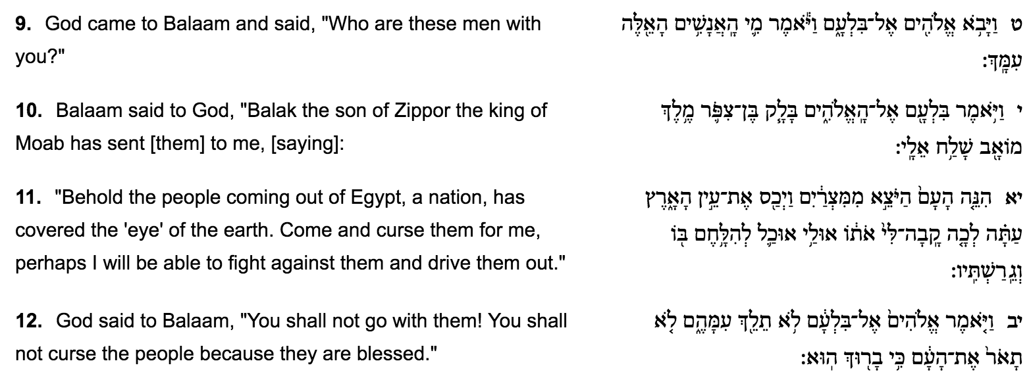
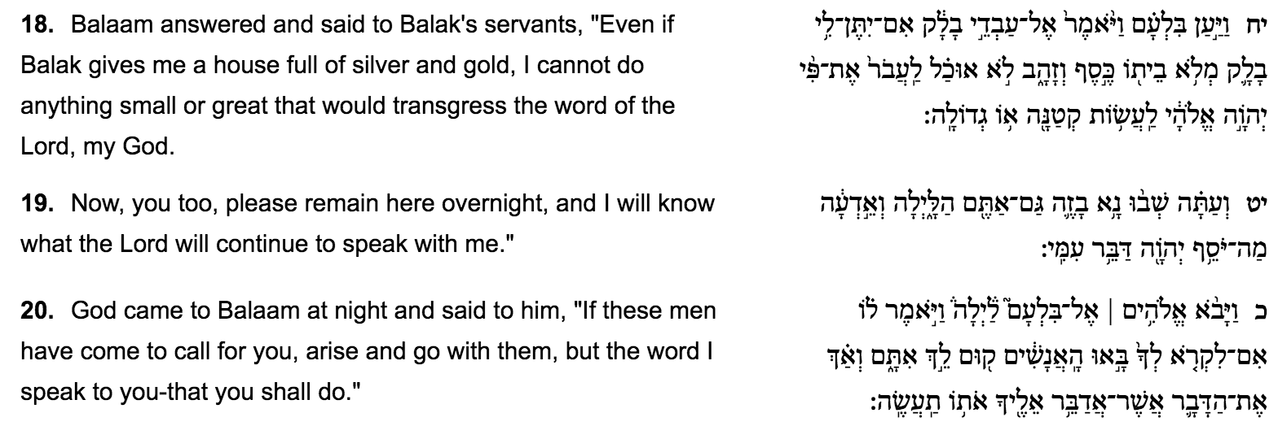
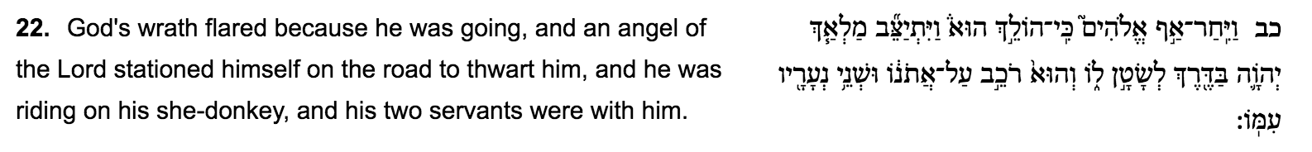

STORY: “Life with the Wright Family”

One day the Wright family decided to take a vacation. The first thing they had to decide was who would be left at home since there was not enough room in the Wright family car for all of them. Mr. Wright decided that Aunt Linda Wright would be the one left at home. Of course this made Aunt Linda Wright so mad that she left the house immediately yelling "It will be a right cold day before I return".

The Wright family now bundled up the children, Tommy Wright, Susan Wright, Timmy Wright and Shelly Wright and got in the car and left. Unfortunately, as they turned out of the driveway someone had left a trashcan in the street so they had to turn right around and stop the car. They told Tommy Wright to get out of the car and move the trash can so they could get going. Tommy took so long that they almost left him in the street. Once the Wright family got on the road, Mother Wright wondered if she had left the stove on. Father Wright told her not to worry he had checked the stove and she had not left it on. As they turned right at the corner, everyone started to think about other things that they might have left undone.

No need to worry now, they were off on a right fine vacation. When they arrived at the gas station, Father Wright put gas in the car and then discovered that he had left his wallet at home. So Timmy Wright ran home to get the money that was left behind. After Timmy had left, Susan Wright started to feel sick. She left the car saying that she had to throw up. This of course got Mother Wright's attention and she left the car in a hurry. Shelly Wright wanted to watch Susan get sick, so she left the car too. Father Wright was left with Tommy Wright who was playing a game in the backseat.

With all of this going on Father Wright decided that this was not the right time to take a vacation, so he gathered up all of the family and left the gas station as quickly as he could. When he arrived home, he turned left into the driveway and said "I wish the Wright family had never left the house today! Right?”

Discussion Questions about story: if you want to make it harder, don’t ask them in order
- Why did the Wright family need to leave someone at home?
  - Not enough room in the car
- Who did Aunt Linda Wright yell at? Why did she yell?
  - Father Wright and because she was picked to stay behind
- What are the names of the Wright children?
  - Tommy Susan Timmy Shelly
- What happened when the Wright family left the driveway?
  - A trashcan prevented them from leaving
- Who almost got left behind? Why?
  - Tommy because he got out of the car to move the trashcan
- What was Mother Wright worried about? How did Father Wright respond?
  - She worried she left the stove on and Father said he turned it off
- Where did the Wright family first go on their vacation?
  - Gas station
- What did Father Wright leave at home?
  - wallet
- What did Susan Wright start feeling that got Mother Wright’s attention?
  - sick
- What did Father Wright decide in the end?
  - That it wasn’t a good time for a vacation
- What did Father Wright wish to end the story?
  - "I wish the Wright family had never left the house today! Right?”

Discussion with Parsha:
- (If you didn’t remember details from the story) Why was it hard to recall different details in the story?
- Does the way we listen change when we have a goal in mind for the conversation?
- In the parsha, Bilam repeatedly asks G-d to go with Balak until his answer explicitly seems to be yes. How did Bilam’s desire to go with Balak influence his listening during his conversations with G-d?
- How did Bilam fall prey to selective listening?
  - Guide them to this definition: selective listening is when a someone’s intentions or goals filter their comprehension of a conversation
- What are some moments when you have been talking to someone and you felt like they didn’t fully understand your point? Why do you think that happened?
- What are some moments when you have been listening to someone and haven’t fully gotten their point? Why do you think that happened?
- How can we make ourselves more kan veh achshav during conversations so that we pay closer attentions to what our friends are really saying?

