SETTLERS OF CAMP-TAN
Planner: Maddie Gelfand
Peulat Erev
Time: 50 minutes. First 15 minutes for directions and breaking into groups
Place: Large open space (Beit Am Bet)

**Read the directions first… this will make more sense after you understand what the game is.

Materials
- Masking tape and sharpie for making the gameboard
- 2 dice
- 20 objects to use as tzrifim (plastic cups)
- 15 objects to use as moadoanim (paper cups)
- 15 objects to use as beit am’s (paper plates)
- 10 objects to use as chadars (paper bowls)
- Groups – about 7 chanichim per group (add or remove groups based on how many chanichim you have. Change the camp names if need be – add Palmer and Berkshires unless that would start WW3 between those two groups )
Printed materials
- Resource cards (print document 30 times)
- Development cards (print doc once)
- Port validations (print doc once)
- Kfutzah collection guidelines (print doc once)
- Numbers (print doc once)

Set Up
- Print out all of the documents and cut resource cards, development cards, and port validations
- On the bar/bat mitzvah development card, write in different numbers for where there is a space
- Set up the game board. Use masking tape to make a grid on the floor that is about 25 by 25 squares. Use the tiling on a floor indoors so that you don’t need to tape down every line on the grid (if possible). Now, on the grid, pick 10 locations scattered randomly to be ports. These ports will be at the INTERSECTIONS of the lines on the grid, not squares themselves. Place tape on the intersections that you’ve chosen as ports and label each of them. There will be 2 ports for each resource. One will be 2:1, and one will be 3:1. For example, label one intersection “2:1 Challah Port” and label a different one “3:1 Tefillin Port.” (etc.)
- Set up a mercaz – i.e. a place where all of the resource cards and development cards can be layed out, as well as all of the development objects that will be bought.

Game play
- Have 2 madrichim at the mercaz so chanichim have a central location where they can buy settlements and development cards, and collect resources. Madrichim should be giving out the resources when the dive are rolled, and facilitating transactions like buying tzrifim and upgrading to all of the other objects
- Have one madrich stationed in a central location holding the number cards so that every minute when the dice are rolled, they can yell and hold up the number so that everyone knows what was rolled.
- Have one madrich walking around making sure that chanichim are understanding what’s going on and keeping track of who has the longest road.
- All other madrichim should be walking around helping out kfutzot. If there are enough madrichim, assign one to each kfutzah.
Directions:

It is the dark ages - a time in America where no Machane Ramah exists anywhere (aka it’s 1946). Your job, as a team, is to settle Camp-tan, to settle Machanot Ramah throughout all the land!
The goal of the game is to settle your camp so that it reaches 18 victory points. You get one point for each tzrif on the board, 2 points for each moadoan, 3 points for each beit am, and 8 points for each chadar. Roads are zero points, but you need them to build more binyanim.
You will be split up into different Ramah locations so that you can settle your camps.

The resources that you have to build these camps are as follows: torah, tallis, tefillin, kippot, and challah. You will need to collect these resources in order to build roads, trifim, moadoanim, beit am’s, and a chadar.

Every 60 seconds, a madrich will roll the dice. They will then yell the number rolled and hold up a sign with that number. Someone on your team must then look at the collection guide and see what resources they are allowed to collect for the number rolled. To collect these resources, you must go to the Mercaz. For example, of a 7 is rolled, every kfutzah can collect one of each resource. For every other number, however, each kfutzah collects different resources. Please refer to your team’s resource guide to see what resources you can get for each specific roll. (So when the dice are rolled and you know which recourses you are supposed to be collecting, go to the Mercaz and politely ask for the resources you need.)

When you are ready to buy something – a road, one of the binyanim, or a development card, look at your building costs card and gather your payment. Then go back to the mercaz when you are ready to make a purchase and they will give you the materials you need to build.

Roads are built along the lines of the grid, and binyanim are built at the corners on the grid. Roads built using a pair of shoes from one camper.
You may not build one binyan next to another; in other words, there must be at least 2 roads separating each building from its closest neighbor.
Each team will start with 2 free tzrifim and 2 free roads. Moadoans, beit ams, and chadars are all upgrades. That means that you have to build a moadoan in the place of an old tzrif (which eliminates that specific tzrif), a bait am in the place of an old moadoan (which eliminates that specific moadoan), and a chadar in the place of a beit am (which eliminates that specific beit am). Again, each building is an upgrade to the building immediately lesser that itself. (It’s like monopoly – you can’t just build a hotel. You have to first build houses and then upgrade to the hotel, thus eliminating the houses)

You can also buy development cards at the mercaz using the resources indicated. Development cards will be one of the following. You may use a development card by going to the team you wish to use it upon, or the mercaz. The development cards are as follows:
Year of Plenty – this allows you to take 2 resources of your choosing from the mercaz.
Schmitah – you get to pick another team who is not allowed to collect on the next roll of the dice
Pesach – you are allowed to take all the challah from one team.
Monday/Thursday/Saturday – you are allowed to take 2 torahs from one other team
Hay on the Dreidel – You can pick a team that can only collect half of the resources they are given on the next roll of the dice (if the number is odd, round up: if I am supposed to get 5 Torahs, I take 3)
It’s Your Bar/Bat Mitzvah! Mazal Tov! You get an extra roll of the dice. You may collect resources as if a ___ was just rolled.

There is also trading. You can trade resource cards with any team at any time throughout the game. You can trade 1 for 1, 2 for 1, 3 for 1… any trade that both teams agree on is absolutely fine.
You can also trade with the mercaz. If you go with 4 of one card, they will give you 1 of any other card that you want. For example, if I have a lot of kippot but I really want a Torah, I can go to the mercaz with my 4 kippot and get a Torah in exchange.
This 4 to 1 trading with the mercaz rule holds true unless you build on a port. Ports are marked tape at the intersection between 4 squares of the grid. You may not place your first tzrif on a port, but you are encouraged to build roads leading there so that you can use the port. If your bunk does get a port, go to the mercaz and ask for a port validation. You will be given a paper that shows it is okay that you trade 2 or 3 of a certain object – depending on the port – for any other, instead of 4 of an object for any other. They are specific to one resource, meaning if my bunk acquires a 2 to 1 challah port, I can trade 2 challahs for anything I want, but I can’t trade 2 tefillin for anything I want.

There is also a 2 point bonus for the kfutzah that has the longest continuous road. A madrich will be keeping track of this throughout the game. If there is a tie, no one has the 2 point. A team only keeps those 2 points while they have the longest road.

As a reminder
- Roads are 0 points
- Tzrifim are 1 point
- Moadoanim are 2 points
- Beit Am’s are 3 points
- Chadars are 8 points
- Each banyan is an upgrade from the previous ones
- Binyanim must be 2 roads away at minimum

Questions?

Building Costs

Road
- Tallis
- Kippah

Tzrif
- Tallis
- Torah
- Tefillin

Moadoan
- 3 Challas
- 2 Torahs

Beit Am
- 3 Kippot
- 2 Tallit
- 1 Tefillin

Chadar Chofesh
- 4 Challas
- 4 Tefillin
- 4 Kippot
- 4 Tallit
- 4 Torahs

Development Card
- Tallis
- Tefillin
- Kippah

RAMAH OJAI COLLECTION GUIDE
Number Rolled on the Dice | Resources you can Collect
2 | 3 Challah, 2 Kippot, 2 Torahs
3 | 2 Kippot
4 | 3 Tallis
5 | 1 Challah
6 | 2 Tefillin, 1 Torah, 1 Tallis
7 | 1 Tallis, 1 Tefillin, 1 Torah, 1 Kippah, 1 Challah
8 | 2 Challahs, 3 Kippot
9 | 1 Challah
10 | 2 Torahs
11 | 3 Tefillin
12 | 4 Tallit, 1 Tefillin, 1 Kippah, 1 Torah

RAMAH CANADA COLLECTION GUIDE
Number Rolled on the Dice | Resources you can Collect
2 | 2 Challahs, 3 Kippot
3 | 3 Tefillin
4 | 1 Challah
5 | 1 Challah
6 | 3 Challah, 2 Kippot, 2 Torahs
7 | 1 Tallis, 1 Tefillin, 1 Torah, 1 Kippah, 1 Challah
8 | 3 Tallis
9 | 4 Tallit, 1 Tefillin, 1 Kippah, 1 Torah
10 | 2 Torahs
11 | 2 Kippot
12 | 2 Tefillin, 1 Torah, 1 Tallis

RAMAH POCCONOS COLLECTION GUIDE
Number Rolled on the Dice | Resources you can Collect
2 | 3 Challah, 2 Kippot, 2 Torahs
3 | 1 Challah
4 | 2 Kippot
5 | 2 Torahs
6 | 3 Tallis
7 | 1 Tallis, 1 Tefillin, 1 Torah, 1 Kippah, 1 Challah
8 | 1 Challah
9 | 3 Tefillin
10 | 2 Tefillin, 1 Torah, 1 Tallis
11 | 4 Tallit, 1 Tefillin, 1 Kippah, 1 Torah
12 | 2 Challahs, 3 Kippot

RAMAH DAROM COLLECTION GUIDE
Number Rolled on the Dice | Resources you can Collect
2 | 2 Tefillin, 1 Torah, 1 Tallis
3 | 3 Challah, 2 Kippot, 2 Torahs
4 | 2 Challahs, 3 Kippot
5 | 2 Kippot
6 | 1 Challah
7 | 1 Tallis, 1 Tefillin, 1 Torah, 1 Kippah, 1 Challah
8 | 2 Torahs
9 | 3 Tallis
10 | 3 Tefillin
11 | 1 Challah
12 | 4 Tallit, 1 Tefillin, 1 Kippah, 1 Torah

RAMAH WISCONSIN COLLECTION GUIDE
Number Rolled on the Dice | Resources you can Collect
2 | 2 Torahs
3 | 2 Tefillin, 1 Torah, 1 Tallis
4 | 3 Challah, 2 Kippot, 2 Torahs
5 | 2 Challahs, 3 Kippot
6 | 4 Tallit, 1 Tefillin, 1 Kippah, 1 Torah
7 | 1 Tallis, 1 Tefillin, 1 Torah, 1 Kippah, 1 Challah
8 | 3 Tefillin
9 | 2 Kippot
10 | 1 Challah
11 | 3 Tallis
12 | 1 Challah

RAMAH NYACK COLLECTION GUIDE
Number Rolled on the Dice | Resources you can Collect
2 | 1 Challah
3 | 3 Tefillin
4 | 2 Kippot
5 | 2 Challahs, 3 Kippot
6 | 3 Challah, 2 Kippot, 2 Torahs
7 | 1 Tallis, 1 Tefillin, 1 Torah, 1 Kippah, 1 Challah
8 | 2 Torahs
9 | 4 Tallit, 1 Tefillin, 1 Kippah, 1 Torah
10 | 1 Challah
11 | 2 Tefillin, 1 Torah, 1 Tallis
12 | 3 Tallis

Development Cards:

Pesach
You are hereby granted the power of taking all the challah from one team

Year of Plenty
This card hereby grants you the power to take 2 resources of your choosing from the mercaz

Schmitah
This card allows you to pick another team who is not permitted to collect from the next roll of the dice

Hay on the Dreidel
You are hereby granted the opportunity to choose one team who can only collect half of the resources they would have been given on the next roll of the dice (Round up: if you are supposed to get 5, take 3 instead)

Monday/Thursday/Saturday
You are hereby granted the power of taking 2 Torahs from one team

Bar/Bat Mitzvah
You get an extra roll of the dice. You may collect resources as if a ___ was just rolled.

Port Validation:

2 to 1 Torah Port
This sheet is a validation that you own a port. You may trade 2 Torahs for anything else at the mercaz if you show them this sheet.

2 to 1 Tefillin Port
This sheet is a validation that you own a port. You may trade 2 Tefillin for anything else at the mercaz if you show them this sheet.

2 to 1 Kippah Port
This sheet is a validation that you own a port. You may trade 2 Kippot for anything else at the mercaz if you show them this sheet.

2 to 1 Tallis Port
This sheet is a validation that you own a port. You may trade 2 Tallit for anything else at the mercaz if you show them this sheet.

2 to 1 Challah Port
This sheet is a validation that you own a port. You may trade 2 Challahs for anything else at the mercaz if you show them this sheet.

3 to 1 Torah Port
This sheet is a validation that you own a port. You may trade 3 Torahs for anything else at the mercaz if you show them this sheet.

3 to 1 Tefillin Port
This sheet is a validation that you own a port. You may trade 3 Tefillin for anything else at the mercaz if you show them this sheet.

3 to 1 Kippah Port
This sheet is a validation that you own a port. You may trade 3 Kippot for anything else at the mercaz if you show them this sheet.

3 to 1 Tallis Port
This sheet is a validation that you own a port. You may trade 3 Tallit for anything else at the mercaz if you show them this sheet.

3 to 1 Challah Port
This sheet is a validation that you own a port. You may trade 3 Challahs for anything else at the mercaz if you show them this sheet.

Resource Cards:

Challah  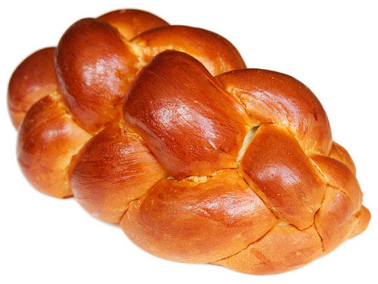 | Challah
Tefillin  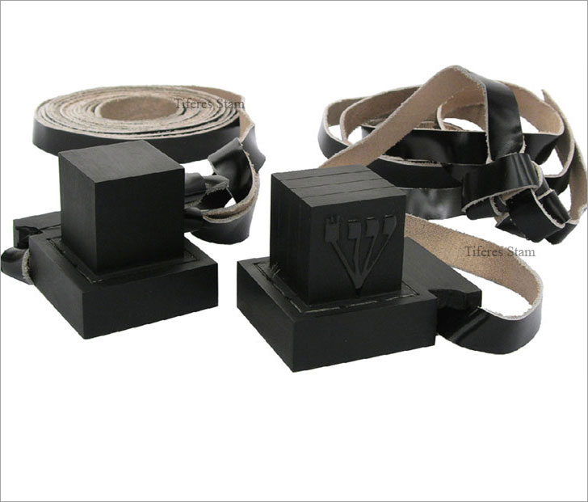 | Tefillin
Tallis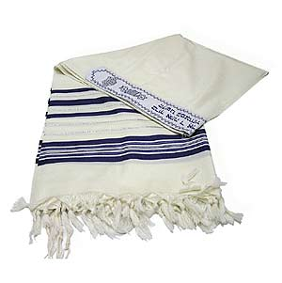 | Tallis
Torah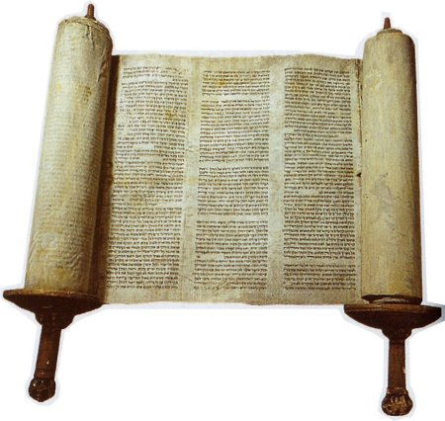 | Torah
Kippot  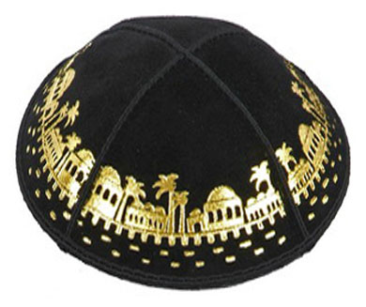 | Kippot

2
3
4
5
6
7
8
9
10
11
12

