T’fillot 7/10
Social Justice/Amidah Discussion

- Split into kvutzot in the chadar
  - 7 kvutzot, each with 2 madrichim
  - Walk to moadon to get siddurim, tefillin, talit
- Talk about the Amidah
  - What do you know about the amidah?
    - How many brachot are in the Amidah? 18
    - How many times a day is it traditionally said?
    - What does the amidah mean to you?
    - Have you ever said the whole amidah before?
  - The amidah is filled with different brachot for different moments and different things we wish for in our lives
- Discuss 3 Specific brachot
  - Have chanichim find these brachot in their siddurim and read these brachot out loud (out loud in English and Hebrew if possible) -- text and questions on back
- Ingathering of Exiles - Kibbutz Galyot
- Year of Prosperity - Brachot Hashana
- Health and Healing - Refuah
- Discussion Points
  - When we do the Amidah it is a chance to pray for what matters to you
  - Here are three brachot in the Amidah, but the Amidah is also a chance to pray for the things that are not written in the siddur as well
  - It is a time to stand up (literally and metaphorically) for issues you care about
- Discussion Questions
  - What social justice issues would you stand up for?
  - How can we stand up for these issues?
  - How can we include them in our amidah?
  - What pieces of the amidah are most meaningful to you?
  - How can you take your own values/social justice focuses and make the amidah meaningful for you? There's no one right way to pray the amidah

- Pray in your group
  - Birkot Hashachar (10)**
  - Baruch Shemar (54)
  - Hatzi Kadish (94)
  - Barchu (96)**
  - Shema and paragraphs after (100)**
  - Micah mocah and the Amidah (104)**
    - Make sure to emphasize themes we discussed above
  - Kaddish shalem (158)
  - Aleinu (160)
  - Adon Olam (162)

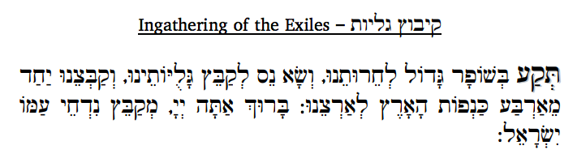
Sound the great shofar for our freedom, raise a standard to gather the exiles and gather together the exiles from the four corners of the earth. Blessed are You, hashem, Who gathers in the dispersed of His people Israel.

- What do you think this bracha means?
- Why do we pray for God to gather exiled people?
- If the Amidah is only 18 things, Why have this in the Amidah?
- How can this be applied to today's world? → refugee crisis
- When have you come together for a specific cause with a group of people? Did you feel that the larger group created a more powerful atmosphere?
→ This bracha because we were once exiles
→ The Amidah includes social justice issues even when they are not directly relevant to our lives

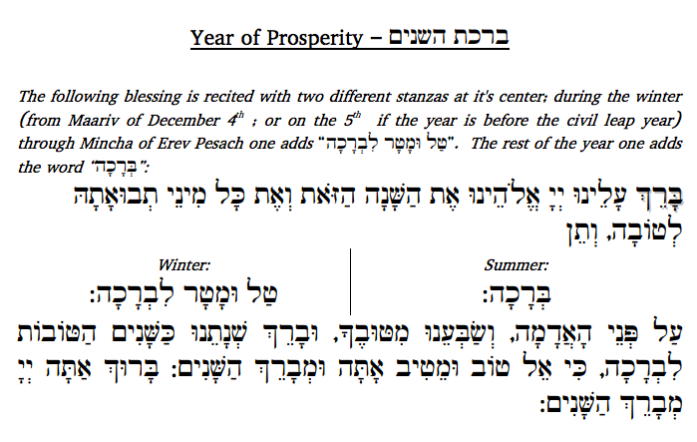
Bless for us, hashem, our God, this year and for all kinds of crops to be the best crops, and bless us with dew and rain on the face of the earth, and satisfy us with Your goodness, and bless our year like the best years. Blessed are You, hashem, Who blesses the years.

- What does this bracha mean? What is it asking for?
- Why is this in the Amidah?
- How does this bracha relate to you? How can we apply this bracha to today? (Hint at high school being a new beginning for them)

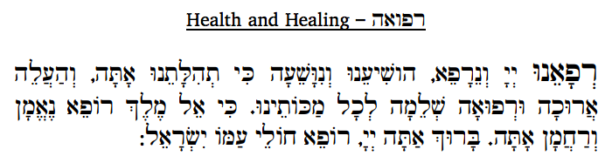 Heal us, hashem – then we will be healed; save us – then we will be saved, for You are our praise; and bring complete recovery for all our sicknesses, for You are God, King, the faithful and compassionate Healer. Blessed are You, hashem, Who heals the sick of His people Israel.
**Just read this bracha and discuss the importance of thinking of others in their life who might need extra help. Sometimes it can be hard to relate to the more complicated brachot, but this one is more universal in the sense that everyone wants the close people their lives to be safe.
→ This is the general prayer for healing, but there is also an add on in the amidah for people who want to add a specific name to their prayer

