Banot and Banim Bonding
Banim Bonding: Improv
By: Eytan, Natan, and Zev
Date: 8/16/18

Duration: 60 minutes
Location: Moadon
Premise
Improv games, with different formats and scenarios. Time capsule activity afterwards.
Goals
Facilitate bonding within banim and have fun!
Set up
The moadon will be set up such that all of the benches are facing the back of the moadon, with one bench at the front for skits
Directions
Round 1: NUMBERS ONLY - Chanichim are given scenarios and can only speak with numbers
Scenarios:
Example: Madrich is shushing chanichim during services
- Rabbi Gelb finds a chanich pooping in the chadar bathroom urinal
- Madrich coaching giving pump up speech to team
- Chanich is explaining injury to olga and she examines him
Round 2: TWINNING - Chanichim are paired together as twins with connected brains and have to talk at the same time
Scenarios:
Example: Natan is asking Zev and Eytan about favorite music
- Three twins (six people) give “Oh my Lord”’s
Round 3: WISDOM CARDS - Eytan and Natan are given scenarios and have to integrate the “wisdom cards” (which are single lines written by chanichim prior to round 3) into the scene in whatever format they want
Example Wisdom card: Shower flip flops are both unnecessary and ugly
Scenarios:
- Madrich dealing with homesick kochavimer
- Two friends saying goodbye on the last day
- Two chanichim meeting one another for first time in Illanot

Bonus
Time capsule activity in which each chanich is given a small piece of paper and is told to write their individual and group goals going into next summer as a banim. Each piece of paper will be folded and placed into a pringles container, and then buried into the ground, while all of the banim and circled around the hole with arms around one another, chanting. (The chant will be something Eytan, Natan, and Zev will teach.)
Supplies needed for bonus
- Pringles container
- Lots of paper
- Pens and markers

Banot Bonding: Paint Twister
By: Zev, Jillian
Date: 8/16/18

Duration: 60 minutes
Location: Old Kfar
Premise
The banot will play a gigantic game of paint twister, and then sign and handprint others’ shirts with paint
Goals
Facilitate bonding within banot and have fun!
Set up
Banot tzevet arrives early to set up in old kfar (on the big concrete slab). Place 3 sheets far apart from each other. Place circles of paint as shown below.
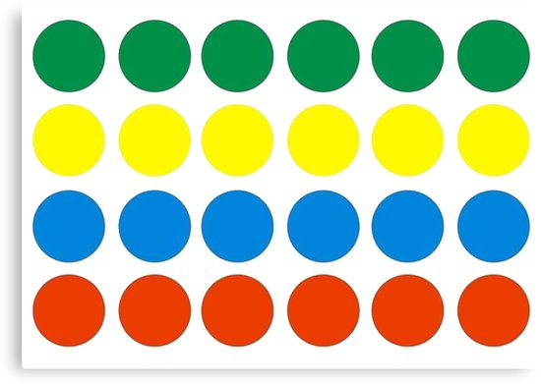

Materials
- 3 sheets
- Green, yellow, blue, and red paint (as much as possible!)
- Cups
- Twister app to decide directions randomly
Directions
- Tell all banot to wear clothes they don’t care about and can be ruined
- Tell the banot to start anywhere on the paper they want. One madricha will call out directions and the rest of the madrichot will play twister with the chanichot.
- After around 25-30 minutes, let the banot sign others’ shirts!

