Capture the Yanks
Program Type: Peulot Erev
Approximate Duration of the Program: 1 Hour
One-Line Description:
Overall Goals/Themes:
Methods Used:
Supplies/Resources Needed: cones, glow sticks and other colorful objects, chadar paper, hula hoops, face paints
Educational Content: American History, Hebrew
Ideal Location and Room Setup: Machane Gimel
Tzvet Preparation and Roles:
Instructions:
- Chanichim will be placed into teams and must change before dinner into their colors
- Divide Machane gimmel into four quadrants: Betsy Ross, Abigail Adams, George Washington, and Alexander Hamilton
  - Add a middle section for the trivia
- Each team/quadrant will have a hula hoop full of objects of their own teams color in a hula hoop and a large sheet of chadar paper
- Once the game begins they will have to run into other quadrants’s safe zone and get items from the hula hoops to bring back to their quadrant to create a picture/image on the chadar paper
- You must have one foot in a quadrant to be considered in that quadrant
- Once you get to a safe zone without being tagged, you take a single item and get safe passage back to your quadrant
  - If you get safe passage you must hold the item up over your head and walk back to your quadrant
- If you get tagged in another quadrant you must go to the trivia zone and answer a trivia question correctly to go back to your quadrant and continue playing
  - If you get tagged in another quadrant you must hold both hands up and walk to the jail zone
- You must complete the prompt/image fully and check it with the madrich near your safe zone
- If you answer 3 questions correct in a row at the trivia zone, you may go safely to another quadrant and get an item for free
Timeline:
Bechirot: Change into color and learn group
815:
Rain Plan: Do the game in the bag using the stage as a jail/questions for bonus points
Prompts:
- American flag
- Portrait of their person
- Map of america
- The most american thing you can think of
- Alpine tower
- An eagle
- Statue of liberty
- Captain america shield
- The capitol building
Extra Missions:
- Say at least 20 states.
- Translate a line of the American anthem to Hebrew.
- Sing the anthem in a funny/creative/weird way.
- Invent a dance for the song “Born in the USA “ and dance with at least 6 kids.
- Write a new constitution in a 30 sec.
Trivia
George Washington:
- George Washington was born on February 22, 1732
- He was born in Virginia
- When he was born, they didn’t yet use the Gregorian calendar which is the one we use today
- When the government finally adopted the Gregorian, all dates were moved back 11 days. Thus Washington's actual birth date became February 11th.
- George Washington had many fake teeth that were made of animal bones and human teeth
- His favorite breakfast was simple cornmeal pancakes
- His close friends and family usually called him “General”
- He didn’t have a middle name
- His hair was all real
- He was an honorary citizen of France
- He received the highest US military award in the history of the country
- When in office, his salary was made up of 2% of the national budget
- Throughout his life he suffered from many of the worst diseases at the time
- It is estimated that he wrote between 18,000 to 20,000 letters in his life
- Before the military, he worked as a professional surveyor
- Before fighting against the british, he fought for them in Ohio
- He owned around 30 dogs
- He only had one tooth in his mouth at his inauguration
- He was the only president ever to physically go to battle while in office
- He dropped out of school at age 15
- He was unanimously elected two times
- He could crack walnuts in between his finger
- He was the only president not to work out of the white house
Alexander Hamilton Facts
- He has a musical about him
- Hamilton was born on January 11, in either 1755 or 1757
- He was born on the island of Nevis in the British West Indies
- His Dad was Scottish, Mother was from Nevis
- He was rejected by Princeton, but accepted to Columbia
- He was General George Washington’s aide de camp, or his right-hand man
- Hamilton also personally led an attack and charge at the Battle of Yorktown on a British temporary fort (redoubt)
- He taught himself law and passed the exam
- He studied law with John Jay and William Paterson, two future Supreme Court Justices
- He helped promote the Constitutional Convention of 1787
- Hamilton’s constitutional legacy was the Federalist Papers
- His authorship of the Federalist Papers wasn’t made public until after his death
- He died in 1804
- Hamilton founded the Treasury Department and strengthened the banking system
- Hamilton was the first Secretary of the Treasury
- Hamilton also formed the First Bank of the United States
- He was able to convince other nations that the United States was financially sound
- Hamilton inspired the first American political party, the Federalist Party
- In response to the creation of the Federalist Party, James Madison and Thomas Jefferson formed a political faction known as the Republicans that directly objected to Hamilton and his ideas
- Hamilton helped his own political enemy, Thomas Jefferson, become President
- Aaron Burr killed Hamilton in a duel
- Hamilton and Burr had been rivals in New York before the 1800 election, and Hamilton worked to deny Burr’s election to the New York governorship
- Hamilton refusing to retract an insult led to the duel that killed him
- Hamilton was the founding trustee of the hamilton-oneida academy, which later became Hamilton College
- Hamilton is on the 10$ Bill
Betsy Ross Trivia:
- Betsy Ross made the first American Flag
- Betsy Ross was born Elizabeth Griscom
- Ross’s parents were Samuel Griscom and Rebecca James Griscom
- Her dad, Samuel Griscom, helped build the bell tower on Independence Hall
- Her design was based on a sketch from George Washington
- Betsy was born on January 1, 1752
- Ross lived most of her life in Philadelphia
- Ross was number eight of seventeen children and was raised by her mother and father
- Ross was a quaker
- Ross was taught sewing by her aunt, and then did apprenticeships with an upholster
- Ross met her husband, John Ross, at the apprenticeship with the upholster
- John Ross was killed by a gunpowder explosion while performing guard duties with the local military
- Ross married a total of three times
- Ross met with George Washington, George Ross, and Robert Morris in the spring of 1776, to have the discussion that eventually led to the sewing of the first American flag
- Betsy Ross was the mother of two daughters with her second husband, and the mother of five daughters with her third husband.
- She continued to run her upholstery business while reportedly making flags for the U.S. until the late 1820s.
- She died on January 30, 1836.
- She was originally buried in Philadelphia at a Quaker burial ground
- A year before the United States bicentennial in 1975, arrangements were made to have the remains of Betsy Ross removed from the cemetery in Mt. Moriah to the Betsy Ross House courtyard as this was the location where she supposedly lived while making the first American flag
- Betsy Ross was nicknamed the little rebel by the British Soldiers who occupied her home
- Betsy Ross went to the Rebecca Jones School for Quakers founded by William Penn
Abigail Adams Trivia:
- She was married to the second president and mother of the 6th president
- Abigail Smith was born November 11, 1744
- She never went to school
- She studied philosophy and famous authors in her father’s library
- Abigail and Jon met when Abigail was 11
- She gave birth to 16 children
- She was the first First Lady to live in the White House
- She assumed an active role as an informal adviser to the president and as the First Lady.
- Abigail was an advocate for women’s rights and equal public education for women.
- She supported the emancipation of slaves which she considered a threat to democracy
- During the American Revolution she was often left in charge of all the household responsibilities which not only included raising their children but also handling business dealings such as purchasing land, selling crops, and tenant interactions.
- Abigail Adams was very politically active and while in the White House was referred to by some as "Mrs. President"
- In fact she wrote to the Continental Congress, as they worked on forming the United States government, to "remember the ladies". She spoke about equal representation for women and how women should not be governed by laws that they had no representation in creating; the same grievances the colonist had against Britain that led to the American Revolutionary War.
- Estimates put the number of letters they exchanged at more than 1100.
- she was descended from many well known New England families.

Machane Gimmel Setup:
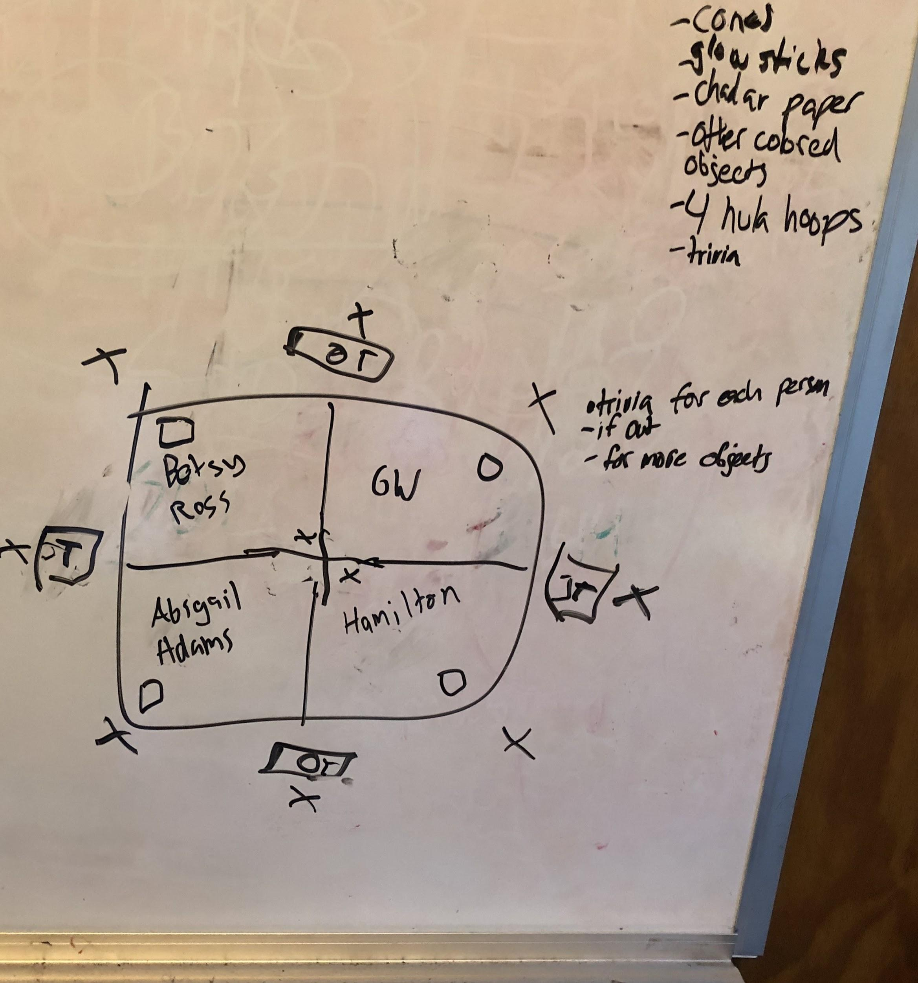
To do:
-Groups
-finish trivia
-gather supplies
-come up with better name

