Create your own Jewish Era!
Peulot Erev Sunday July 2nd
Goal:
- Educate about Jewish Eras
- Encourage group brainstorming
- Introducing the chanichim to working b’yachad on a larger scale
- Introduction to Nivonim programming interacting with other edot
Location: Moadon Nivonim (Rain: Old Chadar)
Description:
This is the start of a two day peulot-erev-to-peulot-erev Peulah in which the chanichim will be split up into four groups of 24 where they will be tasked with creating their own Jewish Era. They will be given 5 tasks to split up and complete by the end of the peulot erev. They will come up with a backstory for their era as a group, and then split up into groups to make a banner, a language/culture, and a song/anthem.
Materials:
- Roll of Chadar Ochel tablecloths (banners)
- Markers
- Pencils
- Paint
- Paper
- Texts from Commentators
- List of Jewish Eras (to base eras off of)
- Resource packet about Jewish Eras
Overview:
- Gather chanichim into Moadon (Chadar Ochel if raining). Introduce peulah:
Script:
“You are about to create your own journey into the future of Jewish
history. Throughout your zman at this machneh, you have learned time
and time again about the great downfalls and great accomplishments of
our predecessors. Now, as Nivnomim 2017, it is your time to create a
new era of the Jewish people. Right now, we will assemble into arbah
kvuzot, guided by your wise madrichim, to create four potential eras
for our people.”
Break chanichim into four groups, one madrich with each group.
  - In Kfar, disperse into different areas in Kfar
  - In Chadar, disperse into four corners of building
- Madrichim explain to their respective groups that there will be four tasks to complete this evening, and that their effort in these tasks will be incredibly important on Monday, and specifically, Monday night’s peulot erev.
- Madrichim will begin the first task of creating the backstory by going through provided Jewish Era examples packet. (30 minutes or until below tasks are complete)
- Facilitate a group brainstorm of the backstory, which should include:
  - Outfits
  - Culture
  - Influential Jewish Figures/Leaders
  - History
    - Moment in time (How did your era come to be)
  - Slogan
  - Domesticated object and other creativity
    - Can’t worship it, just care for it deeply
- Once backstory is complete and agreed upon (or 30 minutes have passed), assign chanichim to the remaining tasks:
  - 8 chanichim to make banner
  - 4-5 to write anthem
  - 3-4 to find quotes by their leaders/commentators
  - 8 to make and teach the language to the rest of the group
    - Notes for developing language:
- No English
- No American Sign Language
- Think about making a language that is easy to remember
- Think about what kind of simple things you need to communicate during the day?
- How can you make your language unique enough that others couldn’t figure out what you’re communicating without knowing the language?
- Recommend that the language makers write down their language so that their other team members have a cheat sheet to help learn it

Influential Jewish Leaders and Facts about their Eras
Group 1 – Rabbi Akiva, 1st Century C.E.
- Also known as Akiva Ben Yosef
- He was a leading contributor to the Mishnah and Midrash halakha
- He is referred to in the Talmud as the “Chief of Sages”
- Before studying Torah for 24 years and accruing 24,000 disciples, Rabbi Akiva was illiterate.
- The trait of modesty is often strongly associated with Rabbi Akiva’s work
- Believes in G-d having two attributes: The Attribute of Justice, and the Attribute of Mercy.
  - He believes that G-d combines goodness and mercy with strict justice
- Akiva married the daughter of his wealthy employer, for whom he worked as a shepherd
- One legend relates that the reason G-d placed crowns on the letters of the Torah was so Rabbi Akiva would find meanings in these ornamental marks

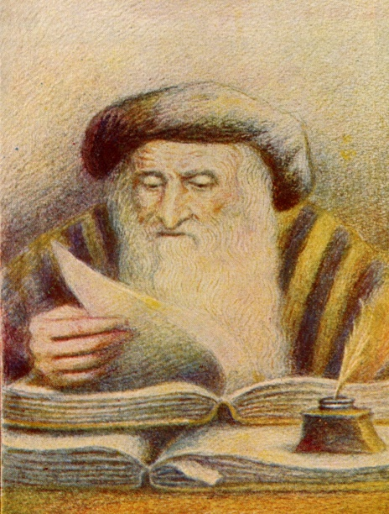

Group 2 – Rashi, 10th Century C.E.
- Also known as Rabbi Shlomo Yitzkaki
- Lived in 10th Century France
- His commentary on the Tanakh, particularly the Chumash (Five Books of Moses) is one of the most famous and important of all Rabbinic commentaries
- Rashi’s commentaries are known as SUPERCOMMENTARIES
- Rashi was one of the first known Feminists, and encouraged his daughters to study Torah
  - Source – Oren Bazer
- Without Rashi’s commentary, the Talmud would have remained a closed book.
- It is believed that Rashi’s name derives from a name that is derived from the French word for Moon…

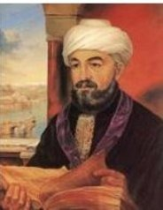
Group 3 – Rambam, 11th Century C.E.
- Also known as Maimonides, Rabbi Moses ben Maimon
- Lived in 11th century Spain
- He was a preeminent Astronomer
- He was a physician
- Was the head of the Jewish community in Egypt
- He is sometimes known as "ha Nesher ha Gadol" (the great eagle)
- He wrote the 13 Principles of Faith, summarizing what he viewed as the required beliefs of Judaism::
  - The existence of G-d.
  - G-d's unity and indivisibility into elements.
  - G-d's spirituality and incorporeality.
  - G-d's eternity.
  - G-d alone should be the object of worship.
  - Revelation through G-d's prophets.
  - The preeminence of Moses among the prophets.
  - The Torah that we have today is the one dictated to Moses by G-d.
  - The Torah given by Moses will not be replaced and that nothing may be added or removed from it.
  - G-d's awareness of all human actions and thoughts.
  - Reward of good and punishment of evil.
  - The coming of the Jewish Messiah.
  - The resurrection of the dead.

- He wrote Guide for the Perplexed, an attempt to reconcile the existence of G-d with the existence of evil.

Group 4 – Ramban, 12th Century C.E.

- Also known as Nachminides, Moses ben Nahman
- Lived in 12th century Spain
- Strong emphasis on mysticism from the Kabbalah
- One of the first Zionists
  - Declared that it is a mitzvah to take possession of Israel and live in it
- Moved to Israel during the Crusades and died there
- Believes strongly in reward and punishment
- Believes that man possesses a special soul that existed before the creation of the world, and the reincarnation of that soul into another human
- He believes that the body is a TEMPLE.

