Shoafim Peulat Shabbat, 8/12- Parshat Eikev
By Sarah Binney, Nate Gillman, and Eliav Glam

Description: the campers will learn about various steps in the production of Rolos, and then they will engage in a meaningful discussion about Birkat Hamazon and hakarat hatov (gratitude) at camp.

Goals: Talk about Birkat Hamazon, (kef (fun!!)), learn about where our food comes from.

Location: Mirpeset/around tzad aleph.

Tzevet Rolos: Six Tzevet members will travel between the kvutzot bringing their stations with them, and all other madrichim will stay with their assigned groups. After the activity, there will be a discussion, and the travelling madrichim will sit with the kvutzah they are in last, and help with the discussion.

Steps of the peulah:
- 10 min—Large kvutza introduction about parsha, break into kvutzot.
- 25 min—activity rotation, 6 min per peulah.
- 15 min—discussion in small groups.

Activities:
- Learning about chocolate
  - Knowledge: The first stage in chocolate production starts on large cacao farms in Africa and Latin America. Large cacao pods are knocked off of trees by farmers with large sticks, and then they are cracked in half with machetes to get rid of the thick outer later to reveal the cacao beans on the inside.
  - The following task represents the process of agriculture in food production: Each kvutzah will be given a set of Russian-dolls style boxes (big to small inside of each other), and each box will have a task written on it. The kvutzah will have to pass around the box and each person will have to do the task before they open the next box. They must go through all of the tasks to get to the smallest box that will have rolos in it (but this is a haftaah (surprise)!!)
- Learning about sugar
  - Knowledge: After sugarcane is harvested, it is transported to manufacturing plants where it is chopped up very finely, and the juice is extracted and made into syrup. The liquid evaporates, and the sugar is crystalized and becomes unrefined sugar. The sugar is then shipped to various refining plants across the country, where unrefined sugar is separated to become white granulated sugar and molasses. This sugar is then shipped across the country to different companies, such as the Rolo company, where the sugar is made into a product. Finally, these products are shipped to grocery stores, vending machines, and Machane Ramah, where they are distributed to consumers. Throughout all this transportation, the product travels from place to place, but lots of resources and energy are wasted in the process.
  - This task represents the process of transportation in food production: A bucket of mayim will be placed on one side of the area, and an empty bucket will be placed on the other side. The kvutzah will be given a cos with holes in the bottom, and without covering the holes, they must transport as much mayim as possible to the other bucket, relay race-style. Afterwards, they should discuss the fact that much water was spilled.
- Learning about corn syrup
  - Knowledge: When corn syrup is produced in a factory, the process starts with number 2 yellow dent corn, which is a type of corn that cannot be eaten as is. The corn is processed into starch and then into syrup, but a large amount of mass is lost along the way. 25 kg of corn, or one bushel, only produces 15kg of syrup, so 40% of food mass, as well as lots of resources, are lost in the production of this product.
  - The following task represents the manufacturing process of corn syrup: Play a couple rounds of telephone, where the counselor starts with a very long convoluted sentence. An example sentence includes:
    - Tailor, trim my car and slash the trash before a riot breaks out.
  - Discussion: in this game (as well as in corn syrup production), a lot of information (and natural resources) are lost on the way, leaving a sentence (a product) that doesn’t look the same as the original.

Discussion:
- Why is it important to think about where our food comes from?
- How does the Birkat help us think about where our food comes from? Read this quote.
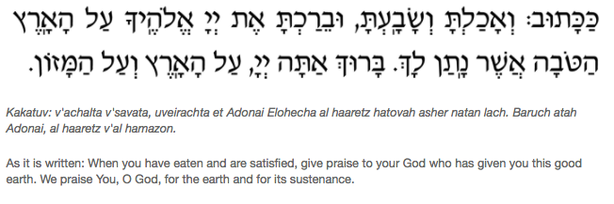
- Talking point: in our world, food is relatively easy to acquire. We are served already-made food in the chadar ochel, and we can buy prepared food and everything we need from grocery stores. It used to be that in order to have food, the farming, killing of animals, and cooking would have to be done by yourself. Now, we are much more separated from this process.
- Talking point: Hakarat hatov (being thankful in general, in life). Why is it important to recognize the work that other people have done for you?
- How can we do hakarat hatov at camp?

Tzevet rotation: 2 rotations are happening in parallel. Each activity is happening in 2 different groups led by 2 madrichim.

Madrich #1 | Madrich #2 | Madrich #3 | Madrich #4 | Madrich #5 | Madrich #6
1 | 4 | 2 | 5 | 3 | 6
2 | 5 | 3 | 6 | 1 | 4
3 | 6 | 1 | 4 | 2 | 5

