Puzzle #1
1. Q. Name the next letter in this sequence: J F M A M J J A S O N ?

2. Q. I’m an odd number. If you take away one of the letters in my name, I become even. What number am I?

3. Q. A girl fell off of a 30-foot ladder, but she didn’t get hurt at all. How is this possible?

4. Q. A plane crashes in the middle of the Mediterranean. Where do they bury the survivors?

5. Q. A magician promises that he can throw a ball as hard as he can and have it stop, change direction, and come back to him. He claims he can do it without the ball bouncing off of anything, the ball being tied to anything, or the use of magnets. How is this possible?

6. Q. Can you name three consecutive days without using the words “Wednesday,” “Friday,” or “Sunday”?
7. Q. How many cats can you put in an empty box?
8. Poor People have me, Rich people need, and if you eat me, you die. What am I?
Two words that sound alike in Hebrew:
הוא:מנגנים בו על הגג , היא: ימה בישראל ( Jesus walked on it)

Puzzle #2
Camp Trivia
- How many years has Rabbi Gelb spent at camp?
- Which Ramah camp is located in Lakewood?
- Which Ramah camp did Ben Platt go to?
- Which Niv was Maddie and Emily in?
- Who did Simon and Didi replace?
- When was the last time Palmer sweeped Berkshires on Yom Roo?
- What year did camp begin?

Puzzle #3: Words around Ramah
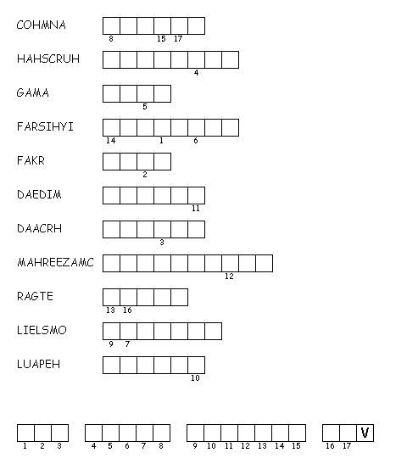

Puzzle #4
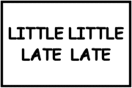

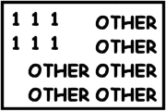
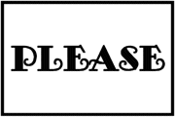
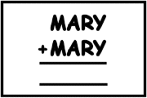

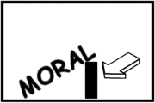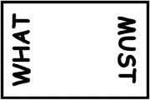

Puzzle #5
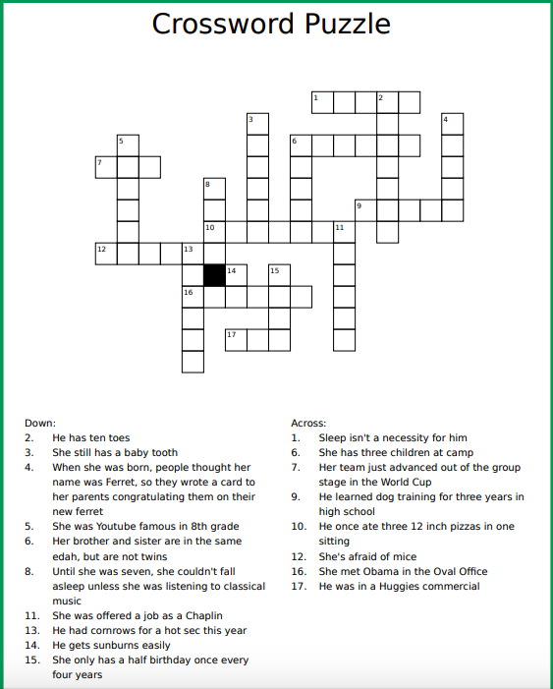

Puzzle #6
- How many parliament members those the “kneset” have?
2. Who was Israel’s first president?
3. Who was Israel’s second prime minister?
4. Who was the prime minister before Bibi Netanyahu?
5. What date (month and date) was Israel founded?
6. What is the lowest point in Israel (and the world)?
7. What animal is on the seal of Jerusalem?
8. What are the four biggest cities in Israel?

Puzzle #7
Hanhallah 2018
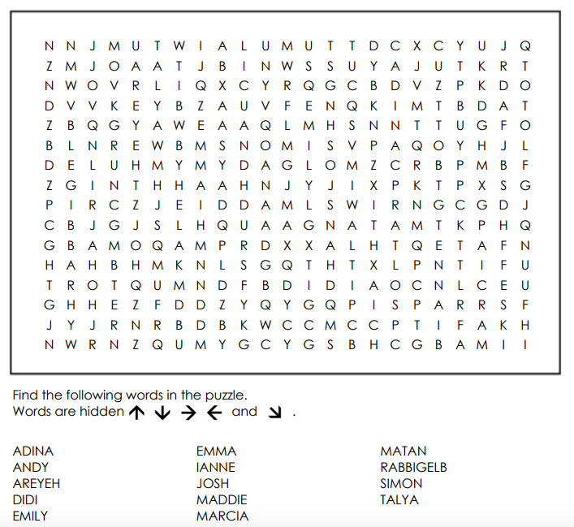

Puzzle #12
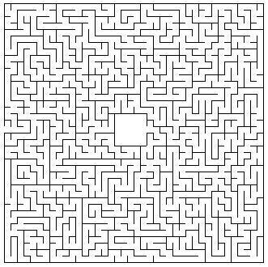

Puzzle #9 (free answer 17 down is “party”)
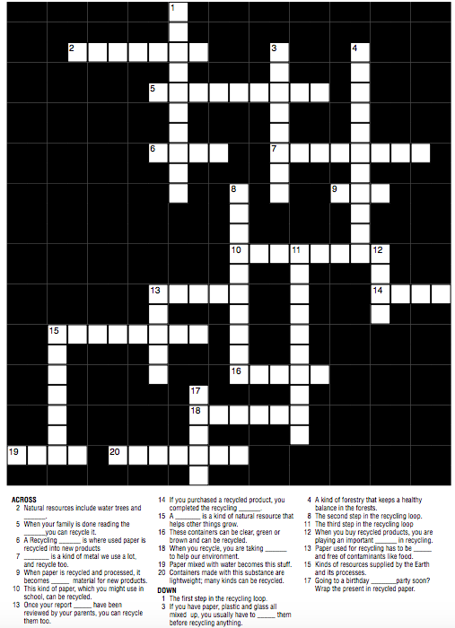
Puzzle #10: Write a sentence for each of the following meah milim (10 word minimum sentence length)
ספסל

קבוצה

תחרות

ימין

צריף

בקבוק
Puzzle #11: List them!
Name all 10 Ramah overnight camps:

Name all 5 Ramah Day camps:

Name all 10 Plagues (Hebrew and English)

List the books of the torah (Hebrew and English):
ANSWER GUIDE:

Puzzle #1
1. Q. Name the next letter in this sequence: J F M A M J J A S O N ?
A. D. The sequence contains the first letter of every month, in order.

2. Q. I’m an odd number. If you take away one of the letters in my name, I become even. What number am I?
A. Seven. (Take away the S!)

3. Q. A girl fell off of a 30-foot ladder, but she didn’t get hurt at all. How is this possible?
A. She fell off the bottom step!

4. Q. A plane crashes in the middle of the Mediterranean. Where do they bury the survivors?
A: you don’t bury survivors

5. Q. A magician promises that he can throw a ball as hard as he can and have it stop, change direction, and come back to him. He claims he can do it without the ball bouncing off of anything, the ball being tied to anything, or the use of magnets. How is this possible?
A. He throws the ball straight up in the air!
6. Q. Can you name three consecutive days without using the words “Wednesday,” “Friday,” or “Sunday”?
A. Yesterday, today, and tomorrow.
7. Q. How many cats can you put in an empty box? A. One. After that, the box isn't empty anymore.
8. Poor People have me, Rich people need, and if you eat me, you die. What am I? Answer: Nothing
Puzzle #2
Camp Trivia answers
- 13
- Poconos
- Ojai
- Nivonim 2012
- David Offit
- 2005
- 15
- 1953
Puzzle #3
- Machon
- Churshah
- Agam
- Sifriyah
- Kfar
- We forget the answer, if they really cannot get it let it pass :))
- Chadar
- Machazemer
- Etgar
- solelim
- Peulah Rad Hayom Shemesh tov
Puzzle #4
Top secret too little too late robin hood
Six of one, half a dozen of the other pretty please summary
Moral support split personality what goes up must come down

Puzzle #5: Just check it
Puzzle #6
- How many parliament members those the “kneset” have? 120
- Who was Israel’s first president? Chaim Weitzman
- Who was Israel’s second prime minister? Moshe Sharat
- Who was the prime minister before Bibi Netanyahu? Ehud Olmert
- What date (month and date) was Israel founded? May 14, 1948
- What is the lowest point in Israel (and the world)? Dead Sea
- What animal is on the seal of Jerusalem? Lion
- What are the four biggest cities in Israel? Haifa, Tel Aviv, Jerusalem, Baer Sheva
Puzzle #7
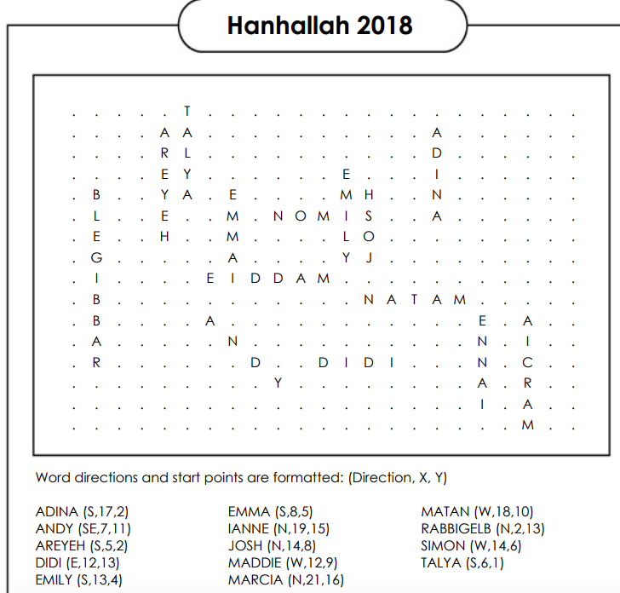
Puzzle #12: Maze → JUST CHECK IT
Puzzle #9
Puzzle #10: Just check it
Puzzle #11: List them!
Name all 10 Ramah overnight camps: WIsconsin, Ojai, Nor Cal, Rockies, New England, Ramah Sports Academy, Darom, Berkshires, Canada, Poconos
Name all 5 Ramah Day camps: Israel, D.C., Phili, Chicago, Nyack
Name all 10 Plagues (Hebrew and English)
  - Water into blood (דָם): Ex. 7:14–24
  - Frogs (צְּפַרְדֵּעַ): Ex. 7:25–8:15
  - Lice (כִּנִּים): Ex. 8:16-19
  - Mixture of wild animals (עָרוֹב): Ex. 8:20-32
  - Diseased livestock (דֶּבֶר): Ex. 9:1–7
  - Boils (שְׁחִין): Ex. 9:8–12
  - Thunderstorm of hail and fire (בָּרָד): Ex. 9:13–35
  - Locusts (אַרְבֶּה): Ex. 10:1–20
  - 3.99. Darkness for three days (חוֹשֶך): Ex. 10:21–29
  - 3.1010. Death of firstborn (מַכַּת בְּכוֹרוֹת): Ex. 11:1–12:36
List the books of the torah (Hebrew and English): Genesis, Exodus, Leviticus, Numbers, Deutoronomy // Bereshit, Shmot, Vayekra, bamidbar, dvarim

