Peulat Shabbat for 7-16-16
Theme: Different Perspectives/Stepping into different shoes
Time: 5:00-6:00pm
Location: Tzad Bet Migrash
Goal: Introduce chanichim to new and different interpretations of the story of Moses hitting the rock. Enable them to explore issues of leadership, ego and humility, etc. through this story and these different commentators.
Description: Begin the discussion by introducing the parsha. In case no chanichim know the story, a summary is provided below. Then discuss the most common interpretation of why Moses and Aaron were banned from entering Israel. Then discuss the other commentators. After Context and Support are two more commentaries without a list of questions. Based on time, you can explore those with your group as well.

Parsha Summary:
Moses is taught the laws of the red heifer, whose ashes purify a person who has been contaminated by contact with a dead body. After forty years of journeying through the desert, the people of Israel arrive in the wilderness of Zin. Miriam dies, and the people thirst for water. G-d tells Moses to speak to a rock and command it to give water. Moses gets angry at the rebellious Israelites and strikes the stone. Water issues forth, but Moses is told by G-d that neither he nor Aaron will enter the Promised Land. Aaron dies at Hor Hahar and is succeeded in the high priesthood by his son Elazar. Venomous snakes attack the Israelite camp after yet another eruption of discontent in which the people “speak against G-d and Moses”; G-d tells Moses to place a brass serpent upon a high pole, and all who will gaze heavenward will be healed. The people sing a song in honor of the miraculous well that provided them water in the desert. Moses leads the people in battles against the Emorite kings Sichon and Og (who seek to prevent Israel’s passage through their territory) and conquers their lands, which lie east of the Jordan.

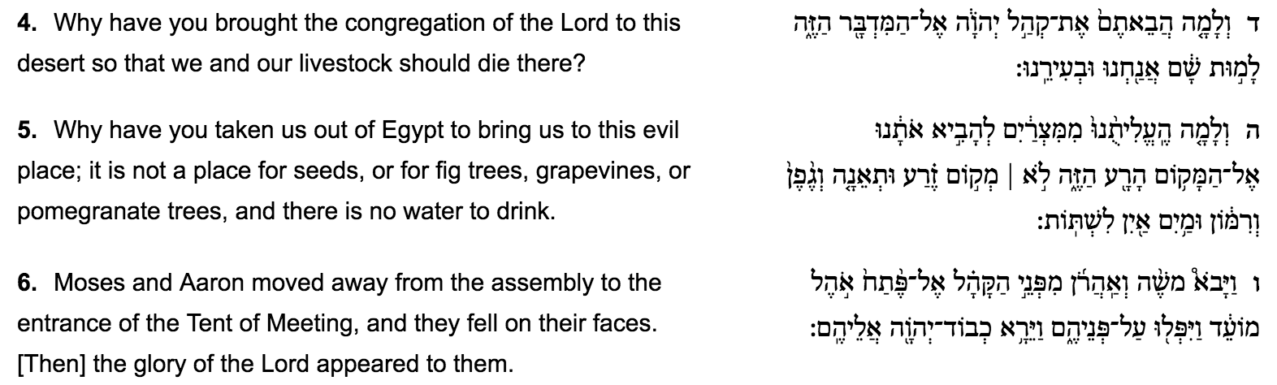
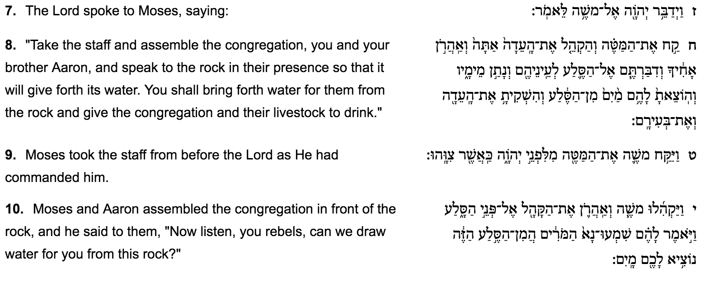
Rashi, offering the simplest and best-known explanation, says that Moses’ sin lay in striking the rock rather than speaking to it. Had Moses done as he was commanded, the people would have learned an unforgettable lesson: “If a rock, which neither speaks nor hears nor is in need of sustenance, obeys the word of G-d, how much more so should we.”*
- Why do you think this interpretation is so widely known? What makes it more comprehensive than other commentary?
  - Going for that its fairly simple and explicit so its easy to understand
- What problems does this interpretation face?

Transition: Now we are going to explore other understandings and interpretations of Moses actions and whether or not he (and Aaron) deserved to be banned from entering Israel.

Expectations of Leadership
Rambam (Moses Maimonides) says that Moses’ sin lay in his anger – his intemperate words to the people, “Listen to me, you rebels.” To be sure, in anyone else, this would have been considered a minor offence. However, the greater the person, the more exacting are the standards G-d sets. Moses was not only a leader but the supreme role-model of the Israelites. Seeing his behaviour, the people may have concluded that anger is permissible – or even that G-d was angry with them, which He was not.*
- Why is it so important for Moses to represent G-d accurately and honestly for the Israelites?
- Why is it different when an Israelite speaks angrily and when Moses speaks angrily?
- What differentiates a “leader” and a “supreme role-model”? How do the two roles interact?
- Should leaders be held to a higher standard? Why?
- Should leaders be perfect examples for their communities?
- How do we react when leaders make mistakes? What makes it different than an average person making a mistake?
- How can a higher standard for a leader benefit the community? How can it damage a community?
- Do we hold ourselves to the same standards as our leaders? Similar standards? If yes or no, why?
- How can our expectations of our leaders undermine or enhance a community? Give examples from your communities.
- How can we in Machon as leaders in camp enhance our Machaneh Ramah community?
Concluding: Being a leader inherently requires immense responsibility not only in the work it requires but in the expectations that stem from the community and must be met. While often intangible, excelling past these expectations can allow a leader to have a incredible positive impact on their community.

Ego and Humility:
Ramban (Nachmanides), following a suggestion of Rabbenu Chananel, says that the sin lay in saying, “Shall we bring forth water for you from this rock?” – implying that what was at issue was human ability rather than Divine miracle and grace.
- Assuming you accept this interpretation, do you think it was fair of Moses and Aaron to even imply that the water stemmed from their human capabilities? Why or why not?
- Why might it be important for the Israelites to understand that G-d was the power that caused the water and not Moses or a human being?
- Why might it be important for us to understand G-d’s power in aspects of our daily lives? Particularly for aspects, we take credit for? (Ex. waking up in the morning because we set an alarm)
- What important parts of our daily lives do we typically take credit for that might have immense support from other sources? (Ex. a goal in a sports game that happened from a play you learned from a coach)
  - When do you attribute credit to yourself and when do you attribute credit to something larger/G-d?
- (read the group and see if this question fits the discussion: When do we most often discuss “divine intervention”? Why?)

Concluding: Whether or not the chanichim believe in G-d, it is important to recognize that humans often underestimate how much their peers, teachers, mentors, coaches etc. change and propel their lives and actions.

Context and Support:
R. Joseph Albo and others (including Ibn Ezra) suggest that the sin lay in the fact that Moses and Aaron fled from the congregation and fell on their faces, rather than standing their ground, confident that G-d would answer their prayers.
- Given the Israelites frustration, was it reasonable for Moses and Aaron to flee? Why or why not?
- How did Moses and Aaron’s level of faith in G-d impact their reaction to the Israelites’ frustration?
- Would you feel comfortable “standing your ground” in Moses and Aaron’s position? Have you found yourself in a similar circumstance to Moses and Aaron? (Ex. all your friends want to go to one restaurant except you, the team votes someone captain who you know is a bully)
- Before we discussed how leaders are often held to higher standards. How do the higher standards Aaron and Moses are held to conflict with or compliment the empathy we feel for their circumstance?
- Are we more critical of leaders who crumble under pressure? Or of non-leaders who crumble under pressure?
- Are we more critical of ourselves when we crumble under pressure or our peers when they do? Why?
- Why is it important to understand the context of circumstances putting pressure on our peers, our leaders and ourselves?
- How can we expand our consciousness of our peers and leaders’ circumstances? How can we better support them? (ex. thinking before you speak/react, checking in and offering help)

Conclusion: When we consider context, our assessment of people and ourselves become more nuanced and complicated. It is usually much more complicated than they failed to have faith in G-d or I was too scared to speak up against the team captain.

Abarbanel makes the ingenious suggestion that Moses and Aaron were not punished for what they did at this point. Rather, their offences lay in the distant past. Aaron sinned by making the Golden Calf. Moses sinned in sending the spies. Those were the reasons they were not privileged to enter the land. To defend their honour, however, their sins are not made explicit in the biblical text. Their actions at the rock were the proximate rather than underlying cause (a hurricane may be the proximate cause of a bridge collapsing; the underlying cause, however, was a structural weakness in the bridge itself).
- How did Aaron and Moses’ past actions undermine their role as leaders?
- Why would the Torah explicitly attribute Moses and Aaron’s ban from entering Israel to hitting the rock and not their past sins? Why is a positive memory of their honor important?

More recently, the late Rav Shach zt”l suggested that Moses may have been justified in rebuking the people, but he erred in the sequence of events. First he should have given them water, showing both the power and providence of G-d. Only then, once they had drunk, should he have admonished them.
- Do we teach what we want to teach when we want to tech it or do we bring people along their own path? Do we prime them to be able to process the lesson?

