**ImpROOvement**

**GOAL:** Come up with an idea to make the Machane better

**METHOD:** Each Shulchan gets a part of the Machane that they need to improve and will spend the Erev coming up with ideas to improve it. If the idea is good enough, it will be IMPLEMENTED AT THE MACHANE

Times of day -- Table (peulat erev location)

* Aruchot (meals) -- 40 Table (cafe Ramah)
* Nikayon -- 41 Table (Bab)
* Hargaa/Shower Time -- 42 table (bag)
* Shaat Menucha-- 49 table (sif)
* Kima (Wake up)-- 54 table (bag)
* Yom Play-- 56 table (sif- bet midrash room)
* Shabbat-- 58 table (bab)

**HOW THIS WILL WORK:**

1. Brainstorm the problem at Dinner
   1. Get problem checked by celeb judge (David Offit)

**At Peulat Erev in the assigned locations**

1. Brainstorm Solution in the Kvusot (groups) (12 min)
2. Complete Tasks: Each group needs to
3. Film an Ad (~4 kids)
   1. Use the Madrich’s phone to film the ad
   2. Will be judged based on whether the Ad
4. Make a Pitch to investors (why it is a good solution in a short presentation) (~4 kids).
   1. Must write a script that:
      1. Explains the problem
      2. Explains why this solution is the best solution.
5. Create a Copyright/Patent design on a posterboard (blueprint) (~4 kids)
   1. Posterboard
   2. Markers

**ImpROOvement: Ad Filming**

Final Product: A 30 to 60 second video advertisement that promotes the group’s solution in a creative, captivating and synergetic way.

The Requirements

* Video must stay within the time constraints
* At least 4 (no less) chanichim must appear in the video. These chanichim must be distinct from those who worked on the copyright designed and those who worked on the pitch
* Video must use at least 3 of the meah milim.

How to:

* Write a script for your advertisement along with a short jingle
* Shoot the Advertisment on the Madrich’s phone, with the jingle being sung at some point in the Ad

**ImpROOvement: Investor Pitch (הרב גלב)**

Final Product: This group’s task is to create a 2 minute “Investor Pitch” that succinctly explains their “Strength in the Making” (the issue that they have identified), and their “Product” (the group’s proposed solution)

The Requirements

* The Pitch must be between 1.5 and 2.5 min.
* The Pitch must use 3 of the meah milim. The milim must be distinct from those used in the Advertisement.
* The Pitch must use a variation of the words “Synergy,” “Disruption,” or “Impact,” at least 8 times.
* At least 4 (no less) chanichim must refine and perform the “Pitch”. These chanichim must be distinct from those in the Advertisement and the Copyright design.

How To:

* Brainstorm the ways in which your “Product” is Innovative, can Improve the Machane’s “Efficiency Ecosystem,” and “Leverages Synergies” to boost the Machane’s mission and “Revenue Potential.”
* Write down a pitch that concisely summarizes the “Strength in the Making” and the “Product,” while emphasizing the points you have just brainstormed.
* Visual Aids may be helpful (i.e. “Radical Moose Lambs)

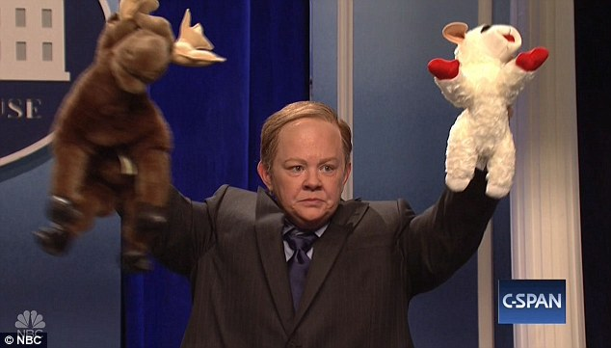

**ImpROOvement: Copyright/Patent Design**

The Final Product: A Posterboard Size, detailed diagram of how your proposed solution would operate.

Requirements:

* The diagram must include labels of all relevant people and objects
* Must include a Key (like a key on a map) that allows the reader to easily identify what things are
* Must emphasize why the “Product” is “Good for the Community”
* At least 4 (no less) chanichim must create the Copyright/Patent Design. These chanichim must be distinct from those in the advertisement and who worked on the pitch