Peulat Shabbat for 7-9-16: Theme – Letting Go
Materials:
Buckets
Filled Water Bottles from campers
Benches
Limbo material
Cones

Location: Tennis Courts

Time: 5:00pm to 6:00pm

Description: Introduce the parsha. Then, have a relay race where the chanichim carry a bucket while completing the course and add water bottles to the bucket every time they complete the course. Then discuss the weight of negative emotions and jealousy. Course: benches, then cones to run between, then lunges then limbo.

Activity: Relay Race
- Have a group of chanichim standing in a line at the each end of the course.
- First have every chanich do the course with just the empty bucket to show them how easy it is.
- Then, restart with the first chanich running with an empty bucket again.
- Ask the first chanich to add a water bottle to the bucket and then give it to a chanich from the other group. The chanich who just ran should go to the end of the line and the chanich who just got the bucket run the course.
- Add a weight every time a chanich completes the course.

Discussion:
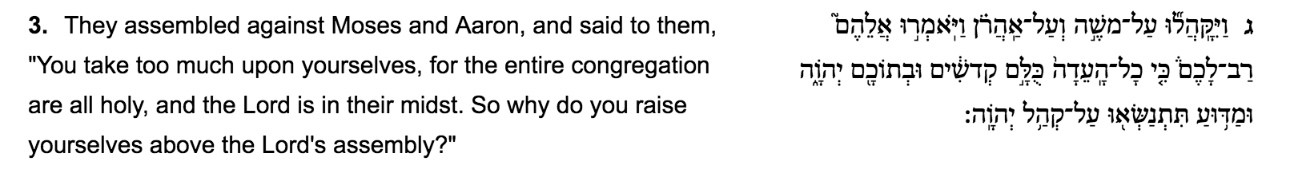
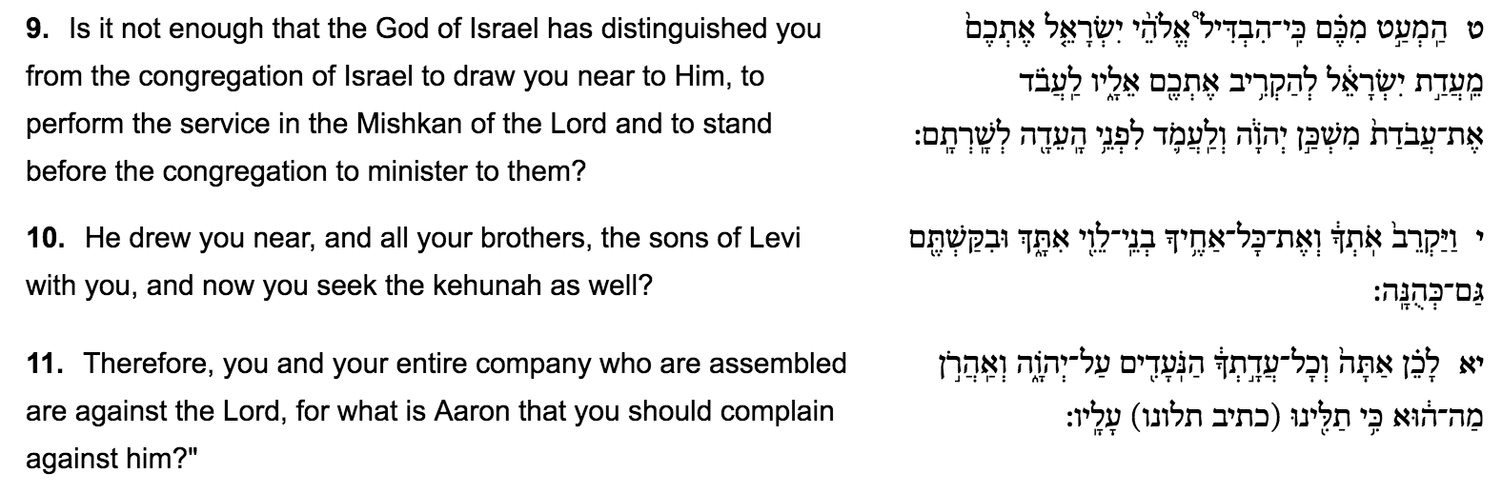
- What do you think was the purpose of this activity? Why?
- Why did we ask everyone to do the course with an empty bucket? What became more difficult as we added water bottles?
- Based on what you know about Korach, what did the weight of the water bottles represent? Why?
- What was Korach weighed down by in the parsha? How did it impact his goals?
- You were not allowed to put the bucket down during the course. What else can you not “put down” during the day?
- How did the weight of Korach’s jealousy harm him and his kehilla?
- How can the weight of jealousy or anger prevent you from completing tasks?
- How does jealousy impact your friendships at camp?
- What can you and Korach do to release that weight?

