MAGSHICHON PEULAT EREV TASKS (This is the Magshicon PE. It was fantastic for both Edot)

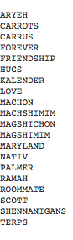
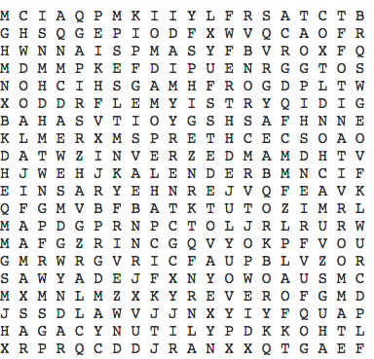
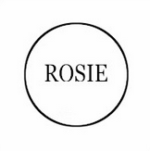
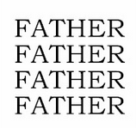

CHOOSE THE BEST “BEST FRIEND PIC” AND ON THE BACK OF THIS PAPER WRITE WHY IT IS THE BEST; ALSO COME UP WITH A BACKSTORY FOR THE PICTURE
Make your best thunder impression complete with dance and present it to a judge.

Draw a magshichon plant, name it, and create 3 fun facts about it.

New Hampshire trivia:
What states border New Hampshire?
What is the capital of New Hampshire?
What place in New Hampshire has the world record for the highest winds?
What is the motto of New Hampshire?
The first alarm clock was invented in New Hampshire in 1787 and it only rang at one time. At what time did it ring?

University of Maryland fight song (THIS IS TOTALLY NOT REAL):
Fill in the blanks of the University of Maryland fight song
Fight, fight, fight for Maryland,
Honor now her ___________ again,
Push up the____________, keep on fighting for more,
For Maryland, GO___________!
And we will fight, fight, fight for terrapins,
Keep on __________ 'till we win.
So sing out our song as we go marching___________,
To__________!!!

Write an edah song for Magshichon

Magshichon is a new Hebrew word. What does it mean?

Get into a Kalender family portrait.

Design a kippah for Aryeh and Scott to both wear. Make sure the kippah design resembles how Ramah has fortified the relationship between Scott and Aryeh.

The Aryeh Kalender Calendar - In each box of the Kalender, write one of the following things:
- One reason that you love Aryeh
- One thing about your pair that you both have in common with Aryeh
- One reason that you think Aryeh’s kippa is so floppy

TAKE A SELFIE WITH YOUR WHOLE GROUP

WRITE A HAIKU ABOUT SCOTT’S ELBOWS

WRITE 10 WORDS ABOUT HOW YOU FEEL ABOUT ARYEH’S NEW HAIR CUT

Pick your favorite line of Ashrei and explain why it is your favorite

One reason why Aryeh and Scott are both good Jewish role models

Come up with a new coin. Design both sides.

WRITE ALL 50 STATE CAPITALS

Alabama
Alaska
Arizona
Arkansas
California
Colorado
Connecticut
Delaware
Florida
Georgia
Hawaii
Idaho
Illinois
Indiana
Iowa
Kansas
Kentucky
Louisiana
Maine
Maryland
Massachusetts
Michigan
Minnesota
Mississippi
Missouri
Montana
Nebraska
Nevada
New Hampshire
New Jersey
New Mexico
New York
North Carolina
North Dakota
Ohio
Oklahoma
Oregon
Pennsylvania
Rhode Island
South Carolina
South Dakota
Tennessee
Texas
Utah
Vermont
Virginia
Washington
West Virginia
Wisconsin
Wyoming

