Peulat 7/30, Music Auction

Goal: Facilitate Tzrif bonding and have fun!

Description: Each Tzrif is a team. We play songs for them and they have to figure out the hidden meaning of the song to figure out what that song’s prize is. For example, the song “I want candy” would be the prize of a bag of hershey kisses.

Songs

|  |  |  |
| --- | --- | --- |
| song | prize | Where to get it |
| Just dance | Emma Neusner/Noam leads a dance lesson | DONE |
| Firework | Plastic bag | **bunk** |
| I want candy | Hershey kisses | DONE |
| Fire burning | Bunk medurah | DONE |
| Rock and roll all nite | Rock and toilet paper | **bunk** |
| Bubbly | Seltzer | DONE |
| Party in the USA | USA flag | **danny** |
| Paper planes | Make paper airplanes | DONE |
| Dum Dee Dum | Dum dum lollipops | DONE |
| Hollaback girl  <https://www.youtube.com/watch?v=iOghSaZ-FQA> | Challah | DONE |
| You’ve got a friend in me from toy story | play-doh | DONE |
| Somewhere over the Rainbow | Cloud watching with Sarah Berman & Zev | DONE |
| Shake it off | Ice cream in a bag | DONE certificate |

**7/30-**Music Auction

By Zev, Maya, Danny, and Shawn

**Premise:** Songs willed be played that allude to a specific prize that the Chanichim can bid on as a Tzrif.

**Duration**:

Explanation: 5 minutes

Implementation: 45 minutes ish

* Playing songs: 1 minute each
* Tzrif discussion and planning for bidding: 1-2 minutes each
* Bidding: 1 minute each

**Goals:**

1. Facilitate Tzrif bonding
2. Chanichim have the chance to win interesting prizes

**Supplies:**

All of the things bolded in the prizes.

**Any extra material or details needed for the peula:**

1. Division to groups.
2. Texts to read out loud.
3. Handouts.

Congratulations!

Please join us to make ice cream



with your tzrif

Next Peulat Tzrif

39 Bennett Street, Palmer MA 01069

Congratulations!

This shabbat you will enjoy a

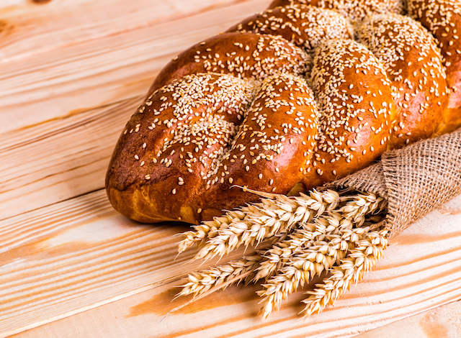

challah

with your tzrif

39 Bennett Street, Palmer MA 01069

Congratulations!

Please join us for a tzrif medurah



Next Peulat Tzrif

39 Bennett Street, Palmer MA 01069

Congratulations!

You will enjoy a dance lesson with



Noam as a tzrif

39 Bennett Street, Palmer MA 01069