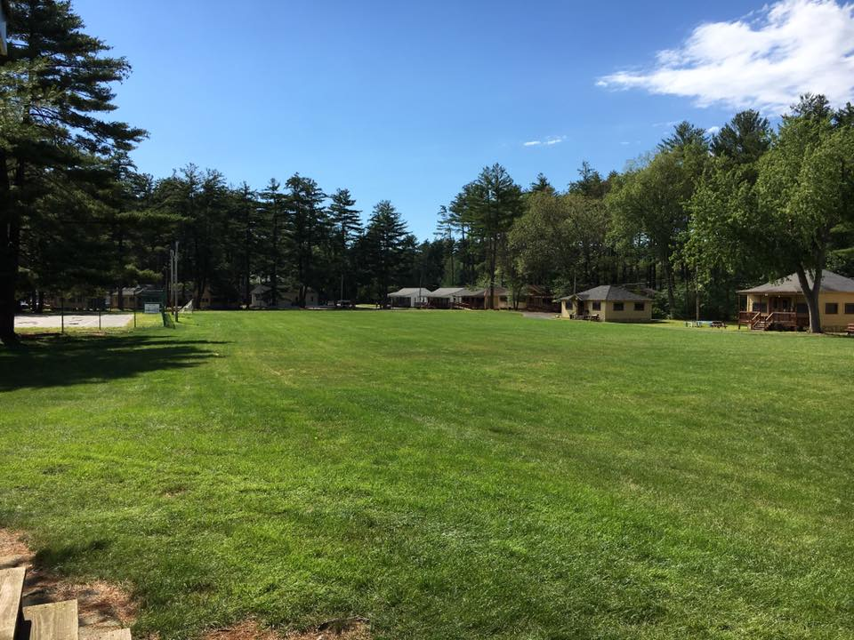

Rainbow Ramah Tag
Magshimim 2017
June 28, 2017

Materials needed:
- One color marker per madrich
- Some sponges
- Resources
- Madrichim wearing colored shirts
  - Madrichim in 50 – red/adom
  - Madrichim in 51 – orange/katom
  - Madrichim in 52 – yellow/tzahov
  - Madrichot in 48 – green/yarok
  - Madrichot in 46 – blue/kachol
  - Madrichot in 44 – purple/segol

Set up:
- Chanichim gather in front of little house
- Madrichim sit bein haHanichim
- Maddie gives the directions, gives madrichim 30 seconds to spread out, then everyone goes!

How to play:
- The goal is to get all of the colors on your hand. Madrichim will be around the migrash dressed in the colors that they represent. These colors represent different parts of camp, so the goal is to get the full Ramah experience.
  - Red - Roo
  - Orange – shabbat
  - Yellow - Makolet
  - Green - tzrif
  - Blue - tefillot
  - Purple - chadar
- To get the full experience, you need to put in the work! That means that the madrich won’t give you a color unless you show them you’ve tried by collecting the resources you need. There are 2 different resources needed for each color. F
- Example: a kador and a migrash for Roo, both on red (well, pink) pieces of paper.
- Collect both, go to the madrich, and get your color.
But!!!! There are some forces working against you. If any of the other madrichim tag you, they will wipe all of the colors off, and you have to start again!

Questions?

