Shabbat Shalom! It's that time of the month again! We are in Mishnaic times and it is the responsibility of community members to identify when the new moon comes and tell the rabbis when see find it. During these times, 2 witnesses would have to come before something called a Beit Din, a court of 3 Rabbis. These two witnesses must fit certain criteria, so they are trustworthy. Each person also received a card describing their job or role in this society, these qualifications will determine whether or not you are trustworthy. Good Luck finding new moons!

Here is how the peula works: Your tzrif will receive six pictures. Your tzrif must find the "New Moons" hidden in each picture. Think of this as a "Where's Waldo" game. Once you find the new moon in each picture, you must also use the clues in the picture to determine which Hebrew month that picture represents. (Hint: all of the pictures have something to do with a holiday that takes place during that month.) Once you know where the moon is and which month the picture represents, pick two members of your group and send them to the Beit Din (under the Omanut Ohel) to "testify" that they spotted the New Moon. The witnesses must also give the correct month their picture represents. Be Careful! Your witnesses must be "legitimate," so if they have a job that you think makes them untrustworthy, don't let them appear before the Beit Din.
The tzrif that finds the most new moons or tzrifim that finish all six puzzles in the allotted time will receive Hershey's Kisses! Come before the Beit Din if you have any questions.
One more thing…Rabbi Akiva, someone who is known for sending witnesses back, may appear at some point. If the line for the Beit Din is getting too long or he sees more than two witnesses coming to testify together, he may send you back to your group and make you try again.
This is what you are trying to find in each picture:

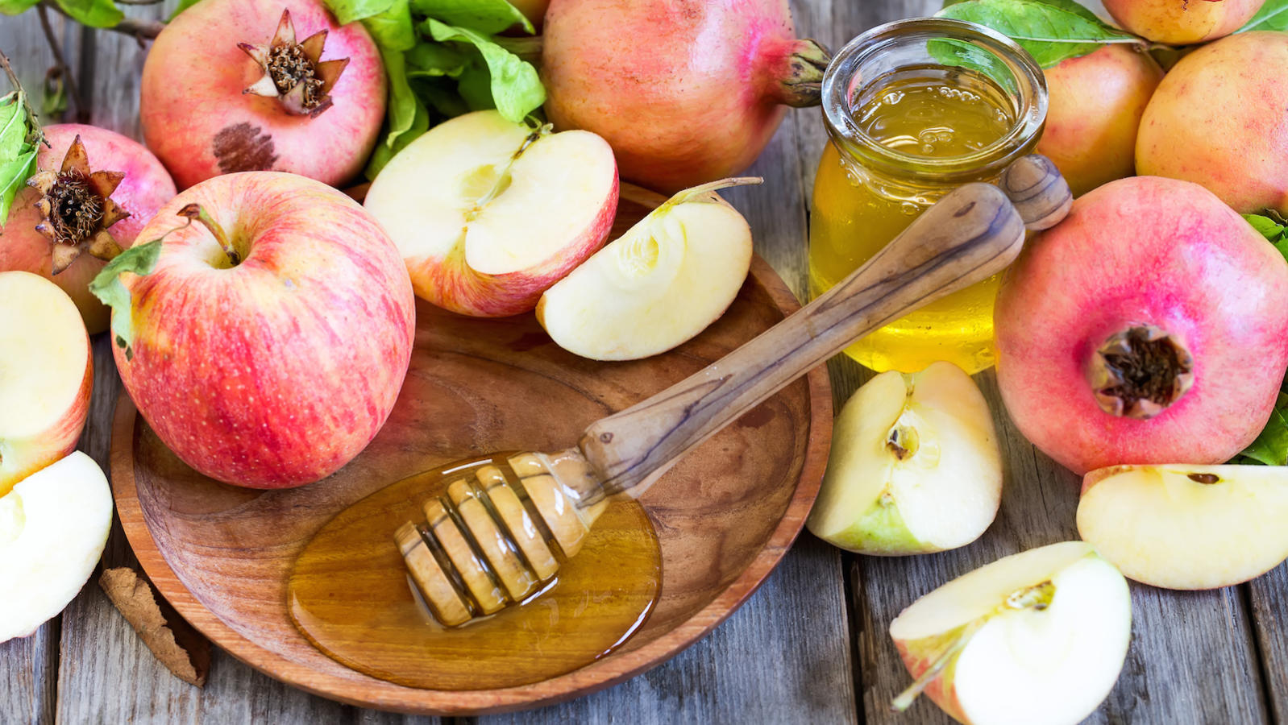

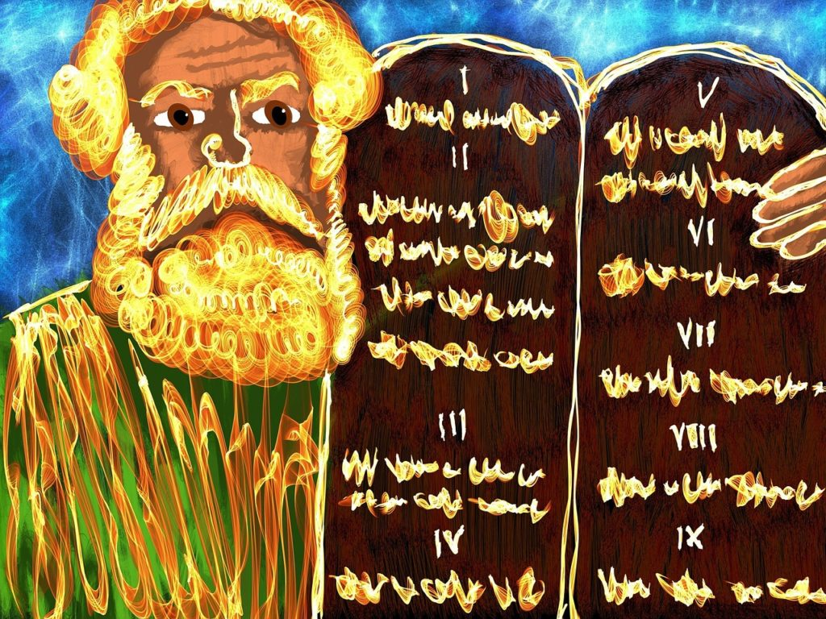

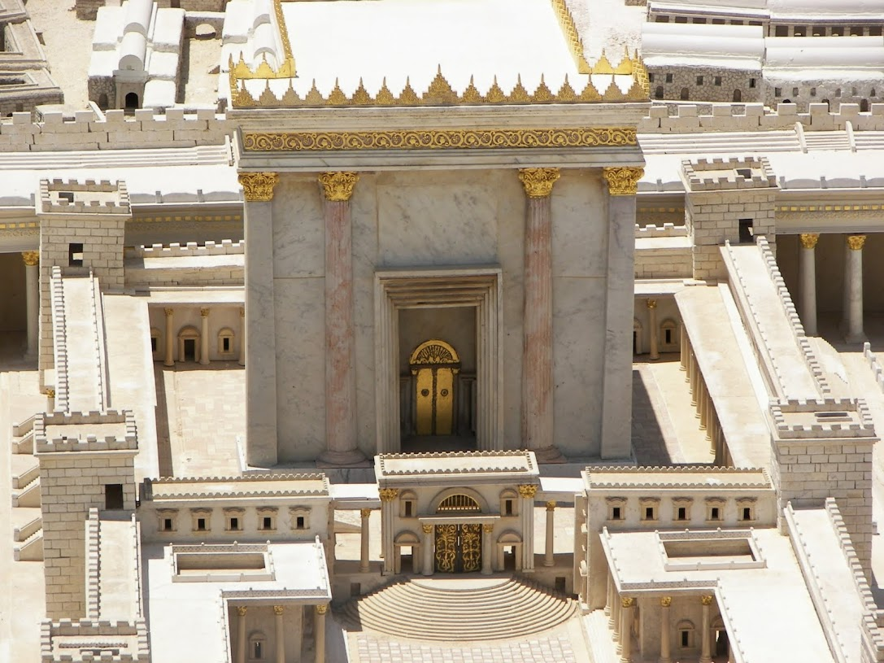
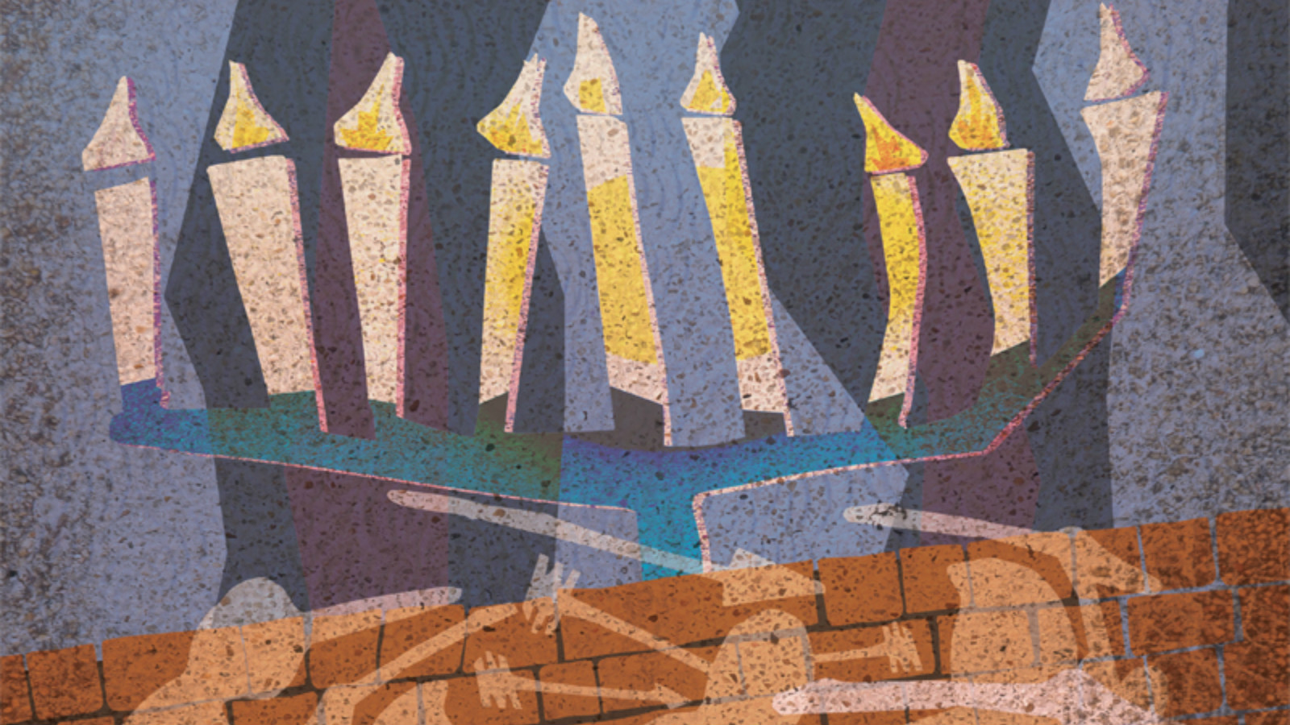

Gamblers
Pigeon Racers
Sellers of Sabbatical year Produce (#MYCABBAGES)
Bankers who lend with interest
Father
Son
Shop-owner
Rabbi
Farmer
Milkman
Chef
Madrich
Rosh Edah
Cantor
Beit Midrash Attendant
Chug Gimmel Madrich

