SLAM DUNK SCHEDULE PRESENTATION
6/23/2015

Program Type: Peulat erev
Duration of Program: 45 Min
Suggested Edah: Amitzim
Program Summary:
Campers will become Familiar with the schedule by making slam dunks into a small hoop based on the part of the day.
Overall Goal/Themes:
Becoming familiar with the schedule.
Supplies/Resources Needed: -
-Small basketball hoop
-balls with pictures taped to each ball (one for each camper)
Ideal Location and Room Setup:
Indoors: Beit Am Gadol, BBall hoop in middle
Staff Preparation and Roles:
- All staff will gather the campers in a circle and give each one a ball
- We will go through the schedule and at each part, the camper who has the corresponding perek’s ball (with the right picture on it) will get up, high five the other person with the matching picture and make a slam dunk!
Appendices/Additional Files:
Pictures for the balls
Authors:
Max Beede, Ophir Peleg, Avi Young
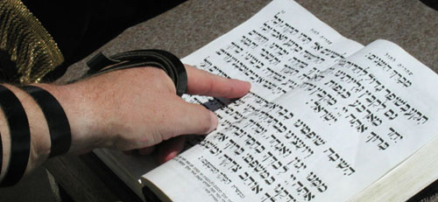
Chug aleph

sport
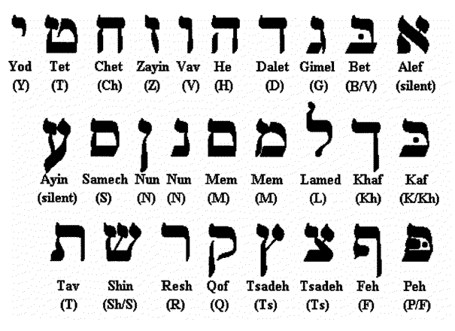
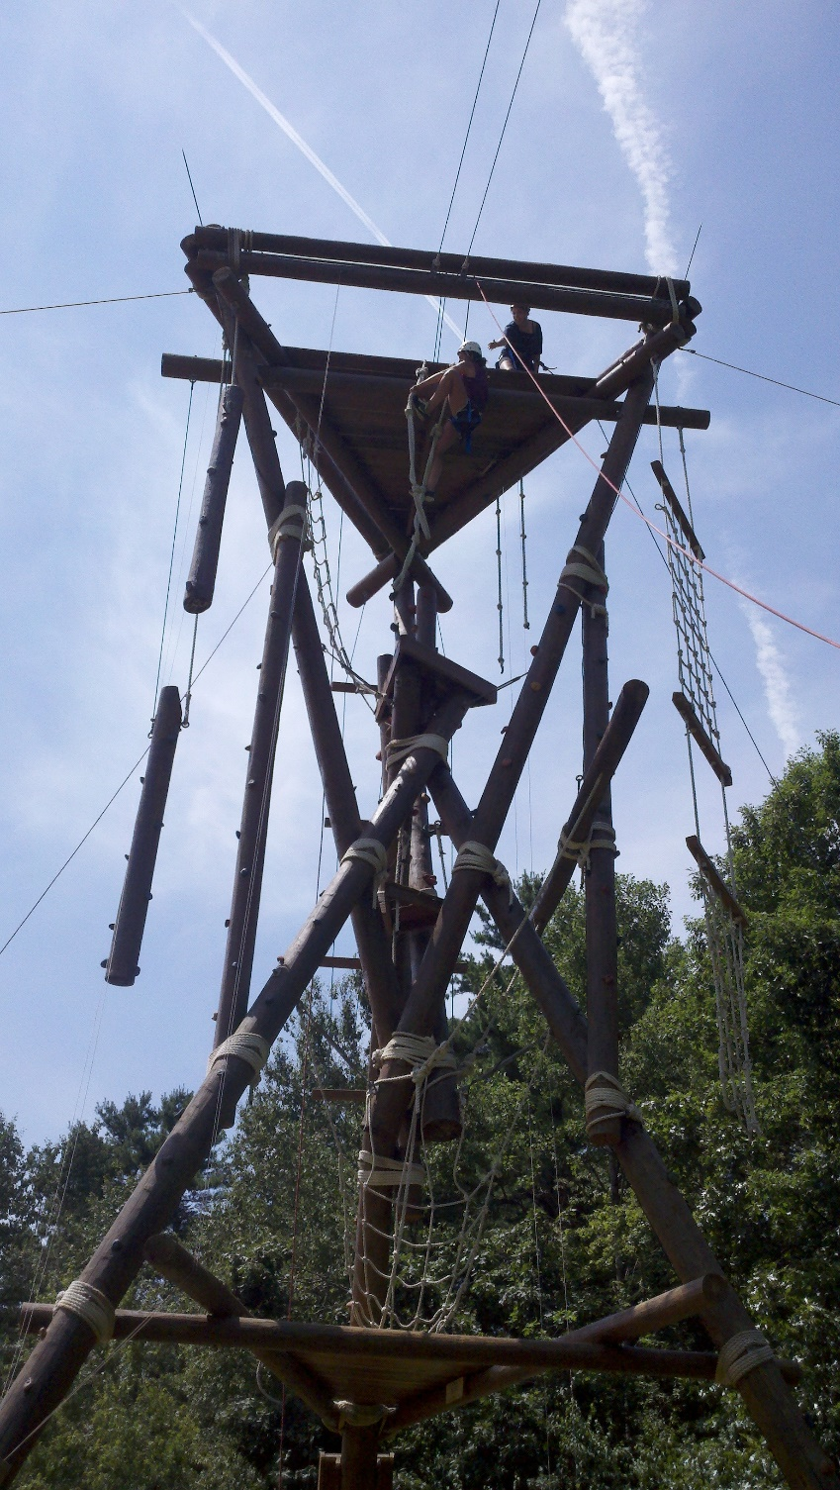chug gimme

