Peulat “Types of Pasta”

Goal: arts and crafts with pasta

Materials:
Types of raw pasta (2 boxes of each)
- Penne
- Bowties
- Rotini
- Wagon wheels
- Elbows
- Orzo

Wooden/foam picture frames
Glue
String/yarn
Scissors
Pipe cleaners
Construction paper
Food coloring
Paper plates
Popsicle sticks
Newspaper

Location: Old chadar ochel

Duration: 45 minutes (including set up/clean up)

Overview: Different madrichot run different arts and crafts stations with various types of pasta. Chanichim can choose which craft they want to do.

Role of madrichim:
Ben, Rachel - jewelry making
- Types of pasta - penne, elbows, wagon wheels
- Materials - string/yarn, pipe cleaners, scissors
Ruthie, John - picture frames
- Types of pasta - all except orzo
- Materials - picture frames, glue
Eve, Saul - noise makers
- Types of pasta - orzo, elbows, wagon wheels
- Materials - paper plates, glue, popsicle sticks
Jillian, Eli - mosaic
- Types of pasta - all except orzo
- Materials - construction paper, glue, food coloring

Jewelry
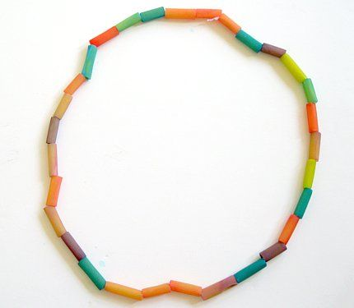

Picture frames
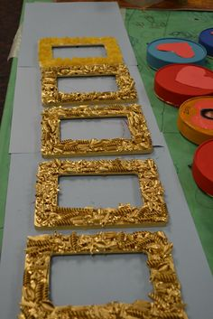

Noise makers
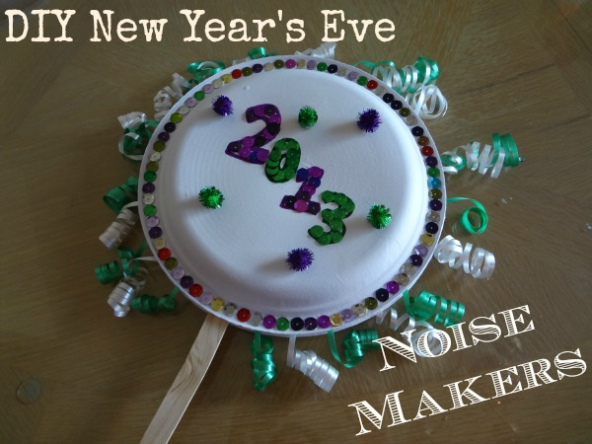

Mosaic
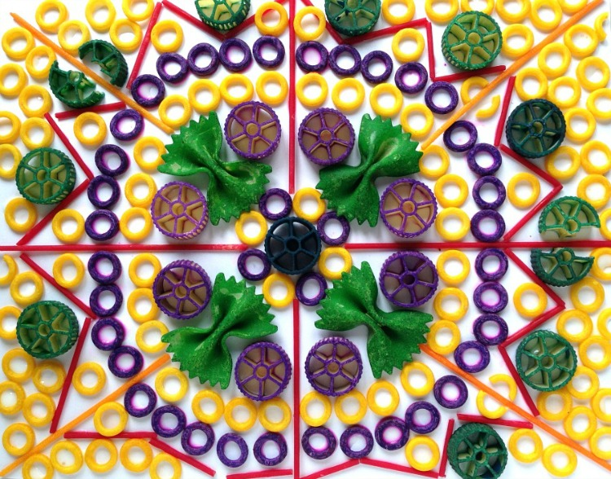

“Types of Pasta” Challenge competition (if we have extra time after the pasta crafts)

- Noodling Around

A bunch of pieces of penne pasta are set up along the edges of a table, with the open ends facing outward. Each contestant gets a piece of spaghetti. When the time starts, the contestants must hold the spaghetti in their mouths, with their hands behind their backs. The goal is to skewer as many pieces of penne as they can with their piece of spaghetti in the minute they are given. If their piece of spaghetti breaks, they are disqualified. The contestant with the most pieces of penne on their unbroken piece of spaghetti at the end of the minute, wins.

Materials - table, penne, spaghetti

2. Noodle blow

Each contestant must blow a piece of Rotini from the start line to the finish line using only their breath. The team who blows their piece of pasta to the finish line first, wins.

Materials - Rotini

