Where the Warm Wind Blows
Yom Ruach, Wednesday July 18th

Yesterday, the wind blew, and man was it warm. It blew all over the machene – from the alpine tower to the beit am aleph, from the new chadar to the old chadar, from moadoan kochavim to moadoan nivonim. The warm wind blew over all of the chanichim, and all of the madrichim, except for two…
These two had no idea that the warm wind didn’t pass over them. They were just minding their own business when the warm wind blew. But for whatever reason, the warm wind did not blow by them.
The warm wind, you see, carries you to olam haba, the world to come, one day. It passed over machene Ramah because we Ramahniks effuse love of Judaism and kindness towards our kehillah. The warm wind accidentally missed two members of the Machon kehila, and it is up to us to figure out who we need to bring the warm wind to.

You will each be given an envelope filled with evidence of the Warm Wind’s pattern. Your task is to ascertain who the Warm Wind passed over. Remember, the madrichot deserve to go to olam haba, as well.

This will be much easier if you are able to obtain an edah list. To get an edah list, every person in the kvutzah must read the Shabbat ending of birkat HaMazon to Maddie. To do so, you must first go through and find alibis for at least 2 clues.

Read out the groups

Friends: be #bein. Some of these clues are easy, and some of them are not. If you know how to do one of them, keep it to yourself!

There are 13 to be found
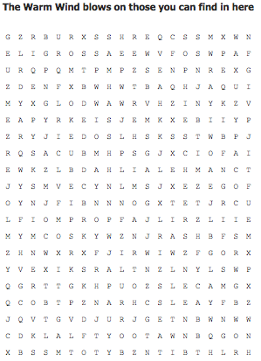
During the Warm Wind’s passing, there were a few people who went for a run. They stopped by the Sif water fountain to get water. Go check who left their water bottles by the Sif water fountain to ascertain who the Warm Wind blew over.

The Warm Wind blew on those who were on, or who were siblings with, members of tzevet Magshimim 2017.

The Warm Wind blew through Miles of Forest and Snow and Waves and Park and the morning dew.

Sandra is the best, so the Warm Wind obviously blew on her!

Some chanichim were writing letters when the Warm Wind passed over them. Check out the letters in the outoging mail box by the programming office to see who the Warm Wind passed over.

Decode.

Key = 6

znk cgxs cotj hrkc ut pgjkt, yuvnog, gtj ynkrhe

The Warm Wind blew through the machene in “SONG”

Some Machoners were practicing their Torah Readings when the Warm Wind blew on them. Check behind the Aaron HaKodesh in the Beit Knesset to see the list of Torah readers this week

The Warm Wind blew on:
- mavin polio
- feb gap thetas
- blazer mobster renegade
- agar tiler yak
- cam karts whiz

The following people were in Limud when the Warm Wind blew over the chorsha:
- The one who anointed David HaMelech Yisroel, as well as the Melech himself
- The first man
- The one(s) who took over after Moshe
- The Truth
- The first Jew
- The one(s) who were swallowed by the whale
- The GOOD one
- The one who was the father of the 12 tribes (last name)
- The first high priest(s)
- Moshe’s Sister
- The Holy Land and the river that flanks its east side

Because of their namesake, the Warm Wind blew on those who share the name of our matriarchs: Sarah, Rebecca, Rachel, Leah.

The Warm Wind blew over a ‘true gem’ and a PERIwinkle flower

The Warm Wind blew over the chanichim in Omanut. Check out Maddie's clipboard to see the chanichim who are signed up for omanut.

The Warm Wind blew the PETshafts: Fish, Katz, and Fry-dogs that Wagner their tails and Barkal

During the time of the Warm Wind, some chanichim were spotted star gazing. Draw in the constellations to see who it was. (attached)

There are no color copiers in camp. Check the black and white copier for a clue you need to decode.

