Peulat Erev, Solelim 2017
iRamah (AKA the Winning Showcase Peulat Erev!)

Goals:
- #HaveKef
- Entertain the tzad
- Teach edah about internet safety

Jewish Values:
- Kehillah
- Lashon Hara

Materials:
- 7 Cardboard iPhones
- Construction Paper Apps
  - 7 Each
- White Paper (Agamstagram)
- Markers
- Paper
- Blank Maps
- Mad Minutes
- Answer Keys

Apps:
- Facebook
  - Create profiles for biblical/ramah characters
    - Moshe
    - David Offit
- Instagram
  - #agamstagram
- Twitter
  - Given hashtags
    - #Kayitz2017
    - #ThingsChanichimSay
    - #ChadarChadash
    - #MeahMilim
  - Make up tweets from said hashtags
- Spotify
  - Guess the song
    - Jungle
    - Eshet Chayil
    - Sieben Seiben
    - Shir Ramah
- Google
  - Trivia
    - What Niv was David Offit?
      - 2007
    - Who was Rosh Tzad Aleph in 2004?
      - JEdelglass
    - When did they restart Yom Ketzef (Foam)
      - 2008
    - When was the Beit Am Gadol Built?
      - 2012
    - How many years has Olga worked at camp?
      - 30 Years
    - How many ice cream flavors are at Rondeau’s?
      - 54
    - What is the Town of Palmer’s slogan?
      - Gateway to Western Mass
      - The Town of Seven Railroads
- Palmer Weather
  - Create Weather Forecast
    - Snow? HA. You Never Know!!
- Angry Birds
  - Cardboard Boxes
  - Dodge Balls
- News
  - Make Tomorrow’s Roosletter
- Maps
  - Blank Maps of Israel and USA to fill out
- Calculator
  - Mad Minutes
- Pinterest
  - Found Objects Yad
- Word Search

TZEVET COPY OF ALL CHALLENGES
(HAHA -- No Answers Here -- Slicha!)
- Facebook
  - Create a Facebook profile page for: David Offit and Moshe
    - Things to Include: Name, Birthday, Job Title, Profile Picture, Likes, Facebook Status Updates, etc.
- Instagram
  - Draw an agamstagram -- it might even be posted! #agamstagram
- Twitter
  - Make up 4 different tweets using 140 characters (letters/numbers/spaces) or less based on the given hashtags -- we will be counting, so don’t cheat!
    - #Kaytiz2017
    - #ThingsChanichimSay
    - #ChadarChadash
    - #MeahMilim
- Spotify
  - Ask your madrich/a to play the songs and guess them as fast as you can! Write your answers below:
- ____________________________________________
- ____________________________________________
- ____________________________________________
- ____________________________________________
- Google
  - Ramah Trivia -- Write your answers next to the nikudah!
    - What Niv was David Offit?
      - ____________________________________________
    - Who was Rosh Tzad Aleph in 2004?
      - ____________________________________________
    - When did they restart Yom Ketzef (Foam)
      - ____________________________________________
    - When was the Beit Am Gadol Built?
      - ____________________________________________
    - How many years has Olga worked at camp?
      - ____________________________________________
    - How many ice cream flavors are at Rondeau’s?
      - ____________________________________________
    - What is the Town of Palmer’s slogan? (There are two)
      - ____________________________________________
      - ____________________________________________
- Weather
  - Create a 5-day forecast for weather in Palmer, Massachusetts!
    - Creativity is encouraged!
- News
  - On a separate sheet of paper, write tomorrow’s Solelim Roosletter.
    - Feel free to include hoda’ot and me’ah milim!! :)
- Maps
  - Fill in the blank maps of Israel and the United States
    - For the blank map of Israel, fill in the cities and noteworthy sites
    - For the blank maps of the US, fill in the states and their capitals
- Calculator
  - Fill out the Mad Minute worksheet
- Pinterest
  - Send one member of your kvutza outside to find a couple random objects. Once they return, create a DIY Yad for Solelim Torah readings!
    - If any kvutza’s entry is exceptional and useable, we might actually adopt it as the Solelim Yad!
- Word Search
  - Complete the iRamah Word Search

- Ramah Trivia -- Write your answers next to the nikudah!
  - What Niv was David Offit?
    - ____________________________________________
  - Who was Rosh Tzad Aleph in 2004?
    - ____________________________________________
  - When did they restart Yom Ketzef (Foam)
    - ____________________________________________
  - When was the Beit Am Gadol Built?
    - ____________________________________________
  - How many years has Olga worked at camp?
    - ____________________________________________
  - How many ice cream flavors are at Rondeau’s?
    - ____________________________________________
  - What is the Town of Palmer’s slogan? (There are two)
    - ____________________________________________
    - ____________________________________________

Send one representative to Hannah to guess Ramah songs as fast as you can! Write your answers below:

- ____________________________________________

- ____________________________________________

- ____________________________________________

- ____________________________________________

- News
  - On a separate sheet of paper, write tomorrow’s Solelim Roosletter.
    - Feel free to include hoda’ot and me’ah milim!! :)
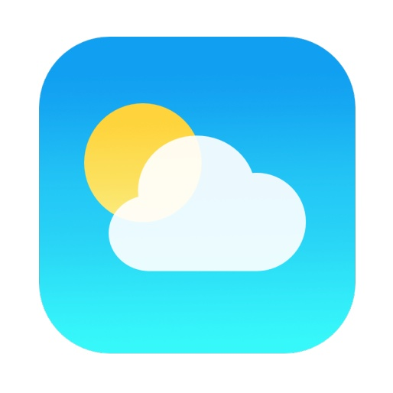

- Weather
  - Create a 5-day forecast for weather in Palmer, Massachusetts!
    - Creativity is encouraged!

  - Send one member of your kvutza outside to find a couple random objects. Once they return, create a DIY Yad for Solelim Torah readings!
- Facebook
  - Create a Facebook profile page for: David Offit and Moshe
    - Things to Include: Name, Birthday, Job Title, Profile Picture, Likes, Facebook Status Updates, etc.

- Instagram
  - Draw an agamstagram -- it might even be posted! #agamstagram
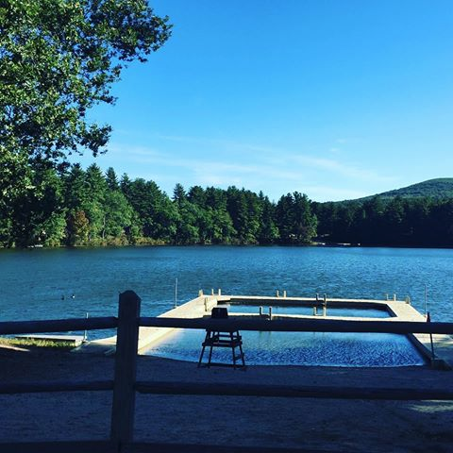

- Twitter
  - On a separate piece of paper, write 4 different tweets using 140 characters (letters/numbers/spaces) or less based on the given hashtags -- we will be counting, so don’t cheat!
    - #Kaytiz2017
    - #ThingsChanichimSay
    - #ChadarChadash
    - #MeahMilim

iRamah ANSWER Coding

SPOTIFY AND GOOGLE ANSWER KEY
(Hannah and Smond’s Eyes ONLY!)

- Spotify
  - Guess the song
- Jungle
- Eshet Chayil
- Sieben Sieben
- Shir Ramah
- Google
  - Trivia
    - What Niv was David Offit?
      - 2007
    - Who was Rosh Tzad Aleph in 2004?
      - JEdelglass
    - When did they restart Yom Ketzef (Foam)
      - 2008
    - When was the Beit Am Gadol Built?
      - 2012
    - How many years has Olga worked at camp?
      - 30 Years
    - How many ice cream flavors are at Rondeau’s?
      - 54
    - What is the Town of Palmer’s slogan?
      - Gateway to Western Mass
      - The Town of Seven Railroads

iRamah

Peulat Erev
Sunday, July 30th

Solelim 2017
Kvutzot and Tzevet Assignments

Kvutza 1: (Aviya)  Daria  Ben  Syd  Levi  Ethan C.  Avi  Kvutza 2: (Sahar)  Katie  Alitza  Elle  Daniel Simon  Isabella  Daniel M.  Sam  Kvutza 3: (Sophie)  Rebecca  Couch  Gavi  Joe  Gerson  Noa  Kvutza 4: (Alex)  Sophie C.  Miriam  Ari  Ellie P.  Lexi  Eden | Kvutza 5: (Ido and Raz)  Mira  Abby  Adin  Ben  Yael  Joel  Kvutza 6: (Thomas)  Gabi  Dafna  Aryeh (Ari)  Ezra  Zavier  Shayna  Kvutza 7: (Ori)  Panda  Shoshana  Oren  Josh B.  Jayden  Olivia
Kvutza 1: (Aviya)
Daria
Ben
Syd
Levi
Ethan C.
Avi

Kvutza 2: (Sahar)
Katie
Alitza
Elle
Daniel Simon
Isabella
Daniel M.
Sam
Kvutza 3: (Sophie)
Rebecca
Couch
Gavi
Joe
Gerson
Noa

Kvutza 4: (Alex)
Sophie C.
Miriam
Ari
Ellie P.
Lexi
Eden
Kvutza 5: (Ido and Raz)
Mira
Abby
Adin
Ben
Yael
Joel

Kvutza 6: (Thomas)
Gabi
Dafna
Aryeh (Ari)
Ezra
Zavier
Shayna
Kvutza 7: (Ori)

Panda
Shoshana
Oren
Josh B.
Jayden
Olivia

