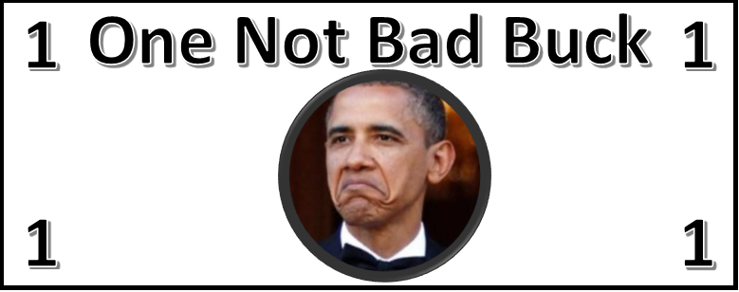





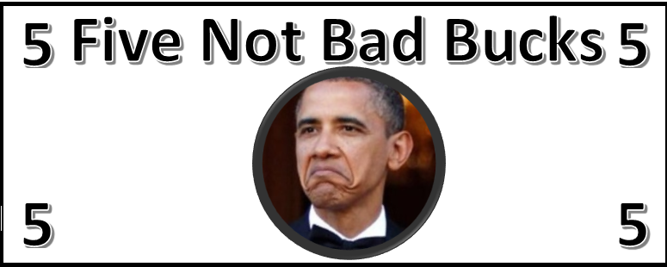

**Particularly Not Bad**

**Particularly Not Bad**



**Particularly Not Bad**

**Particularly Not Bad**



**Particularly Not Bad**

**Particularly Not Bad**

