2018 Machon Tiyul

Thursday August 2
- Camp → Boston Synagogue
  - Boston Synagogue address: 55 Martha Rd, Boston
  - Depart 8:45, arrive 10:30
  - Bus
  - 78 miles; 1:21
- Boston Synagogue → Faneuil Hall
  - Faneuil Hall address: 4 S Market St, Boston
  - Depart 11:00, arrive 11:30
  - Walk 0.8 miles
  - Directions
    - Head east on Martha Rd toward Nashua St (407 ft)
    - Continue onto Lomasney Way (.1 mi)
    - Turn left onto Merrimac St (.3 mi)
    - continue onto Congress St. (.2 mi)
    - Turn left onto North St (500 ft)
LUNCH 1:00-1:30 in Faneuil Hall

- Faneuil Hall → Holocaust Memorial
  - Holocaust memorial address: Carmen Park, on Congress Street
  - Depart 1:30, arrive 1:40
  - Directions
    - head west on clinton st
    - turn left on North St (230 ft)
    - right on Union St.
- Holocaust Memorial → Aquarium
  - New England Aquarium address:
  - Depart 2:00, arrive 2:10
  - 0.5 miles, 10 minutes
  - Directions
    - walk eastward through Faneuil Hall to the end
    - continue on S market St (0.2 mi)
    - continue onto Christopher Columbus Park Path (161 ft)
    - turn right onto Atlantic Ave (230 ft)
- Aquarium → ICA
  - ICA address: 25 Harbor Shore Drive, Boston
  - Depart 4:30, arrive 4:50
  - 0.9 miles, 19 minutes
  - Directions
    - head south on Atlantic Ave toward State St (0.4 mi)
    - turn left onto Oliver St/Seaport Blvd (0.2 mi)
    - slight left to stay on Seaport Blvd (0.1 mi)
    - Turn left onto Fan Pier Boulevard (300 ft)
    - Turn left onto Marina Park Drive (320 ft)
    - Turn right at Harborwalk (0.1 mi)
- ICA → Frog Pond / Boston Common
  - Frog pond address: 38 Beacon Street, Boston
  - Depart/arrive at 5:45/6:15 or 6:30/7:00
  - Walk 1.5 miles, 40 minutes
  - Directions
    - Head northwest toward Marina Park Drive (0.1 mi)
    - Turn left onto Marina Park Drive (320 ft)
    - Turn right onto Northern Ave (230 ft)
    - Turn left onto Fan Pier Boulevard (300 ft)
    - Turn right onto Seaport Blvd (0.3 mi)
    - Continue onto Oliver St (0.2 mi)
    - Turn left onto Water St (0.1 mi)
    - Turn left onto Washington St (108 ft)
    - Turn right onto School St (0.1 mi)
    - Turn left onto Tremont St (0.1 mi)
DINNER IN BOSTON COMMON 7:00-7:45
- Boston Common → Boston Synagogue
  - Boston Synagogue address: 55 Martha Rd, Boston
  - Depart at 9:30, arrive 9:50
  - 0.9 miles, 20 minutes
  - Directions
    - head northeast out of Boston Commons
    - head North on Joy St. (0.3 mi)
    - right onto cambridge St. (30 ft)
    - Left onto Staniford St. (0.2 mi)
    - When you reach Merrimac St., slight eft to continue on Lomasney Way (0.1 mi)
    - Continue on Martha Road (400 ft)

Friday, August 3
- Boston Synagogue → Warrior Ice Arena
  - Warrior Ice Arena address: 90 Guest St. Brighton
  - Depart 9:00, arrive 9:30
  - Bus
  - 7.2 miles, 15 minutes
- Warrior Ice Arena → Camp
  - Camp address: 39 Bennett Street, Palmer
  - Depart 11:30, arrive 12:50
  - Bus
  - 69 miles, 1h:20m

Holocaust Memorial Activity
Have your chanichim take 5-10 minutes to walk through the Holocaust memorial and then find a spot off to the side to have a brief 8-10 minute discussion about reactions about the memorial.

Some questions to consider:
- How did you feel as you walked through this memorial?
- What are your thoughts about having the numbers displayed in this memorial opposed to names?
- How is the holocaust represented in this memorial (6 pillars for the 6 million Jews)?
- Even though approximately 11 million people died in the Holocaust, here we only think of the 6 million Jews. Is that appropriate?
- Do we have a responsibility as Jews in relation to the Holocaust (remember, teach, etc.)? If so what is it?
- What do you think about the materials used in this memorial and what they represent (glass, concrete, etc.)?
- Have you been to other Holocaust memorials and museums? How does this one compare?

Warrior Ice Arena
90 Guest Street Brighton, MA 02135
Phone: 617-927-7467 ext 102
Fax:
Camp Ramah in New England Maddie Felfand 39 Bennett Street Palmer, MA 01069
Facility Confirmation Phone: (203) 505-1460 Maddie Felfand Email: madelinegelfand@gmail.com
Date Day Complex Facility Event Type Event Time Dur. Rate
Other
Chg Tax Amount 8/3/2018 Fri WIA Events Fieldtrip 9:30 AM - 11:30 AM 2/0 0.00 0.00 0.00 0.00
Schedule Notes: Dahlia, 77 kids 14 adults, skating and tour after skating. Planning to arrive at 9:30 am
2 (hrs) / 0 (min) Sub Total $0.00 Tax $0.00
Grand Total $0.00
Page 1 Printed on 7/27/2018 9:59:51 AM

ICA Meme Challenge

Find 10 pieces of art and take a picture of it (bonus points if you are in the picture).
With your kvutza write down the best meme/caption for that picture and write it below
Have your kvutza leader send all pictures to Maddie and hand in this sheet at the end of your time at the ICA. Enjoy!!

- Description of Artwork: ____________________________________________________
Meme/Caption for Artwork: ______________________________________________________

- Description of Artwork: ____________________________________________________
Meme/Caption for Artwork: ______________________________________________________

- Description of Artwork: ____________________________________________________
Meme/Caption for Artwork: ______________________________________________________

- Description of Artwork: ____________________________________________________
Meme/Caption for Artwork: ______________________________________________________

- Description of Artwork: ____________________________________________________
Meme/Caption for Artwork: ______________________________________________________

- Description of Artwork: ____________________________________________________
Meme/Caption for Artwork: ______________________________________________________

- Description of Artwork: ____________________________________________________
Meme/Caption for Artwork: ______________________________________________________

- Description of Artwork: ____________________________________________________
Meme/Caption for Artwork: ______________________________________________________

- Description of Artwork: ____________________________________________________
Meme/Caption for Artwork: ______________________________________________________

- Description of Artwork: ____________________________________________________
Meme/Caption for Artwork: ______________________________________________________

Quincy Market / Faneuil Hall *PHOTO/VIDEO* Scavenger Hunt
Boston Trip 2018

While you walk around Quincy Market / Faneuil Hall be sure to do this Scavenger Hunt! Take all the photos/videos on your madrich(a)’s phone and send them to Maddie! Boston is a great city, so lets learn more about it :)

- Take a photo of a group member drinking coffee (4 points)
- Take a video of a group member interviewing a street performer (8 points)
- Take a video of your group singing Eishet Chayil (10 points)
- Take a video of five group members doing the Lo Normali Rikud! (6 points)
- Take a video of Maddie singing her favorite song (8 points)
- Take a video of a group member asking a stranger for directions to Machane Ramah (8 points)
- Take a group photo on the stairs of Quincy Market (4 points)
- Take a video of group singing edah song as street performers (8 points)
- Take a video of a group member doing the chicken dance in front of a restaurant that sells chicken! (6 points)
- Take a video of a group member getting signatures for a petition of your choosing! (6 points)
  - BONUS: If you get 100 signatures on the petition you will get 100 points!!
- Take a photo of your group in a human pyramid (4 points)
- Take a photo of a group member eating ice cream (4 points)
- Take a photo of your group outside of Hard Rock Cafe (4 points)
- Take a photo of a group member shopping in Urban Outfitters (4 points)
- Take a photo of your group outside a starbucks (4 points)
  - BONUS: If you get a photo of your group outside of three starbucks, you get 20 additional points!
- Take a photo of a group member buying something from Newbury Comics! (6 points)
- Take a video of your group singing Rad Hayom (8 points)

Packing list

Day bags
- Wear sneakers/walking shoes. We’re walking a lot
- Water bottle
- Sunscreen
- Pack-out lunch
- Sweatshirt for nighttime

Overnight bag
- Sleeping bag
- Pajamas
- Toothbrush and toothpaste
- Deodorant
- Facewash and other like toiletries
- Tampons/pads if you need
- Clothes for Friday appropriate for ice skating
  - Long pants, long sleeve
- Pair of long socks

Boston Synagogue→ Faneuil Hall (16 min, .8 mi)
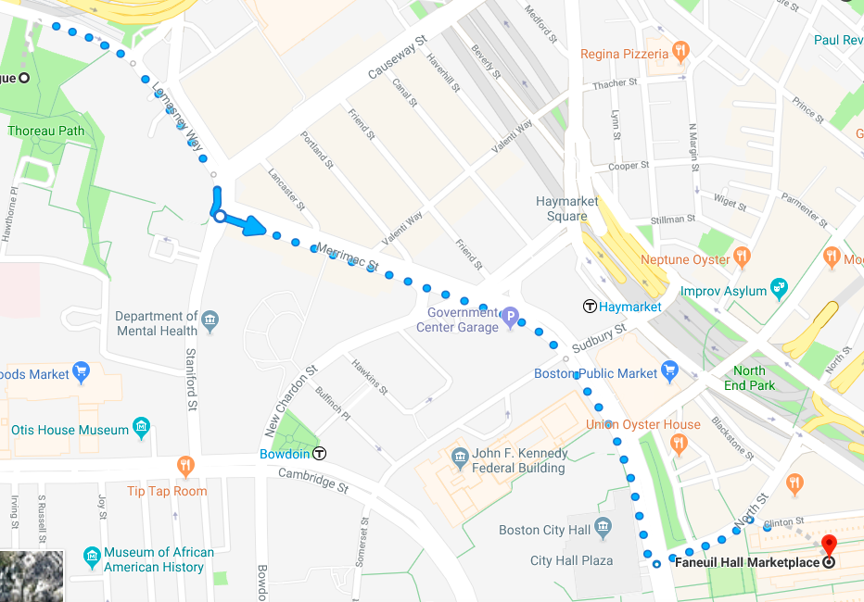

Aquarium → ICA (19 min, .9 mi)
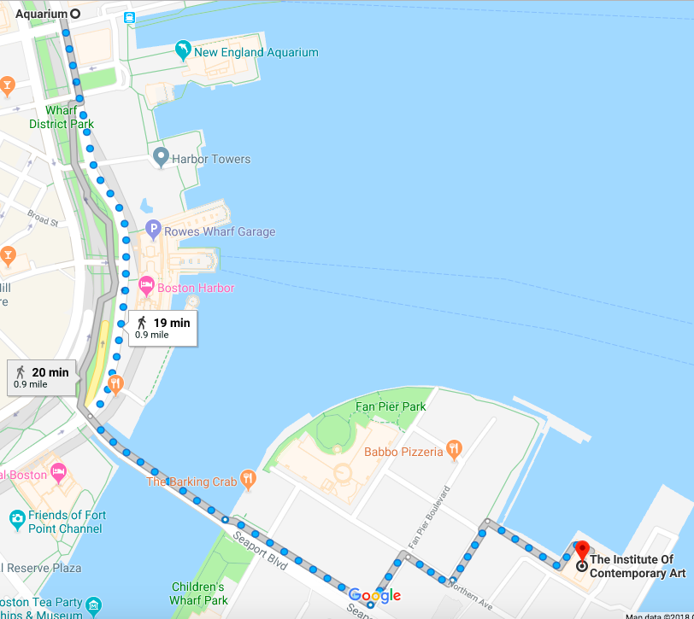

ICA→ Boston Common/Frog Pond (31 min, 1.5 mi)
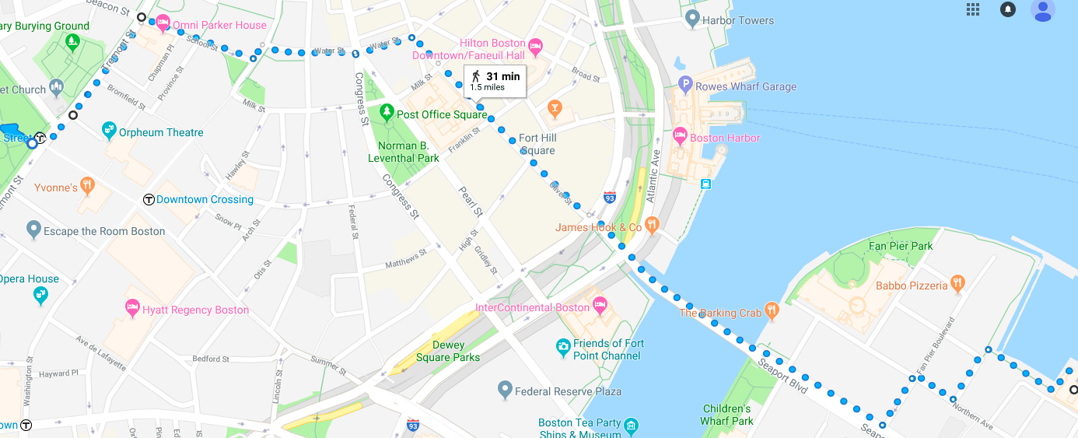

Boston Common → Boston Synagogue (20 min, 0.9 mi)

