Yom Around The World Extended Schedule

Time Peulah Location
8:00 Aruchat Boker Chadar Ochel
8:45 T’fillot Mirpeset
9:45 Nikayon Tzrifim
10:45 Australia Meet at Mirpeset
11:45 Antarctica Mirpeset/BAA
12:45 Aruchat Tzohorayim Tzevet to Mirpeset
1:30 Menucha Tzrifim
2:30 Japan Mirpeset
3:00 European Food Tour Mirpeset
3:45 Glidah Gladness O”CH
4:15 Change Tzrifim
4:40 Water Slides (Banim) Outside Misrad
Peulat Tzrif (Banot) Tzrifim
5:05 Water Slides (Banot) Outside Misrad
Peulat Tzrif (Banim) Tzrifim
5:30 Bechirot -- Change out of bathing suits, zman miklachat and soccer, beading, rikud
6:30 Aruchat Erev Chadar Ochel
7:15 Mini Olympics Migrash
8:30 Lilah Tov Tzrifim
Australia (10:45)

Location: Tzad alef upper migrash, tzad aleph lower migrash, and beit midrash complex

Overview: first part takes 20 minutes, second part takes 30 minutes, then all come back to the moadon and prove that you completed all the tasks

Instructions:
- Ben introduces Australia as an Australian explorer.
  - Tells everyone that they have each discovered their own countries
- Break everyone into their kvuztot
- Each kvuzta leader will lead a mini session where each kvuzta should come up with their own country using the sheet provided
  - Name
  - Location on a map
  - Climate, culture, etc.
  - Flag
  - Anthem
  - Signature Dance Move
    - Once all of that is finished the Australia specific program begins
    - The head madrich should explain to their kvuzta that that are having an Australian race all over camp! Each task must be videoed or photographed by the marich
      - Australia Tasks
        - 2 chanichim have to hop like a kangaroo from tzrif 1 to tzrif 8
        - A chanuch must have a conversation with Didi or Simon in an australian accent and ask them about tomorrows breakfast
        - Get a picture of the entire kvutza koala hugging trees in the churshah
        - Go on the stage in the beit am alef and video a 10 second synchronized crocodile dance
        - Go to the beit midrash and sing the shma in opera like the Sydney opera house

I went to Sydney last week, I knew I had to venture out to find P. Sherman 42 Wallaby Way
          - Go to A-side lower migrash and find the hidden pair of goggles

Name
Location on a map
Climate, culture, etc.
Flag
Anthem
Signature Dance Move

AUSTRALIA

- 2 chanichim have to hop like a kangaroo from tzrif 1 to tzrif 8
- A chanuch must have a conversation with Didi or Simon in an australian accent and ask them about tomorrow’s breakfast
- Get a picture of the entire kvutza koala hugging trees in the churshah
- Go on the stage in the beit am alef and video a 10 second synchronized crocodile dance
- Go to the beit midrash and sing the shema in opera like the Sydney opera house
- I went to Sydney last week, I knew I had to venture out to find P. Sherman 42 Wallaby Way… Go to the sandy area on tzad aleph and find the hidden pair of goggles

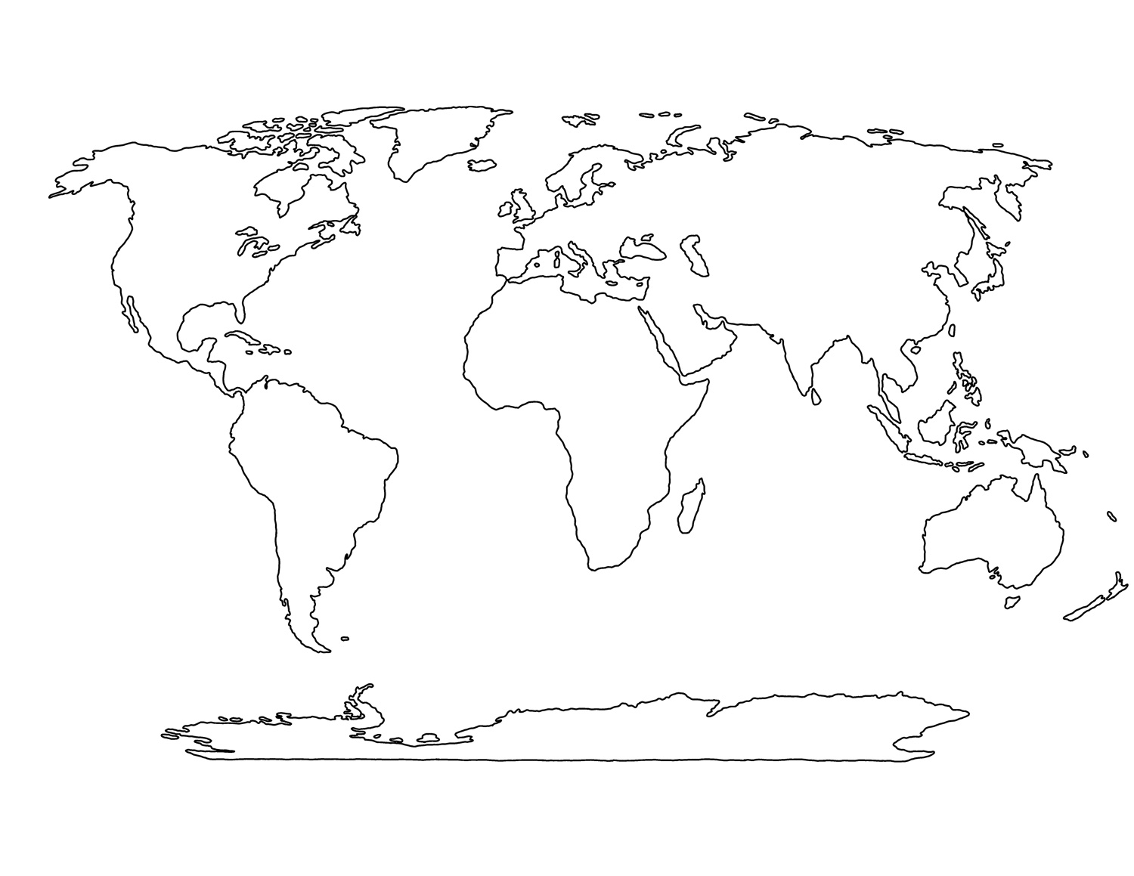
Antarctica (11:45)

- (https://www.youtube.com/watch?v=0Wb8tWzVD_Q)
- Supplies: baking soda, bowls, spoons, shaving cream, glitter, paper, scissors, foam ball, cones
- location: beit am aleph and the mirpeset if too hot outside
- setup: Ingredients for the snow will be set up in a few different spots so all chanichim have the ability to make snow if they want to. The other location will have the foam ball and cones set up as goals.
- Instructions:
  - Explain to chanichim the two different options for what they can be participating in during the perek (art projects or hockey). The activities will be going on simultaneously.
  - Have a madrich explain the process of making snow and maybe have a batch already made to show the chanichim. They will also guide them to the materials to make the snowflakes and have an example prepared.
    - After the chanichim make the snow they can try to make it into snowmen but NO THROWING THE SNOW. The snowflakes can later be hung up in the moadon.
  - Other madrichim will oversee the hockey and change the rules every few minutes. A constant raule is that there are no hockey sticks so chanichim will use either their feet or hands to pass and score.
    - Examples of rules:
      - Only use your feet walking like a crab and use feet to shoot
      - You have to be linking arms with someone else on your team
      - You cannot travel forwards (only side to side and backwards, and you can pass)
      - Only have the ball in possession for three seconds
      - No catching but keep the ball in the air (like volleyball)
      - Everytime you pass you say the persons name who you are passing too
    - Change goalies everytime the rule changes

Japan (2:30)

- Robotics Dress-Your-Madrich
- Supplies: random materials that each campers brings from his or her tzrif, tin foil, pipe cleanerss
- location: mirpeset
- setup: Counselors announce that chanichim must go to their tzrifim and bring back one random object. They do not know what the object is for.
- Instructions
  - Chanichim come back with materials
  - Madrichim announce that each group must dress up their madrich up as a robot and then explain the meaning and function of the robot
  - Give each group 20 minutes to design their robot and then give time for chanichim to present to the rest of the edah

European Food Tour (3:00)

  - supplies: candy (mike and ikes, twirlers, rolos), cookies, plates, napkins, markers, paper
  - location: mirpeset
  - staff prep: get all food materials in advance and set up stations around the moadon, each staff member is assigned one
  - setup: Everyone meets in the moadon. Tzevet are already assigned to which stations they will be running (there will be multiple stations of the same activity). They will have all materialss with them. Chanichim names will be read allowed and assigned to a tzevet member and then the peulah will begin.
  - instructions:
    - someone will introduce that we are now doing a european food tour
    - counselor announces the first part of the peulah
      - Create the story of how pizza was made/invented while also proving why your made up country is the founder of the pizza
      - Create a script and present a skit of how pizza was created, also draw a picture of the original pizza, declaration of pizza
        - There will be a panel of historian judges to determine which story is most thorough and creative
        - The group who wins will get the materials to make thier own candy pizzas first
    - make a personal pizza on a cookie using different types of candy to represent normals pizza toppings and enjoy :)
    - Also hopefully ice cream will be served at this time (gelato)

Bechirot (5:30)
The Bechirot are:
- Soccer
- Bocce
- Beading
- Settlers of Catan
- Rikud

