YOM DISNEY (Adat HaIlanot)
Peulah | Timing | Location | Tzevet (Hevrati’im)
Peulat Erev I: Lip Sync Contest to Disney Songs | 7:15 PM-8:00 PM  (Monday) | Ilanot Medurah | All
Breakfast | 8:00 AM-8:45 AM | Chadar Ochel | All
T’fillot | 8:45 AM-9:30 AM | Moadon | All
Troll-Rock Hunt | 9:35 AM-10:45 AM | Camp-wide | Group B on
Conversation about Disney Tropes (then play Heads Up with a Disney pack) | 11:00 AM-12:00 PM | Moadon Ilanot | Group B on (except Danny Byrne)
Lunch | 12:15 AM-12:45 PM | Chadar Ochel | All
Nikayon | 1:00 PM-2:00 PM | Tzrifim | All
Menucha | 2:00 PM-3:00 PM | Tzrifim | All
Disney Themed Camp-Wide Relay | 3:10 PM-4:10 PM | Camp-wide | Group A
Alice In Wonderland Gardening**** | 4:20 PM-5:00 PM | Outside Moadon Ilanot | Group A
Peulat Erev II: Start Moana | 5:10 PM-6:25 PM | Cafe Ramah | Group A on
Dinner | 6:30 PM-7:00 PM | Chadar Ochel | All
Finish Moana | 7:10 PM-8:00 PM | Cafe Ramah | Group B on

****About halfway through this perek (4:40ish), Joe, Elianna, Eliana S. and Jeisen should go ahead to Cafe Ramah and start setting up the movie. See Didi and Simon for the projector and projector screen.

Group A:
Jenna
Eliana B (Roo perek 11:00AM-1:00PM)
Adina
Ilana (Roo perek 10:30AM-11:00AM)
Feldman (Roo perek 11:00AM-1:00PM)
Yoav
Off time: 160 minutes (minus Roo prakim)

Group B:
Jeisen (Roo perek 2:00PM-4:00PM)
Danny (Roo perek 4:00PM-6:00PM and Umpiring from 11:00 AM-1:00PM)
Eliana S.(Roo perek 2:00PM-4:00PM)
Orel (Roo perek 4:00PM-6:00PM)
Idan (Roo perek 4:00PM-6:00PM)
Elianna (Roo perek 2:00PM-4:00PM)
Sugarmann (Roo perek 2:00PM-4:00PM)
Off time: 175 minutes (minus Roo prakim)

Master Materials List:
-Get from Tzrifim
-Ask Programming Office
-Get from Chadar
-To Do/Make
-Get from Walmart/Buy outside

Things we need:
- 6 Large Cardboard boxes (for car race)
- Tape
- 6 brooms (1 from each tzrif)
- 6 Towels
- Blindfolds
- Some kind of hockey puck thing
- 6 hula hoops
- Cornhole game
- 6 buckets of water
- 6 green apples
- 30 red apples
- 50 troll rocks (20 are already done)
- Cut up disney song lyrics (CHORUS ONLY) (Let It Go, Part Of Your World, Bare Necessities, Circle of Life, I’ll Make a Man Out of You, How Far I’ll Go)
- Bag of Hershey kisses
- 6 Tutus and pairs of slippers
- Plants for gardening
- Shovels/Watering cans
Peulat Erev I: Lip-Sync Battle to Disney Songs

Each group is assigned a Disney song. They have 10 minutes to prep their performance/lip sync (costumes optional) and they will then perform for the whole edah at the medurah. Andy will judge the performances and the best group will win a Disney-themed prize!
NOTE: If your name has an asterisk next to it, you are on s’mores duty once the chanichim are seated around the medurah. Idan and Danny, please leave aruchat erev a few minutes early to start the medurah.

- Group 1 - Adina* (“Friend Like Me” - Aladdin)
- Group 2 - Jenna (“Under The Sea” - The Little Mermaid)
- Group 3 - Ilana (“I’ve Got A Dream” - Tangled)
- Group 4 - Jeisen* (“You’re Welcome” - Moana)
- Group 5 - Yoav (“I’ll Make A Man Out of You” - Mulan)
- Group 6 - Feldman (“Hakuna Matata” - The Lion King)
- Group 7 - Suggy (“That’s How You Know” - Enchanted)
- Group 8 - Elianna (“Dig A Little Deeper” - The Princess And The Frog)
- Group 9 - Eliana S* (“Supercalifragilisticexpialidocious” - Mary Poppins)
- Group 10 - Eliana B (“Try Everything” - Zootopia)
- Group 11 - Idan (“Be Our Guest” - Beauty And The Beast)
- Group 12 - Orel* (“Zero To Hero” - Hercules)
- Group 13 - Danny (“Love Is An Open Door” - Frozen)

Disney T’fillot:

Birkot HaShachar: In Birkot HaShachar, we thank God for helping us and those in need. Similarly, Esmeralda asks God to help those in need in The Hunchback Of Notre Dame.

https://www.youtube.com/watch?v=MEEpavnk7Uw

Hallelujah: Halellujah is about expressing our appreciation through musical instruments. Marie, Tolouse and Berlios also use musical instruments to express themselves.

https://www.youtube.com/watch?v=tEL-RsUsKlw

Or Hadash: During Or Hadash, we thank God for light. Rapunzel also has a moment of appreciation for light.

https://www.youtube.com/watch?v=gLSrOijxFKQ

Troll Hunt
Group B
Instructions: There are Frozen trolls hidden around the machaneh (trolls can disguise themselves as rocks, so bear this in mind when decoding clues for locations). The team that finds the most trolls wins! Use the clues given at the beginning of the peulah and at each location to find trolls in different places. HOWEVER, each kvutzah is only permitted to take ONE (1) troll per location. This means that a kvutzah will have to hit as many locations as possible to collect the most trolls. Please be back at the Moadon BY 10:55. If your group arrives late, you will have a troll taken away for each minute you are late.

I used to greet anybody coming into camp and make sure they weren’t here to hurt us, but they built a new version of me and now I sit unused.

A striking part of the Tzad Aleph skyline, I am where you want to go to practice your climbing techniques.

Next to boating, I am where Tzad Aleph chanichim enter the agam for free swim, water toys, and more.

Every friday night, you will find a different edah doing shira and rikud on me in front of the entire machaneh.

Off limits to chanichim, I am where tzevet members go to relax in their z’man chofshi. Out in front of the chadar, I prevent huge puddles from making it hard to get in for aruchot.

I am where Tzad Bet chanichim go to practice for swimming competitions.

Troll Hunt Location Loop
Old Guard House⤵
Tzad Aleph Climbing Wall⤵
Tzad Aleph Hof Agam⤵
Sif complex⤵
Horshah Bean⤵
Moadon Tzevet⤵
Chadar Ochel drainage system⤵
Alpine Tower⤵
Tzad Bet Hof Agam⤵
↑Old Niv K’far
Please DO NOT touch these materials unless you are in Ilanot!
I used to greet anybody coming into camp and make sure they weren’t here to hurt us, but they built a new version of me and now I sit unused.

Please DO NOT touch these materials unless you are in Ilanot!
A striking part of the Tzad Aleph skyline, I am where you want to go to practice your climbing techniques.

Please DO NOT touch these materials unless you are in Ilanot!
Next to boating, I am where Tzad Aleph chanichim enter the agam for free swim, water toys, and more.

Please DO NOT touch these materials unless you are in Ilanot!
Whether you want to borrow some books, learn, or just grab a drink from my ice cold water fountain, I am where you want to go.

Please DO NOT touch these materials unless you are in Ilanot!
Every friday night, you will find a different edah doing shira and rikud on me in front of the entire machaneh.

Please DO NOT touch these materials unless you are in Ilanot!
Off limits to chanichim, I am where tzevet members go to relax in their z’man chofshi.
Please DO NOT touch these materials unless you are in Ilanot!
Out in front of the chadar, I prevent huge puddles from making it hard to get in for aruchot.

Please DO NOT touch these materials unless you are in Ilanot!
I tower over Machane Gimel, and I am where the best climbers in Machane Ramah show off their skills.

Please DO NOT touch these materials unless you are in Ilanot!
I am where Tzad Bet chanichim go to practice for swimming competitions.

Please DO NOT touch these materials unless you are in Ilanot!
I used to be where Nivonim spent their nights, but now I am just a parking lot next to the Tzad Bet basketball courts.

Gender Roles in the Disney Universe Peulah
Group B

Intro 15 minutes:
Break into six groups, with each group being led by a madrich.

Once divided into groups, each madrich will have everyone in their circle answer the following question: Who is your favorite Disney character and why?

The group leader should say the following to the hanichim: We are going to discuss some of the more popular Disney characters. Our main focus is going to be about how male characters are portrayed in Disney movies and how female characters are portrayed. I am going to pass around some pictures. Everyone should take a look at them and tell me what they notice (ask everyone to give one response to the question).

Lead the chanihcim to the following answer: The men are portrayed as very large, muscular, and tall. Women are portrayed as skinny, short, and small.

Ask the following questions:
- Raise your hand if you noticed the stark differences between the men and women in Disney movies.
- How do the differences between men & women in Disney movies change how you feel about these movies?
- What message does the difference in body type send to children who watch Disney movies?
- Despite the men and women being out of proportion in these movies, do you know of any Disney heroes who are women? How are they heroic?

Comparing Disney Heroes to Biblical Heroes (10 minutes)

Groups 1, 2 & 3: Devorah & Mulan
Ask:
- Can anyone tell me about the movie Mulan? What happens in it and what is the main part of the story?
- Can anyone tell me who Devorah the prophet is? Why is she so famous?
Read Judges 4:4-8:
4. Deborah, wife of Lappidoth, was a prophetess; she led Israel at that time.
5. She used to sit under the Palm of Deborah, between Ramah and Bethel in the hill country of Ephraim, and the Israelites would come to her for decisions.
6. She summoned Barak son of Abinoam, of Kedesh in Naphtali, and said to him, “The LORD, the God of Israel, has commanded: Go, march up to Mount Tabor, and take with you ten thousand men of Naphtali and Zebulun.
7. And I will draw Sisera, Jabin’s army commander, with his chariots and his troops, toward you up to the Wadi Kishon; and I will deliver him into your hands.”
8. But Barak said to her, “If you will go with me, I will go; if not, I will not go.”

Say: Devorah is a prophet who leads her people into battle. Mulan disguises herself as a man, so she can go into battle and fight for her ailing father. Both are leaders who take on roles that were not expected of them during the times they lived
Ask:
- After reading a little more about Devorah, how is she similar to Mulan? How is she different from Mulan?
- How would things be different today if Devorah and Mulan lived in the 21st century?
- What would you do if you were in Devorah & Mulan’s shoes?

Groups 4, 5 & 6: Moana & Miriam
Ask:
- Can anyone tell me anything about the movie Moana (without too many spoilers)? What is the main storyline?
- Who can tell me about Moses’s sister Miriam, what is she famous for?
Say: Moses’s sister Miriam always helped the Israelites acquire water along their journey in the Desert. Moana is another young leader who helps solve her village’s problems with her her sense of adventure and leadership.
Read Ta’anit 9a:
Three good sustainers rose up for the Jewish people during the exodus from Egypt, and they are: Moses, Aaron and Miriam. And three good gifts were given from Heaven through their agency, and these are they:The well of water, the pillar of cloud, and the manna. He elaborates: The wellwas given to the Jewish people in the merit of Miriam; the pillar of cloud was in the merit of Aaron; and the manna in the merit of Moses. When Miriam died the well disappeared, as it is stated: “And Miriam died there” (Numbers 20:1), and it says thereafter in the next verse: “And there was no water for the congregation” (Numbers 20:2). But the well returned in the merit of both Moses and Aaron.

- What was Miriam’s role in the Israelite community?
- How is Miriam similar to Moana?
- How do you think Miriam and Moana’s roles would differ in today’s world?

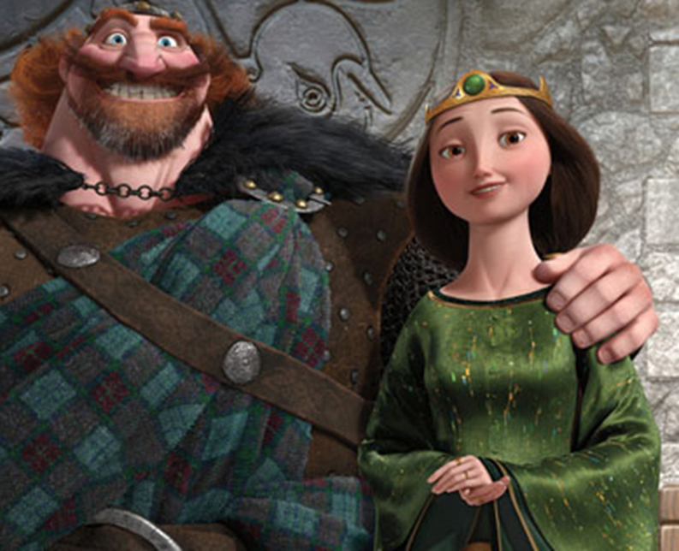

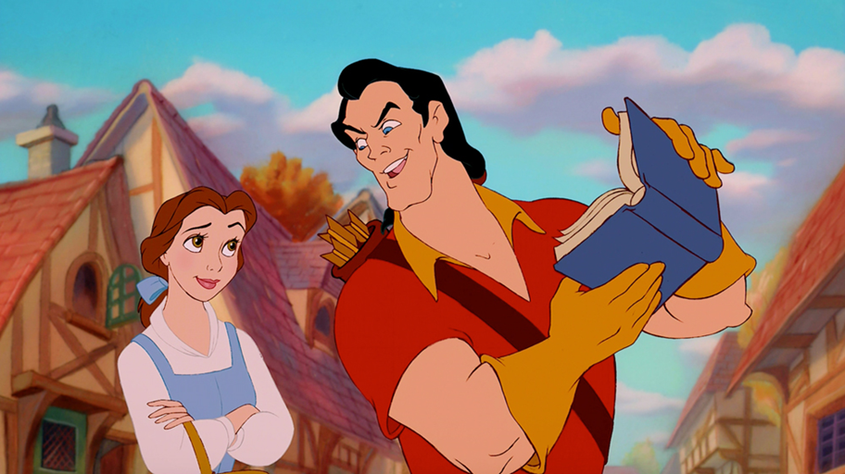

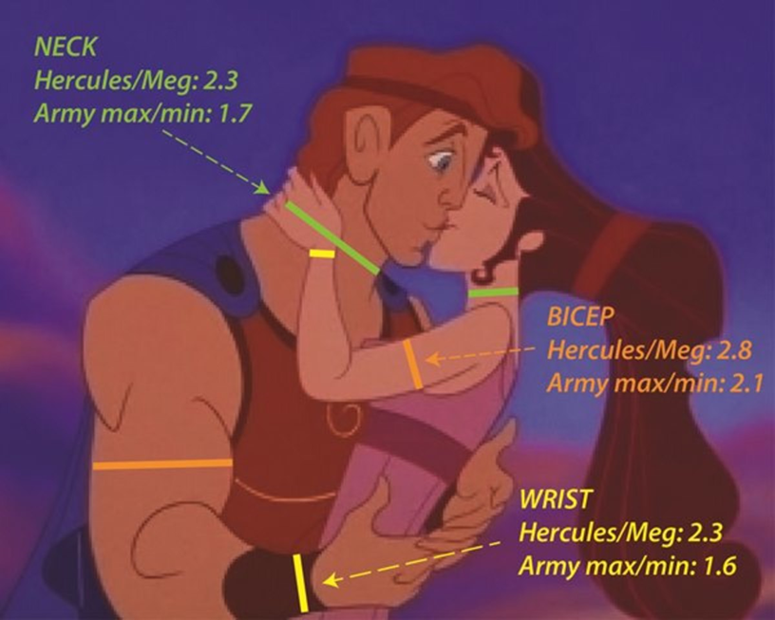

Disney Relay Apache
Group A
Instructions: One madrich is assigned to each tzrif and must delegate tasks for the apache. The madrich should send the first few chanichim to their stations and run with the rest to each station (so no one gets lost).

TASK | START LOCATION | NAME OF CHANICH/A
Cinderella Run: Run to the sign on the upper migrash wearing a tutu and slippers; don’t let the slippers fall off! | Tzrif 32
Tale as Old as Time: Two chanichim must waltz/dance together down to the Tzad Aleph Hof Agam. | Upper migrash sign
WIn the Piston Cup: Drive your tzrif’s “car” from the Agam to 38 | Hof Agam
Moana’s Hula: Hula hoop for 15 consecutive seconds. If the hula hoop falls, start over. Then run to the Marp Medurah. | Tzrif 38
Hercules’ Parthenon: Build a human pyramid | Marp Medurah
Meter Maid Hopps: Tape 3 trees with parking tickets | Horshah
Clean Tiana’s Place: Curling race using brooms | O”Ch
Magic Carpet Race: “Fly”(Run) on your “Magic Carpet” from the O”Ch to Moadon Amitzim. | O’’ch to Moadon Amitzim
Pin the Mirror on the Wall: Have the madrich blindfold and spin a chanich, then have the chanich hook a “mirror” onto Moadon Amitzim. | B-side softball field
Rapunzel's tower bean-bag toss: | B-side tennis court
Disney song scramble: Chanichim must put the words of a scrambled Disney song in order and sing it. | Omanut ohel
Kiss the Kiss: (partner) Throw a Hershey kiss in the air and have another person catch it in their mouth | In front of mercaz
Snow white poison apple bob: Chanichim must bob for the green apple among red apples | Right outside moadon Ilanot
Sit by tzrif in moadon when done

Alice In Wonderland Gardening
Group A

Instructions: Each tzrif will be planting flowers like the garden Alice explores in Wonderland. Get materials (pots, potting soil and seeds) from Andy and then bring them back to the mirpessot/migrash area in front of each tzrif. Before you begin, read the story on the flip side of this sheet about Honi HaMeagal; explain that, while the chanichim from this machzor might not get to see these flowers bloom, putting down roots for the future is the ethical thing to do. Once the tzrif has planted their Wonderland garden(s), go to the Moadon to plant a bulb garden for everyone to enjoy in future kaytzim!

Tzevet-Tzrif Assignments
- Adina with Tzrif 5
- Feldman with Tzrif 9
- Yoav with Tzrif 10
- Jenna with Tzrif 19
- Eliana Bazer with Tzrif 21
- Ilana with Tzrif 25

Honi Ha-Me’agel Sleeps for Seventy Years
A long time ago, there lived in Israel a man named Honi Ha-Me’agel. He was a very wise man. One spring day, Honi went for a walk. “What a lovely sunny day it is today,” he thought to himself. He noticed that there were people in the fields planting vegetables and fruit trees. As he passed by a pretty little house, he saw an old man planting a tree. “Why would such an old man be planting a tree?” he wondered. “It takes a very long time for fruit trees to grow, and planting is hard work. He might not even be around when the tree is big enough to give fruit.” Then Honi said aloud, “Excuse me sir, but what kind of tree are you planting?” “This sapling is a carob tree,” said the man. “I love to eat carob on Tu B’Shevat. In about seventy years, this tree will produce carobs good enough for eating.” “Do you think that you will live seventy more years and be able to eat the carob fruit,” asked Honi. The man looked surprised. “Oh no! But I remember seeing carob trees growing when I was a little boy. I ate some of those carobs on Tu B’Shevat. They were so delicious! Those carob trees were planted by those who wanted to leave a gift for younger people. I am planting this tree as a gift for the people who will be living seventy years from now. Then they can enjoy eating carob on Tu B’Shevat, too. Just as my parents and grandparents planted trees for me, so I plant trees for my children and grandchildren.” “That’s a very smart thing to do,” said Honi, and he continued his walk. After a short while, he began to feel very tired. “I’ll just rest for a few moments,” he thought, as he sat down on the ground. “Maybe I’ll close my eyes for a while. I’ll eat my lunch when I wake up.” Honi stretched out on the ground, closed his eyes and fell into a deep sleep. While he slept, a wonderful thing happened. A rock appeared nearby. It grew bigger and bigger. After a while, it began to surround Honi. Then it grew into the shape of a tent, with Honi inside. The tent protected him from the wind, from the rain, from the cold, and from the hot sun. Honi slept very comfortably inside the tent. He slept on and on for a very long time. He slept for seventy years!

One day, the tent that covered Honi began to shrink. It grew smaller and smaller until it did not cover him anymore. Honi woke up. He looked around. He stretched and stretched. “What a good nap I had!” said Honi, his arms out wide and his mouth yawning. “I must have slept for a long time.” Honi noticed a man picking carobs from a tree nearby. This man was not the one to whom Honi had spoken earlier. Honi stood up and walked over to the man. “Did you plant this tree?” he asked. “No,” answered the man. “My grandfather planted it seventy years ago.” “I can’t believe it,” Honi said to himself. “I must have been sleeping for seventy years!” “I’m going to plant a carob tree also,” said the man. “See, I have a sapling all ready to plant. Someday my children and grandchildren will be able to enjoy carobs just as I do.” Honi remembered the words of the old man. “Just as my parents and grandparents planted trees for me, so do I plant trees for my children and grandchildren.”

