YOM FBI (Adat HaIlanot)
Peulah | Timing | Location | Tzevet (Hevrati’im)
Peulat Erev I | 7:15 PM-8:00 PM  (Monday) | Beit Am Aleph/Mirpesset | All
Breakfast | 8:00 AM-8:30 AM | Chadar Ochel | All
T’fillot | 8:45 AM-9:30 AM | Moadon | `All
Scavenger Hunt | 9:45 AM-11:00 AM | Throughout camp | All
Conversation about Criminal Justice | 11:00 AM-11:40 AM | Moadon | Group B on
Nikayon | 11:55 AM-12:45 PM | Tzrifim | All
Lunch | 12:45 PM-1:15 PM | Tzrifim | All
Banot Water Slides/Banim Menucha | 1:15 PM-1:45 PM | Moadon | All
Banim Water Slides/Banot Menucha | 1:45 PM-2:15 PM | Moadon | All
Peulat Tzrif | 2:15 PM-3:00 PM | Tzrifim | All
Ice cream | 3:10 PM-3:40 PM | Walk chanichim to chadar and back to moadon | Group A on
FBI Training/Arts and Crafts | 3:40 PM-4:40 PM | Lower migrash/moadon area | Group A on
Revelation | 4:55 PM-5:05 PM | Moadon | Group B on (plus Andy and Adina Loeb)
Start Movie | 5:20 PM-6:25 PM | Beit Knesset | Group B on
Dinner | 6:30 PM-7:00 PM | Chadar Ochel | All
Finish Movie | 7:10 PM-8:00 PM | Beit Knesset | Group A on

Group A:
Jeisen
Feldman
Elianna I
Shuggy
Yoav
Adina
Elli B
Off time: 40 min, 90 min; Total: 130 min

Group B:
Danny
Eliana S
Ilana
Orel
Idan
Jenna
Off time: 50 min, 90 min; Total: 140 min

Yom FBI Outline
Premise: Oh no! Andy’s been kidnapped. It’s up to Edat haIlanot to find his captor. All of tzevet Ilanot are suspects. Hanichim will have fun asking madrichim lots of questions, practice deductive reasoning, and have conversations about about the treatment of criminals and suspects (through a Halakhic lense and a secular lens).

Prior Planning
- Email Simon/Didi to reserve BAA & Mirpesset for July 2 Peulat Erev
- Film and edit tzevet interrogations
- Create alibis (real and fake)
- Create a list of activities chanichim must complete to ask questions
- Create clues and background for scavenger hunt

Materials
- Surface on which to watch videos
- Projectors
- Computer
- Painting surface
- Washable paint
- Paper
- Markers

Peulat Erev I
Overview: Introduce the scenario. Hanichim will run around and practice deductive reasoning using different clues given to them. Our suspects will be narrowed down to fewer tzevet members.

Instructions/Rundown: Watch the video. Hanichim are split into thirteen groups, with one madrich responsible for one group. Each madrich will also receive their “real” alibi. To verify whether or not the the video and “real” alibi are compatible, chanichim will have to complete tasks so they can ask their designated madrich questions.

Groups
- Ilana - Ezra , Farryn , Roxanne , Lilian , Emilia , Sam , Arbel
- Jenna- Elissa , Sasha , Mira , Lev , Shaya , Talia P. , Gabriella
- Josh E. - Noa , Zoe , Eliyah , Ariel , Simeon , Avner , Daniela
- Yoav- Anna , Lavi , David , Oliver , Noam B. , Shai , Vered
- Adina - Jacob , Tamar , Maiya , Noam R. , Samantha , Lotem , Issac
- Orel- Elana , Mia , Viktor , Sophia , Livia , annie. , Matthew
- Eliana I- Dani , Elijah , Joel , Jonah , Carrine , Benjamin , Brandon
- Idan- Hailey , Tommy , Liad , Naomi , Gilah , Gabriel , Talia L.
- Eliana B- Gabe M. , Barak , Orli, Liam , Morris , Abraham , Beeri
- Joe- Andrew , Audrey , Nathan , Nadav , Daphna , Benjamin
- Josh F- Ella , Dov , Simon , Dahlia , Ellie K. , Julian
- Eliana S- Eitan L., Ruby , Lilah , Eitan , Maya , Siona
- Danny - Avital , Dov , Tyler , Josephine , Elisheva , Alma

Who gets cleared | Still suspect
Anat  Rotem  Nitzan  Zev  Shaked  Josh E.  Jenna  Ilana  Eliana B  Joe | Adina  Danny  Orel  Idan  Eliana S  Elianna I  Josh F  Yoav

AM Peulah
Overview: This scavenger hunt will narrow down tzevet suspects. Chanichim will get to ask remaining madrichim suspects questions about motive.

Instructions/Rundown: Hanichim will be split into three groups and will have to use different clues to find each suspicious madrich. At each “station,” chanichim will be able to answer questions about motive by solving riddles.

- Bazer - Avner , Audrey , Farryn , Matthew , Anna , David , Gabe M. , Morris , Dahlia , Talia , Noa , Tamar , Abraham , Gabriella , Lilah

- Jeisen - Samantha , Viktor , Lavi , Jonah , Mia , Noam , Dani , Elissa , Emilia , Talia P. , Roxanne , Simon , Ariel , Nadav , Daphna , Simeon

- Orel - Lev , Andrew , Ellie K. , Elijah , Alma , Jacob , Shai , Elisheva , Lotem , Hailey , Ella , Dov , Barak , Benjamin , Joel

- Ilana - Orli , Gabriel , Liam , Mira , Beeri , Julian , Gilah , Benjamin , Maya , Josephine , Nathan , Ezra , Annie , Arbel
- Jenna - Zoe , Issac , Dov , Eitan , Avital , Eliyah , Brandon , Noam R. , Eitan L. , Maiya , Carrine , Sophia , Lilian , Sasha

- Idan - Vered , Ruby , Tyler , Tommy , Sam , Shaya , Oliver , Siona , Naomi , Livia , Liad , Daniela , Elana

Peulat Tzrif

FBI Training
Groups

Leading activities
Danny- sneaking ( moadon)
Feldman- over under benches (in front of tennis courts)
Yoav- push ups and sit ups (tennis court)

Adina - finger painting (Ohel at omanut) Table 1
Eliana Israel - badge making (ohel at omanut) Table 2
Joe- decoding (ohel at omanut) Table 3

- Ezra , Tyler , Dov , Abraham , Gilah , Lilian , Shaya , Oliver , Tommy , Noa , Eitan L. , Gabriella , Dov , Naomi , Shai , Alma , Vered , Daphna , Hailey , Farryn , Sasha , Tamar , Sam , Sophia , Elijah , Annie , Roxanne , Elana , Brandon , Eliyah , Siona , Audrey , Anna , Ellie K. , Andrew ,Lev , Ella , Arbel , Zoe , Nathan , Maya , Daniela , Josephine , Mia

- Julian , Beeri , Lilah , Lotem , Matthew , Livia , Noam R. , Eitan , Gabriel , Avital , Benjamin , Elissa , Emilia , Ruby , Joel , Jacob , Elisheva , David , Simon , Benjamin , Jonah , Dahlia , Ariel , Issac , Viktor , Avner , Carrine , Simeon , Samantha , Gabe M. , Lavi , Talia P. , Maiya , Liad , Mira , Nadav , Barak , Talia , Liam , Noam , Morris , Dani , Orli

Overview: Chanichim will complete physical challenges to prove that they are prepared to join the FBI.

Instructions/Rundown:
Chanichim will be split into random groups and undergo rotation of relay races, over-under benches, situps, pushups. Finger Painting and badge making at beginning, decoding station. Also sneaking around moadon ilanot.

Discussion about Criminal Justice

Groups
- Bazer- Avner , Audrey , Farryn , Matthew , Anna , David , Gabe M. , Morris , Dahlia , Talia , Noa , Tamar , Abraham , Gabriella , Lilah
- Safer- Samantha , Viktor , Lavi , Jonah , Mia , Noam , Dani , Elissa , Emilia , Talia P. , Roxanne , Simon , Ariel , Nadav , Daphna , Simeon

- Orel- Lev , Andrew , Ellie K. , Elijah , Alma , Jacob , Shai , Elisheva , Lotem , Hailey , Ella , Dov , Barak , Benjamin , Joel

- Ilana - Orli , Gabriel , Liam , Mira , Beeri , Julian , Gilah , Benjamin , Maya , Josephine , Nathan , Ezra , Annie , Arbel

- Jenna- Zoe , Issac , Dov , Eitan , Avital , Eliyah , Brandon , Noam R. , Eitan L. , Maiya , Carrine , Sophia , Lilian , Sasha

- Idan- Vered , Ruby , Tyler , Tommy , Sam , Shaya , Oliver , Siona , Naomi , Livia , Liad , Daniela , Elana

Overview:

Instructions/Rundown:

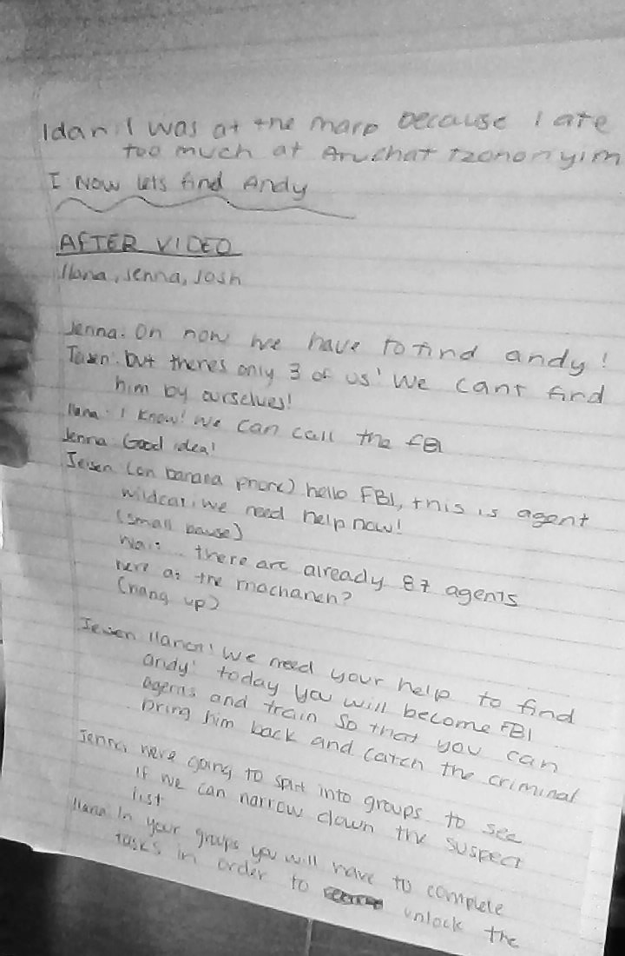

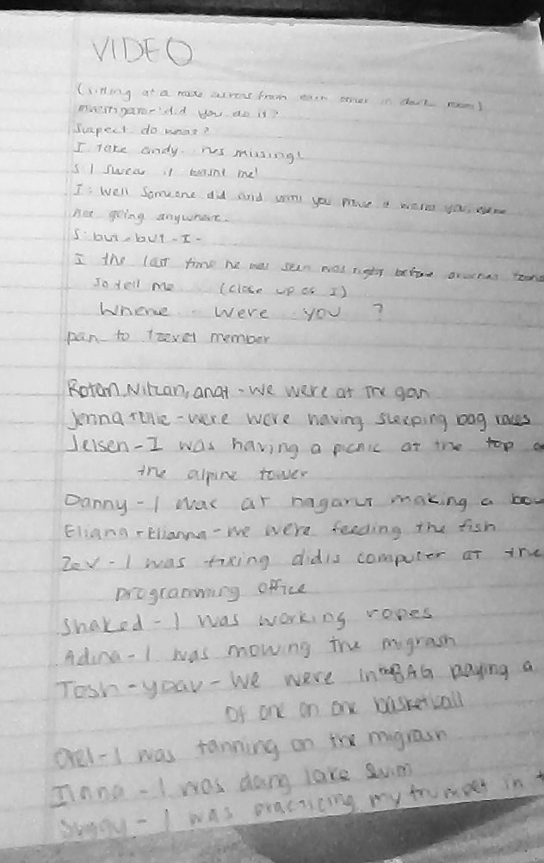

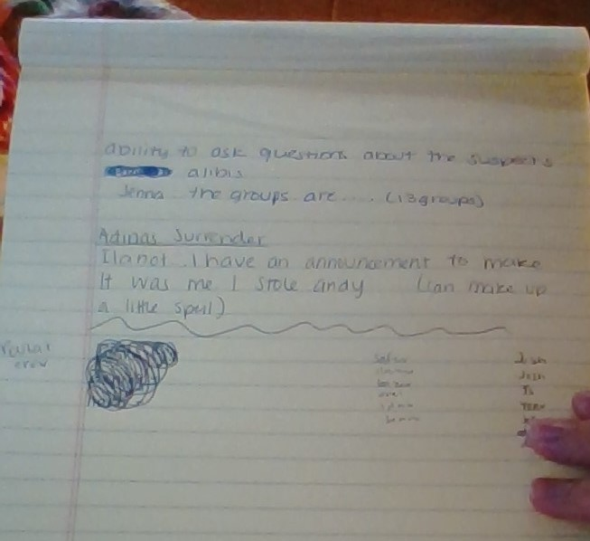

Scavenger Hunt

Directions for Group Leaders: Have your chanichim determine the location indicated in the first riddle and go there. You will receive a second riddle with the “true” location of the stationed tzevet member during Andy’s capture. Help guide the chanichim as they identify whether the “true” location and the place in the original riddle are the same place. If they are the same location, the suspect(s) is/are not suspicious and vice versa. The stationed tzevet member will then give you the riddle for the next location to visit. Repeat the above instructions for each station. Once you have completed each station, please bring your chanichim back to Moadon Ilanot.
Directions for Stationed Tzevet: Give each visiting group a riddle about your “true” location during Andy’s kidnapping. The kvutzah will have to determine whether the place described in this riddle and the location where you are stationed is the same place. If they are the same location, you are not suspicious and vice versa (find your name below to see whether or not you are supposed to be cleared by the end of the peulah). Once the chanichim have determined your status (suspicious or clean), give them the riddle for their next location. Repeat for each visiting group. When you are done, please return to Moadon Ilanot if you are in Group B or enjoy Zman Hofshi if you are in Group A.

- Bazer - Avner , Audrey , Farryn , Matthew , Anna , David , Gabe M. , Morris , Dahlia , Talia , Noa , Tamar , Abraham , Gabriella , Lilah, Ruby , Tyler
  - Order of locations: Adina, Danny, Elianna & Eliana, Yoav & Feldman, Idan

- Jeisen - Samantha , Viktor , Lavi , Jonah , Mia , Noam , Dani , Elissa , Emilia , Talia P. , Roxanne , Simon , Ariel , Nadav , Daphna , Simeon, Tommy , Sam
  - Order of locations: Idan, Adina, Danny, Elianna & Eliana, Yoav & Feldman

- Orel and Sugarman - Lev , Andrew , Ellie K. , Elijah , Alma , Jacob , Shai , Elisheva , Lotem , Hailey , Ella , Dov , Barak , Benjamin , Joel, Shaya , Oliver , Siona
  - Order of locations: Yoav & Feldman, Idan, Adina, Danny, Elianna & Eliana

- Ilana - Orli , Gabriel , Liam , Mira , Beeri , Julian , Gilah , Benjamin , Maya , Josephine , Nathan , Ezra , Annie , Arbel, Naomi , Livia , Liad
  - Order of locations: Elianna & Eliana, Yoav & Feldman, Idan, Adina, Danny

- Jenna - Zoe , Issac , Dov , Eitan , Avital , Eliyah , Brandon , Noam R. , Eitan L. , Maiya , Carrine , Sophia , Lilian , Sasha, Daniela , Elana, Vered
  - Order of locations: Danny, Elianna & Eliana, Yoav & Feldman, Idan, Adina

Who gets cleared | Still suspect
Danny  Elianna I  Eliana S | Josh Feldman  Yoav  Adina  Idan
Adina

I am in front of your tzrif. I have tetherball poles, a gaga pit and a swing set.

I am the binyan where you can make a bowl, a cane, or anything else you can imagine out of wood.

I am in front of your tzrif. I have tetherball poles, a gaga pit and a swing set.

I am the binyan where you can make a bowl, a cane, or anything else you can imagine out of wood.

I am in front of your tzrif. I have tetherball poles, a gaga pit and a swing set.

I am the binyan where you can make a bowl, a cane, or anything else you can imagine out of wood.

I am in front of your tzrif. I have tetherball poles, a gaga pit and a swing set.

I am the binyan where you can make a bowl, a cane, or anything else you can imagine out of wood.

I am in front of your tzrif. I have tetherball poles, a gaga pit and a swing set.

I am the binyan where you can make a bowl, a cane, or anything else you can imagine out of wood.

*Danny - Nagarut

There’s a big sign on my front that says “Mercaz” and I’m across the street from the misrad.

I am one of the mirpessot of one of the banot tzrifim in Ilanot, and my number ends in 9.

There’s a big sign on my front that says “Mercaz” and I’m across the street from the misrad.

I am one of the mirpessot of one of the banot tzrifim in Ilanot, and my number ends in 9.

There’s a big sign on my front that says “Mercaz” and I’m across the street from the misrad.

I am one of the mirpessot of one of the banot tzrifim in Ilanot, and my number ends in 9.

There’s a big sign on my front that says “Mercaz” and I’m across the street from the misrad.

I am one of the mirpessot of one of the banot tzrifim in Ilanot, and my number ends in 9.

There’s a big sign on my front that says “Mercaz” and I’m across the street from the misrad.

I am one of the mirpessot of one of the banot tzrifim in Ilanot, and my number ends in 9.

*Elianna & Eliana - Mirpesset of 19

Eliana’s Location: I am the structure between tzrifim 17 and 21.

Elianna’s Location: I am one of two banot tzrifim that has a full mirpesset but I do not have a shelf.

Come to me whenever you’re on Tzad Aleph and want to shoot some hoops.

Eliana’s Location: I am the structure between tzrifim 17 and 21.

Elianna’s Location: I am one of two banot tzrifim that has a full mirpesset but I do not have a shelf.

Come to me whenever you’re on Tzad Aleph and want to shoot some hoops.

Eliana’s Location: I am the structure between tzrifim 17 and 21.

Elianna’s Location: I am one of two banot tzrifim that has a full mirpesset but I do not have a shelf.

Come to me whenever you’re on Tzad Aleph and want to shoot some hoops.

Eliana’s Location: I am the structure between tzrifim 17 and 21.

Elianna’s Location: I am one of two banot tzrifim that has a full mirpesset but I do not have a shelf.

Come to me whenever you’re on Tzad Aleph and want to shoot some hoops.

Eliana’s Location: I am the structure between tzrifim 17 and 21.

Elianna’s Location: I am one of two banot tzrifim that has a full mirpesset but I do not have a shelf.

Come to me whenever you’re on Tzad Aleph and want to shoot some hoops.

Yoav & Feldman - Tzad Aleph Basketball Courts

Yoav’s Location: I am all the way on Tzad Bet and I have a hockey rink on me and a volleyball court next door.

Josh’s Location: I am the highest banim tzrif number.

I am the binyan that is under Olga’s charge 24/7, and I am where you go after meals if you take meds.

Yoav’s Location: I am all the way on Tzad Bet and I have a hockey rink on me and a volleyball court next door.

Josh’s Location: I am the highest banim tzrif number.

I am the binyan that is under Olga’s charge 24/7, and I am where you go after meals if you take meds.

Yoav’s Location: I am all the way on Tzad Bet and I have a hockey rink on me and a volleyball court next door.

Josh’s Location: I am the highest banim tzrif number.

I am the binyan that is under Olga’s charge 24/7, and I am where you go after meals if you take meds.

Yoav’s Location: I am all the way on Tzad Bet and I have a hockey rink on me and a volleyball court next door.

Josh’s Location: I am the highest banim tzrif number.

I am the binyan that is under Olga’s charge 24/7, and I am where you go after meals if you take meds.

Yoav’s Location: I am all the way on Tzad Bet and I have a hockey rink on me and a volleyball court next door.

Josh’s Location: I am the highest banim tzrif number.

I am the binyan that is under Olga’s charge 24/7, and I am where you go after meals if you take meds.

Idan - Outside Marp

I am across the road from the Sifrya and I have a long ramp that leads up to my mirpesset.

On Shabbat you will find soccer and Ultimate being played on me, and while standing on me you have a great view of all the people who come into camp.

I am across the road from the Sifrya and I have a long ramp that leads up to my mirpesset.

On Shabbat you will find soccer and Ultimate being played on me, and while standing on me you have a great view of all the people who come into camp.

I am across the road from the Sifrya and I have a long ramp that leads up to my mirpesset.

On Shabbat you will find soccer and Ultimate being played on me, and while standing on me you have a great view of all the people who come into camp.

I am across the road from the Sifrya and I have a long ramp that leads up to my mirpesset.

On Shabbat you will find soccer and Ultimate being played on me, and while standing on me you have a great view of all the people who come into camp.

I am across the road from the Sifrya and I have a long ramp that leads up to my mirpesset.

On Shabbat you will find soccer and Ultimate being played on me, and while standing on me you have a great view of all the people who come into camp.

Crime and Punishment Discussion--Leaders Guide

- To start out, let’s go around and say who we think Andy’s kidnapper is right now.
  - Go around the Circle and take one answer from each person.

- If/When we identify the Andynapper, how do you think we should enforce justice?
  - Take on answer from each person. Try to get them to answer: what type of punishment should the andynapper receive?
- How do you think Jewish law would want to punish the kidnapper?

- שמות 21:16 (Sh’mot 21:16) says the following about punishment for kidnapping (read source)
- Why do you think this type of punishment is problematic? What if Andy’s kidnapper was your friend?
- How do we deal with things from the Torah that you disagree with?
- (Read Talmud text and ask) Which approach do you think our leaders should take when dealing with kidnapping? Why do you think this?
- How do you think we can deal with the Andynapper in a compassionate way?

Yom Meyuchad Discussion
Source Sheet by Andy Weissfeld

Exodus 21:16  (16) He who kidnaps a man—whether he has sold him or is still holding him—shall be put to death. | שמות כ״א:ט״ז  (טז) וְגֹנֵ֨ב אִ֧ישׁ וּמְכָר֛וֹ וְנִמְצָ֥א בְיָד֖וֹ מ֥וֹת יוּמָֽת׃ (ס)

Berakhot 7a:3  Said Rabbi Zutra ben Tuvia in the name of Rav: May it be My will that my compassion will conquer my anger, that my compassion will prevail over my other attributes, that I behave towards my children according to the quality of compassion and that I enter before them within the line of the law. | ברכות ז׳ א:ג׳  אמר רב זוטרא בר טוביה אמר רב יהי רצון מלפני שיכבשו רחמי את כעסי ויגולו רחמי על מדותי ואתנהג עם בני במדת רחמים ואכנס להם לפנים משורת הדין

Source Sheet created on Sefaria by Andy Weissfeld

FBI Training

Overview: Chanichim will be split into 2 big groups and undergo rotation of physical challenges and fingerprinting, decoding station. Also sneaking around moadon ilanot.

Materials:
- 6 benches
- 10 cones
- Soccer balls
- Basketballs
- 1 full size goal (already on A side migrash)
- Paint for fingerpainting
- Pens, markers, stickers for badges and fingerpainting
- Paper for fingerpainting and decoding
- Blue tape

Group 1 will begin with Arts and Crafts
Group 2 will begin with relay race

Group 1 alternates around three tables
-Table 1 is fingerprinting
-Table 2 is decoding
-Table 3 is badge making (Make their agent names)

Group 2 alternates between multiple events
-Sneaking practice around moadon ilanot
-over/under benches between tennis courts and road
-situps/pushups area on tennis courts

HOUR AND A HALF
45 MINS per side
15 MINS per activity

FINGERPRINTING/FINGERPAINTING

15mins

Immediately have chanichim start painting

10 mins: fingerpainting
-encourage them to use fingerprinting in their images
-while chanichim are painting: Discussion about why fingerprinting is important
-ask chanichim why they think it is so useful
-prompt them to talk about uniqueness if needed
-Do chanichim think it is the best method to identify criminals today?

5 mins: Clean up area and wash hands in Omanut

DECODING

15 mins: Chanichim decode messages given to them, and get the next one once they are done

A | B | C | D | E | F | G | H | I | J | K | L | M | N | O | P | Q | R | S | T | U | V | W | X | Y | Z
@ | 3 | $ | 1 | ! | * | % | 6 | 9 | ? | + | 8 |  | = | < | 2 | 0 | & | # | / | 4 | () | ~ | 7 |  | 5

Clue:

Clue:

BADGEMAKING

15 mins:

2 mins: Have chanichim think of an APPROPRIATE (and cool) agent name
-If struggling, suggest animals or their school mascots

13 mins: Chanichim receive badge-shaped piece of paper, and can decorate however they want but must include their agent name

SNEAKING PRACTICE

15 mins

5 mins: Teach chanichim/agents how to properly sneak
-knees bent, heads moving side to side to see threats, tiptoe-ing to be extremely quiet
-critique their form, have everyone practice it in front of you
10 mins: Lead them on mission around moadon ilanot, explaining that they must not be detected
-abort the mission multiple times, claiming that they were not stealthy enough
-when they successfully complete mission, congratulate each and proclaim that they have passed FBI stealth training

OVER-UNDER BENCH TRAINING

15 mins

2 mins:
-Explain that it is very important to be agile as an FBI agent because you may be chased by or have to chase bad guys

13 mins:
-Time chanichim going under and over benches and then weaving through cones on way back
-Shake head at them at beginning when you are looking at time, say that you know that they can be way faster but don’t show them time
-At the end be very amazed at how much faster they have gotten, tell them that they are more than fast enough to be FBI agents

SITUPS, PUSHUPS

15 mins

2 mins: Show chanichim proper pushup form, with their hands shoulder length apart and their butt in line with the rest of their body, go around and make sure that they are all set up correctly

3 mins: have Chanichim do as many pushups as they can in this timeframe

2 mins: Show chanichim proper sit up form, with someone holding their feet. Must have arms crossed and go all the way down

3 mins: have Chanichim do as many sit ups they can in this timeframe

5 mins: have Chanichim cool down with stretching and discuss why being strong is important when trying to catch criminals

FBI Training Completion Card

- Fingerprinting  - Sit-ups and Push-ups  - Bench agility  - Sneaking training  - Decoding  - FBI Badge | - Fingerprinting  - Sit-ups and Push-ups  - Bench agility  - Sneaking training  - Decoding  - FBI Badge
- Fingerprinting  - Sit-ups and Push-ups  - Bench agility  - Sneaking training  - Decoding  - FBI Badge | - Fingerprinting  - Sit-ups and Push-ups  - Bench agility  - Sneaking training  - Decoding  - FBI Badge
- Fingerprinting  - Sit-ups and Push-ups  - Bench agility  - Sneaking training  - Decoding  - FBI Badge | - Fingerprinting  - Sit-ups and Push-ups  - Bench agility  - Sneaking training  - Decoding  - FBI Badge
- Fingerprinting  - Sit-ups and Push-ups  - Bench agility  - Sneaking training  - Decoding  - FBI Badge | - Fingerprinting  - Sit-ups and Push-ups  - Bench agility  - Sneaking training  - Decoding  - FBI Badge
- Fingerprinting  - Sit-ups and Push-ups  - Bench agility  - Sneaking training  - Decoding  - FBI Badge | - Fingerprinting  - Sit-ups and Push-ups  - Bench agility  - Sneaking training  - Decoding  - FBI Badge
- Fingerprinting  - Sit-ups and Push-ups  - Bench agility  - Sneaking training  - Decoding  - FBI Badge | - Fingerprinting  - Sit-ups and Push-ups  - Bench agility  - Sneaking training  - Decoding  - FBI Badge

For Chanichim: Eliana B
Alibi Given: I was having a sleeping bag race with Jenna!
Answers that check out with alibis:
- Do either of you have sleeping bags at camp?
  - No
- Does anyone you know have sleeping bags at camp?
  - Yes
- Did these people let you borrow your sleeping bags?
  - Yes
- Where did you have your sleeping bag races?
  - From the Chadar Ochel on the way to Peulat Erev

For Madrich: Eliana B; Activities to be completed w/each question and answers to give. Give chanichim 2 minutes to prepare each activity, then, if they do so successfully, answer the corresponding question as indicated.

- Do either of you have sleeping bags at camp?
  - Activity to complete: Make a human pyramid
  - Answer to give: No
- Does anyone you know have sleeping bags at camp?
  - Activity to complete: Everyone has to dance the first 8 counts of Zeiben-Zeiben
  - Answer to give: Yes
- Did these people let you borrow your sleeping bags?
  - Activity to complete: Everyone has to sing Shir Ramah as loud as they can
  - Answer to give: Yes
- Where did you have your sleeping bag races?
  - Activity to complete: Play 3 rounds of sharks and minnows
  - Answer to give: From the Chadar Ochel on the way to Peulat Erev
For Chanichim: Jenna
Alibi Given: I was having a sleeping bag race with Eliana B!
Answers that check out with alibis:
- Do either of you have sleeping bags at camp?
  - No
- Does anyone you know have sleeping bags at camp?
  - Yes
- Did these people let you borrow your sleeping bags?
  - Yes
- Where did you have your sleeping bag races?
  - From the Chadar Ochel on the way to Peulat Erev

For Madrich: Jenna; Activities to be completed w/each question and answers to give. Give chanichim 2 minutes to prepare each activity, then, if they do so successfully, answer the corresponding question as indicated.

- Do either of you have sleeping bags at camp?
  - Activity to complete: Make a human pyramid
  - Answer to give: No
- Does anyone you know have sleeping bags at camp?
  - Activity to complete: Everyone has to dance the first 8 counts of Zeiben-Zeiben
  - Answer to give: Yes
- Did these people let you borrow your sleeping bags?
  - Activity to complete: Everyone has to sing Shir Ramah as loud as they can
  - Answer to give: Yes
- Where did you have your sleeping bag races?
  - Activity to complete: Play 3 rounds of sharks and minnows
  - Answer to give: From the Chadar Ochel on the way to Peulat Erev

For Chanichim: Elianna I
Alibi Given: I was feeding our fish with Eliana S.
Answers that check out with alibis:
- Do you have fish in your tzrif?
  - Yes
- How often do you feed your fish?
  - Daily
- What type of fish do you have?
  - A beta fish
- Who feeds the fish every day?
  - The madrichot

For Madrichim: Elianna I; Activities to be completed w/each question and answers to give. Give chanichim 2 minutes to prepare each activity, then, if they do so successfully, answer the corresponding question as indicated.

- Do you have fish in your tzrif?
  - Activity to complete: Make a human pyramid
  - Answer to give: Yes
- How often do you feed your fish?.
  - Activity to complete: Everyone has to dance the first 8 counts of Zeiben-Zeiben
  - Answer to give: Daily
- What type of fish do you have?
  - Activity to complete: Everyone has to sing Shir Ramah as loud as they can
  - Answer to give: A beta fish
- Who feeds the fish every day?
  - Activity to complete: Play 3 rounds of sharks and minnows
  - Answer to give: The chanichot

For Chanichim: Eliana S
Alibi Given: I was feeding our fish with Elianna I.
Answers that check out with alibis:
- Do you have fish in your tzrif?
  - Yes
- How often do you feed your fish?
  - Daily
- What type of fish do you have?
  - A beta fish
- Who feeds the fish every day?
  - The madrichot

For Madrichim: Eliana S; Activities to be completed w/each question and answers to give. Give chanichim 2 minutes to prepare each activity, then, if they do so successfully, answer the corresponding question as indicated.

- Do you have fish in your tzrif?
  - Activity to complete: Make a human pyramid
  - Answer to give: Yes
- How often do you feed your fish?.
  - Activity to complete: Everyone has to dance the first 8 counts of Zeiben-Zeiben
  - Answer to give: Daily
- What type of fish do you have?
  - Activity to complete: Everyone has to sing Shir Ramah as loud as they can
  - Answer to give: A beta fish
- Who feeds the fish every day?
  - Activity to complete: Play 3 rounds of sharks and minnows
  - Answer to give: The chanichot

For Chanichim: Yoav
Alibi Given: I was playing a one-on-one basketball game with Josh Feldman in the BAG.
Answers that check out with alibis:
- Do you like to play basketball?
  - Yes
- Does Josh Feldman like to play basketball?
  - Yes
- Which Tzad of camp were you on during Andy’s disappearance?
  - Tzad Bet
- How many times did you score?
  - 3 points

For Madrichim: Yoav; Activities to be completed w/each question and answers to give. Give chanichim 2 minutes to prepare each activity, then, if they do so successfully, answer the corresponding question as indicated.

- Do you like to play basketball?
  - Activity to complete: Make a human pyramid
  - Answer to give: Yes
- Does Josh Feldman like to play basketball?
  - Everyone has to dance the first 8 counts of Zeiben-Zeiben
  - Answer to give: Yes
- Which Tzad of camp were you on during Andy’s disappearance?
  - Everyone has to sing Shir Ramah as loud as they can
  - Answer to give: Tzad Bet
- How many points did you score?
  - Activity to complete: Play 3 rounds of sharks and minnows
  - Answer to give: 8 points
For Chanichim: Josh Feldman
Alibi Given: I was playing a one-on-one basketball game with Yoav in the BAG.
Answers that check out with alibis:
- Do you like to play basketball?
  - Yes
- Does Yoav like to play basketball?
  - Yes
- Which Tzad of camp were you on during Andy’s disappearance?
  - Tzad Bet
- How many times did you score?
  - 10 points

For Madrichim: Josh Feldman; Activities to be completed w/each question and answers to give. Give chanichim 2 minutes to prepare each activity, then, if they do so successfully, answer the corresponding question as indicated.

- Do you like to play basketball?
  - Activity to complete: Make a human pyramid
  - Answer to give: Yes
- Does Yoav like to play basketball?
  - Everyone has to dance the first 8 counts of Zeiben-Zeiben
  - Answer to give: Yes
- How many points did you score?
  - Activity to complete: Play 3 rounds of sharks and minnows
  - Answer to give: 10 points
- Which Tzad of camp were you on during Andy’s disappearance?
  - Everyone has to sing Shir Ramah as loud as they can
  - Answer to give: Tzad Aleph

For Chanichim: Orel
Alibi Given: I was tanning on the migrash.
Answers that check out with alibis:
- Do you enjoying tanning?
  - Yes
- Do you get time off in which you can tan?
  - Yes
- Which Tzad of camp were you on during Andy’s disappearance?
  - Tzad Aleph
- How long did you tan for?
  - 45 minutes

For Madrichim: Orel; Activities to be completed w/each question and answers to give. Give chanichim 2 minutes to prepare each activity, then, if they do so successfully, answer the corresponding question as indicated.

- Do you enjoy tanning?
  - Activity to complete: Make a human pyramid
  - Answer to give: Yes
- Do you get time off in which you can tan?
  - Everyone has to dance the first 8 counts of Zeiben-Zeiben
  - Answer to give: Yes
- Which Tzad of camp were you on during Andy’s disappearance?
  - Everyone has to sing Shir Ramah as loud as they can
  - Answer to give: Tzad Aleph
- How long did you tan for?
  - Activity to complete: Play 3 rounds of sharks and minnows
  - Answer to give: 45 minutes
For Chanichim: Idan
Alibi Given: I was visiting the Marp because I ate too much at Aruchat Erev and had a stomach ache.
Answers that check out with alibis:
- What’s your favorite type of food?
  - I love meat!
- Have you been to the Marp for a stomach ache before?
  - No
- How many golf carts were at the Marp during Andy’s disappearance?
  - One
- Can you tell us who the doctor at camp is this week?
  - Dr. Mark

For Madrichim: Idan; Activities to be completed w/each question and answers to give. Give chanichim 2 minutes to prepare each activity, then, if they do so successfully, answer the corresponding question as indicated.

- What’s your favorite type of food?
  - Activity to complete: Make a human pyramid
  - Answer to give: I love meat!
- Have you been to the Marp for a stomach ache before?
  - Everyone has to dance the first 8 counts of Zeiben-Zeiben
  - Answer to give: No
- How many golf carts were at the Marp during Andy’s disappearance?
  - Activity to complete: Play 3 rounds of sharks and minnows
  - Answer to give: One
- Can you tell us who the doctor at camp is this week?
  - Everyone has to sing Shir Ramah as loud as they can
  - Answer to give: Dr. Ed...?

For Chanichim: Joseph
Alibi Given: I was practicing my trumpet in the bet am aleph
Answers that check out with alibis:
- Do you know how to play the trumpet?
  - Yes
- Does the bet am aleph have good acoustics?
  - No
- Which Tzad of camp were you on during Andy’s disappearance?
  - Tzad Aleph
- How long did you practice trumpet for?
  - 2 hours

For Madrichim: Joseph; Activities to be completed w/each question and answers to give. Give chanichim 2 minutes to prepare each activity, then, if they do so successfully, answer the corresponding question as indicated.

- Do you know how to play the trumpet?
  - Activity to complete: Make a human pyramid
  - Answer to give: Yes
- Does the bet am aleph have good acoustics?
  - Everyone has to dance the first 8 counts of Zeiben-Zeiben
  - Answer to give: No
- Which Tzad of camp were you on during Andy’s disappearance?
  - Everyone has to sing Shir Ramah as loud as they can
  - Answer to give: Tzad Aleph
- How long did you practice trumpet for?
  - Activity to complete: Play 3 rounds of sharks and minnows
  - Answer to give: 2 hours
For Chanichim: Ilana
Alibi Given: I was doing lake swim
Answers that check out with alibis:
- Are you a good swimmer?
  - Yes
- What level did you get on your swim test?
  - Lake swim
- Which Tzad of camp were you on during Andy’s disappearance?
  - I was in the agam but closer to tzad bet than tzad aleph
- How long did the swim take you?
  - 30 minutes

For Madrichim: Ilana; Activities to be completed w/each question and answers to give. Give chanichim 2 minutes to prepare each activity, then, if they do so successfully, answer the corresponding question as indicated.

- Are you a good swimmer?
  - Activity to complete: Make a human pyramid
  - Answer to give: Yes
- What level did you get on your swim test?
  - Everyone has to dance the first 8 counts of Zeiben-Zeiben
  - Answer to give: Lake swim
- Which Tzad of camp were you on during Andy’s disappearance?
  - Everyone has to sing Shir Ramah as loud as they can
  - Answer to give: I was in the agam but closer to tzad bet than tzad aleph
- How long did the swim take you?
  - Activity to complete: Play 3 rounds of sharks and minnows
  - Answer to give: 30 minutes

For Chanichim: Josh Eisen
Alibi Given: I was having a picnic on top of the alpine tower
Answers that check out with alibis:
- Are you a good climber?
  - Yes
- What is your best time climbing the alpine tower?
  - 35 seconds
- Which Tzad of camp were you on during Andy’s disappearance?
  - Tzad bet
- How long was the picnic?
  - An hour and a half

For Madrichim: Josh Eisen; Activities to be completed w/each question and answers to give. Give chanichim 2 minutes to prepare each activity, then, if they do so successfully, answer the corresponding question as indicated.

- Are you a good climber?
  - Activity to complete: Make a human pyramid
  - Answer to give: Yes
- What is your best time climbing the alpine tower?
  - Everyone has to dance the first 8 counts of Zeiben-Zeiben
  - Answer to give: 35 seconds
- Which Tzad of camp were you on during Andy’s disappearance?
  - Everyone has to sing Shir Ramah as loud as they can
  - Answer to give: Tzad bet
- How long was the picnic?
  - Activity to complete: Play 3 rounds of sharks and minnows
  - Answer to give: An hour and a half

For Chanichim: Danny
Alibi Given: I was at nagarut making a bowl
Answers that check out with alibis:
- Do you like nagarut?
  - Yes
- What is your favorite thing to make out of wood?
  - Bowls
- Which Tzad of camp were you on during Andy’s disappearance?
  - Tzad aleph
- How long did it take you to make the bowl?
  - 3 hours

For Madrichim: Danny; Activities to be completed w/each question and answers to give. Give chanichim 2 minutes to prepare each activity, then, if they do so successfully, answer the corresponding question as indicated.

- Do you like nagarut?
  - Activity to complete: Make a human pyramid
  - Answer to give: Yes
- What is your favorite thing to make out of wood?
  - Everyone has to dance the first 8 counts of Zeiben-Zeiben
  - Answer to give: Bowls
- Which Tzad of camp were you on during Andy’s disappearance?
  - Everyone has to sing Shir Ramah as loud as they can
  - Answer to give: Tzad aleph
- How long did it take you to make the bowl?
  - Activity to complete: Play 3 rounds of sharks and minnows
  - Answer to give: 3 hours

For Chanichim: Adina
Alibi Given: I was mowing the migrash
Answers that check out with alibis:
- Do you like gardening?
  - Yes
- Do you like having the migrash mowed?
  - Yes
- Did you get permission from Rabbi Gelb to mow the migrash?
  - Yes
- Can you show us your mowing license?
  - Yes, here it is

For Madrich: Adina; Activities to be completed w/each question and answers to give. Give chanichim 2 minutes to prepare each activity, then, if they do so successfully, answer the corresponding question as indicated.

- Do you like gardening?
  - Activity to complete: Make a human pyramid
  - Answer to give: Yes
- Do you like having the migrash mowed?
  - Activity to complete: Everyone has to dance the first 8 counts of Zeiben-Zeiben
  - Answer to give: Yes
- Did you get permission from Rabbi Gelb to mow the migrash?
  - Activity to complete: Everyone has to sing Shir Ramah as loud as they can
  - Answer to give: Yes
- Can you show us your mowing license?
  - Activity to complete: Play 3 rounds of sharks and minnows
  - Answer to give: Sorry, I forgot it at home

