Yom Finding Dory Schedule

Schedule:

7:40 Tfillot
- Opening skit to introduce Yom Finding Dory
8:30-9 Breakfast

9-10 Nikayon
- Everyone should change into bathing suits under clothes and sneakers.

10:10- 10:45 Flag and cheer/silent cheer
- Moadon- Here we will split everyone into their teams for the day and they will work together to make a team flag and a team cheer with their assigned animal.

10:55- 11:55 Octopi- Tamnun
- Lower migrash- Here we will complete an obstacle course in a relay fashion as octopi.

12:05- 12:50 Turtles- Tzav
- Moadon- Each team will compete in a game of jeopardy. The team with the most points at the end of the game will earn an extra clue.

1:00 Lunch-
- W/ bunk. Pizza sandwiches!

1:45-2:35 Menucha

2:45-3:45 Sharks- Krishim
- Beit am bet- Chanichim will have to complete their final chef test in order to get the ingredients to make candy sushi.
- In order to get past the hungry sharks, each chanich must make shark bait to feed to the sharks or else they themselves will be eaten.

3:55-4:55 Whales- Dagadol
- 20 questions. One madrich will be in the front with water in their mouth. Groups will be given the chance to ask a yes or no question to figure out what the madrich is. After each group has asked a question people will be able to guess what the madrich is.

5:00- 6:20 Dolphins- Dolfin
- Stay at the moadon. This is the final scavenger hunt to find Dory. Each madrich will receive a list of riddles pointing them to different locations on A side (except for the final location which is on B side). At each station the chanichim will have to complete a task to move on.

6:30-7 Dinner
Medura
- Medura will carry on as usual. At the end the chanichim will receive their final clue to find Dory and he will meet them in the moadon in the Dory onesie.

Yom Finding Dory

Turtles-
- Jeopardy
- Location:
  - Categories
    - Camp
      - What year did camp open in Palmer?
      - Who is the current director of camp?
      - Who is the person in the cardboard cutout on the way to the Chadar Ochel?
      - How many bunks are there on A side?
      - How many people are there on tzevet Ilanot?
    - Andy
      - What is Andy’s favorite color? A. Blue B. Purple C. Yellow D. Red
      - Where was Andy born? A. Pittsburgh B. Baltimore C. Canada D. Israel
      - What is Andy’s favorite TV show? A. Friends B. Avatar the Last Air Bender C. Parks and Recreation D. Hannah Montana
      - What room does Andy live in in 32? A. There are no rooms B. 1 C. 2 D. 3
      - How many siblings does he have? A. He doesn’t have any B. 4 C. 2 D. 1
    - Oceanography
      - What percentage of the earth is covered by oceans? A. 40% B. 50% C. 60% D. 70%
      - What is the largest ocean on earth? A. Atlantic B. Pacific C. Mediterranean D. Arctic Ocean
      - How long have turtles existed? A. 215 million years B. 500 years C. 200,000 years, D. 10 million years
      - How many stomachs do dolphins have? A. 1 B. 0 C. 3 D. 2
      - What kind of fish is dory? A. Angel Fish B. Clown Fish C. Blue Tang D. Bluefish
    - Madrichim
      - Which of your madrichim knows how to drive a bus? Adina
      - Which of your madrichim was born in Canada? A. Zev B. Sara H. C. Michal D. Shoshi
      - Which of your madrichim is a black belt in Taekwondo? A. Ari and Jordan B. Zev and Maya C. Ianne and Charlotte D. Adina and Joel
      - Which of your madrichim are twins? Talya and Josh A. Josh B. Talya C. Josh and Talya D. Joel
      - Which of your madrichim met Oprah Winfrey? A. Ari B. Joel C. Olivia D. Amitai
    - Hebrew
      - What does (magevet) mean in English? A. Swing B. Towel C. Tire D. Sign
      - What does (tozaah) mean in English? A. Rope B. Score C. Screen D. Paddle
      - What does (peenah) mean in English? A. Corner B. Goal Post C. Window sill D. Clothesline
      - What does (pgisha) mean in English? A. Surf board B. Parking C. Mail box D. Meeting
      - What does (tacharut) mean in English? A. Flip Flop B. Bush Competition D. Step
  - To do: make jeopardy board
Whales- me’ah millim spit take
- Location:
- Make counselors laugh and do a spit take (like a whale spout)
  - All of the madrichim have a specific trigger word. Each group is tasked with triggering as many madrichim as possible (once a madrich has been triggered, they are out of commission).
  - Chanichim will have to use the words in a sentence in order to trigger a madrich

Dolphins
- Final scavenger hunt
  - Locations:
    - 32
    - Beit Am Aleph
    - Agam
    - Ropes tower
    - Tennis Court
    - Moadon (last location)
Sharks
- Location: Ohel chadash
- Trivia?
- Food station. “Fish are friends, not food” Shark bait, candy sushi
  - Shopping list: fruit roll ups, rice crispies (ordered), mike and ikes, plates,
Octopi
- Location: Lower Migrash
- Multi leg race, water relay race, rope game, sponges/buckets, kiddie pool, sunken treasure
  - Relay race. Tie four campers together (8 legs total), then they have to complete the course
  - each camper in the group of four has to get a ball in a bucket from a certain distance (need buy balls [ping pong balls]?), pass a water balloon without it breaking, at the end of the obstacle course there will be a pool with rocks in it and a piece of “treasure” for each group
  - Order: 1. Going around cones, 2. Run to area and spin around (make a whirlpool), 3. Each kid in the hoola hoop takes a turn throwing a ball into a bucket of water until each kid has made the shot, 4. Use same buckets for sponge bucket activity (once they fill up water to mark on bucket), 5. Run to area and spin around (make a whirlpool), 6. Floor is ocean (jump from thing to thing), 7. 8. Sunken treasure (kiddie pool w key), Key unlocks clue and counselor takes group aside and has them decode clue, sits quietly when done.

Finding Dory will not be easy,
This code might make you a little bit queasy,
So in order to solve this in a breeze,
You will need to remember your A, B, C’s.

10 21 19 20
11 5 5 16
19 23 9 13 13 9 14 7

_ _ _ _
_ _ _ _
_ _ _ _ _ _ _ _

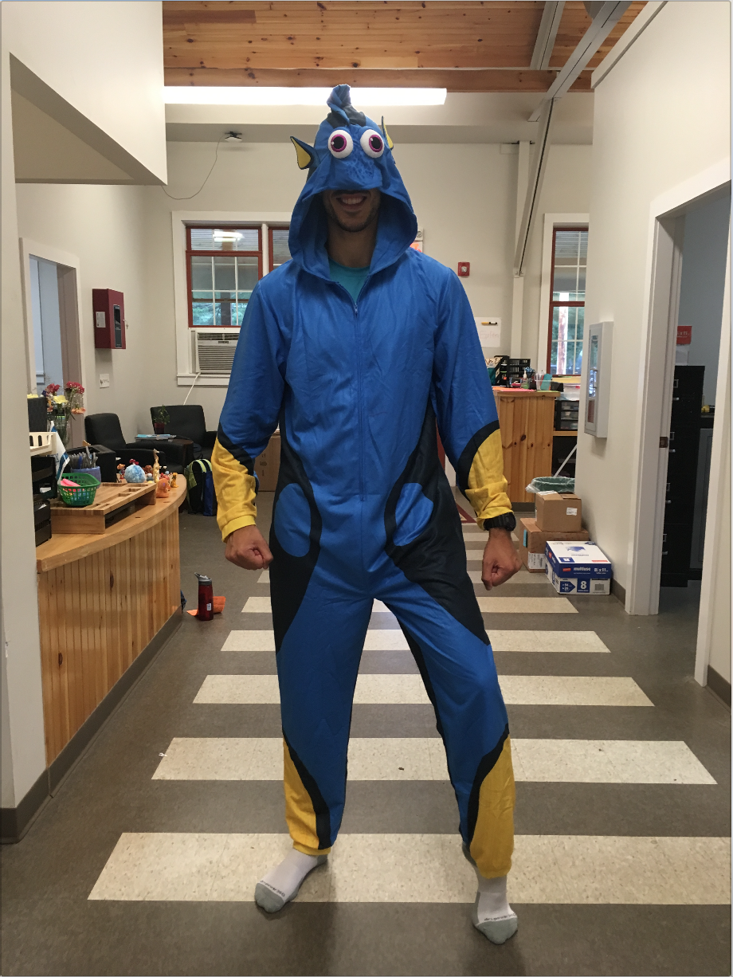
Missing
Name: Dory
Species: Blue Tang
Last seen: P. Sherman 42 Wallaby Way, Sydney

Chef School Final Exam
- 289-12x17+69-23x2=__________________
- What year did the US become independent? ___________________
- What year did Israel become independent? __________________
- Spell octopus in Hebrew: _________________
- How many US presidents have there been? ___________________
- Name 4 cities in Israel: _____________, ___________, ___________, _____________
- What is the smallest unit of life? _______________
- Name 3 elements from the periodic table: ____________, ___________, _________
- Who invented the light bulb? ______________
- Name 3 inventions that were created in Israel: __________, __________, __________.
- John can eat 5 brownies a minute. Suzie can eat 4 brownies in 2 minutes. Both John and Suzie started with a plate of 72 brownies each. They competed for 13 minutes. At the end, Brian added to John’s plate 38 brownies. Assuming that the winner is the person with the least brownies on his plate, who won- John or Suzie? _____________
- Name all 8 planets: ________________________________________________________________________
- What Broadway production is represented on the 2017 Ramah tshirts? ______________
- From what kind of tree do acorns come from?
- How many members were there in the Beatles? _____________
  - Bonus: Name all the members: ____________________________

Chef School Final Exam Answer Key
- 289-12x17+69-23x2=_______108___________
- What year did the US become independent? ________1776___________
- What year did Israel become independent? _______1948___________
- Spell octopus in Hebrew: _________________
- How many US presidents have there been? _______45____________
- Name 4 cities in Israel: _____Tel aviv________, ____Jerusalem_______, _____Haifa______, _____Eilat________
- What is the smallest unit of life? _____cells__________
- Name 3 elements from the periodic table: _____Oxygen_______, _____Hydrogen______, ____Nitrogen_____
- Who invented the light bulb? ____Thomas Edison__________
- Name 3 inventions that were created in Israel: ___Cherry Tomatoes_______, ____USB flashdrive______, ____electric car grid______.
- John can eat 5 brownies a minute. Suzie can eat 4 brownies in 2 minutes. Both John and Suzie started with a plate of 72 brownies each. They competed for 13 minutes. At the end, Brian added to John’s plate 38 brownies. Assuming that the winner is the person with the least brownies on his plate, who won- John or Suzie? ___Suzie__________
- Name all 8 planets: __________Mercury, Venus, Earth, Mars, Jupiter, Saturn, Uranus, and Neptune_____________________________________________________________
- What Broadway production is represented on the 2017 Ramah tshirts? ____Hamilton__________
- From what kind of tree do acorns come from? ______Oak Trees_______________
- How many members were there in the Beatles? ____4_________
  - Bonus: Name all the members: _______John Lennon, Paul McCartney, George Harrison and Ringo Starr_____________________

