YOM PIXAR!!!

Time Peulah Location
8:00 Aruchat Boker Chadar Ochel
8:45 T’fillot BAA
9:45 Nikayon Tzrifim
10:15 INSIDE OUT Mirpeset
11:15 Peulat Tzrif Tzrifim
12:15 Aruchat Tzohorayim O”CH
1:00 Menucha Tzrifim
2:00 TOY STORY Tzad Aleph
3:00 Ice Pops! Mirpeset
3:30 INCREDIBLES BAA
5:30 Bechirot
6:30 Aruchat Erev Chadar Ochel
7:15 MONSTER’S INC
8:00 Lilah Tov Tzrifim
TZEVET OFF-PRAKIM

Everyone gets 2 hours off (most of us are using those 2 hours to coach) over the course of the yom. Please come back promptly after your two hours are up because we need as many people on as possible at all times thank youuuu :)

Time | ON | OFF
11:00 | Aviya, Jacob, Daniel, Shawn, Gabe, Charlotte, Tamar, Faith, Meital, Jess | Hannah, Ben, Lily
12:00 | Aviya, Jacob, Daniel, Shawn, Gabe, Charlotte, Tamar, Faith, Meital, Jess | Hannah, Ben, Lily
1:00 | Hannah, Ben, Lily, Aviya, Jacob, Daniel, Shawn, Gabe, Charlotte, Tamar, Faith, Meital, Jess
2:00 | Hannah, Ben, Lily, Aviya, Shawn, Charlotte, Jess | Faith, Jacob, Daniel, Gabe, Tamar, Meital
3:00 | Hannah, Ben, Lily, Aviya, Shawn, Charlotte, Jess | Faith, Jacob, Daniel, Gabe, Tamar, Meital
4:00 | Hannah, Ben, Lily, Jacob, Daniel, Gabe, Tamar, Faith, Meital | Jess, Charlotte, Shawn, Aviya
5:00 | Hannah, Ben, Lily, Jacob, Daniel, Gabe, Tamar, Faith, Meital | Jess, Charlotte, Shawn, Aviya

For chanichim who want to go watch their older sibling play in a Roo game: They must be able to name their sibling, the edah, and which sport they are playing.
BTW THIS MUST GO THROUGH EMMA -- NO EXCEPTIONS!!
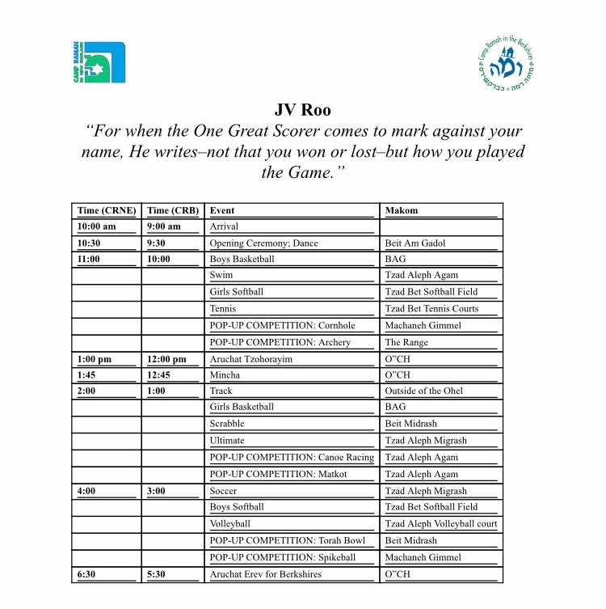For your convenience, above is the schedule for Yom Roo!

Pixar Shacharit

Modeh Ani -- Every morning we start our day by saying modeh ani. We are thanking God for waking us up in the morning and being me. Sometimes it is harder for some than other to get up. Whether you are at camp and it is really cold or you have a big test in school so you don’t want to go. But the point of Modeh Ani is that we should still just be thankful that we woke up and are so happy to be me. And I think we can all feel a little sympathy for Sully when Mike KINDLY wakes him up.
(clip from Monsters Inc where Mike is waking Sully up in the morning)

Birkot Hashachar- The whole purpose of these 14 blessings is to specifically thank God for every part of you. Starting with waking up, and not making you a slave and not making you blind. The 6th bracha thanking God for giving clothes to the naked. We don’t always take time to really appreciate how lucky and fortunate we are to have clothes. So that is why we have this blessing every morning to take a moment and remind us how thankful we should be. We have different outfits for sports, shabbat, parties. Similar to in the movie The Incredibles Edna shows Elastic girl all the costumes so that The Incredibles can fight crime successfully in the right outfits.
(show incredibles clip)

Ashrei (Inside out) Anybody remember what the best definition of Ashrei is??? HAPPY! Every day we say a prayer that we are happy to praise God! But not only is it happiness in praying, we can learn that it is important to have happiness in everything we do. The easiest way to succeed or just have a good day is to be happy! Now we are going to watch a clip from the movie inside out of when joy is missing and the other emotions don’t know what to do because they realize how important happiness is and how it affects everything else

Or Chadash- Sometimes when things don’t go the way we want or expect we get very frustrated. But sometimes all you have to do is follow a different path to succeed. In the prayer God shines a new light on Zion so the people will finally understand how amazing it is. Similarly, In the movie Finding Nemo when Dory and Marlin are searching for Nemo they literally and figurly have a new light shine a path for them.
(nemo)

Hallelujah- Hallelujah talks about praising God with instruments which makes it a unique prayer. I think it conveys an important idea that there are many ways to praise God, not just through the traditional idea of recitation. It incorporates a drum, a horn, a timbrel, dancing, sting instruments, cymbals; and that through all those things you can praise God with your whole soul. Similarly, in the short clip One Man Band two men compete to make a girl happy by playing music.
(one man band)

Ahava Rabah- This prayer talks about Hashem’s love for us. The love this prayer refers to is eternal love. Similar to the love our parent have for us. No matter what we do or how bad of a mistake we make they will always love us. So too with God. Similarly in the short clip I Lava You a volcano is searching for his eternal love and finally finds it.
(I lava you)

INSIDE OUT:
Location: mirpeset

Each group picks a different camp situation from a hat and they rehearse for a few minutes. Each group has a bag with different feelings words in them. Right before the scene starts each chanich picks an emotion and they act out the scene with everyone else acting out different emotions.

Scenarios:
- Yom sport breakout incorporating a camel
- Sneakout gone wrong
- Tornado warning at camp
- Making shabbat brownies
- Campwide havdalah in the agam
- Beyonce walks into the marp waiting room
- Going on the water toys for the first time
- The goats planning and executing an escape

Toy Story: Pizza Planet
Goals: teamwork
Intro: Welcome to the Pizza PLanet! Inside we have some great arcade games that each group will participate in two groups will be playing against each other at every game. We have Human Foosball, Human Air Hockey, Mini Knock Out, and Ninja. A counselor will be at each game and will explain how to play if there are questions. You will have 10 minutes to play each game and we will now tell you where your groups are starting.

Foosball: Woody vs Jessie
Air Hockey: Buzz vs ham
Mini Knock Out: Rex vs. Slinky
Ninja

8 groups: foosball to air hockey to mini kock out to ninja…

Stay tuned for staffing and group rotations…

Foosball with…. (BAA)
- Board outlined with benches, tape will go across the court and everyone must stay on their line and they cannot cross each other. Kicking a soccer ball into the other team’s goal. The ball must stay on the ground.

Air Hockey with… (Upper Migrash)
- Court outlined with benches, everyone sits on the sides and they try to push the puck (a cardboard circle/box attached to a scooter) into the other team’s goal. 2 games are going to be plated.. Split the teams in half

Mini Kock Out with… (A side basketball courts)
- Knock out with the small basketball hoop. Make sure you explain the rules so everyone knows how to play.
- Stand next to someone on the opposite team so it is competitive

Ninja with… (outside 32)
- Explain to the group and make it intense
- Stand next to someone on the opposite team so it is competitive

Bechirot Options!!
- Model Magic
- Storyboard/Coloring Pages
- Tetherball
- Gaga

Monsters Inc.

Go from door to door with your team and compete trivia in order to receive a piece of the “wallpaper”. The wallpaper pieces when all collected will be in the shape of a spoon. You will give this spoon to the final madrich who will give you a real spoon and you will have to dig a tunnel through the city to release Boo into the wild which means: dig through the sand with the spoon in order to find a rock that says WILD on it.

Groups will be split into colors so they will only collect the “wallpaper” of their color.
There will be 10 doors from different tzrifim.
Goal: complete the trivia at the doors as fast as you can to piece the puzzle together and then release boo into the wild
Materials: “wallpaper” pieces, tape, spoons, rocks
Tzrifim:

1: The CEO of monsters inc is…. Answer: Henry J. Waternoose lll
- Options: Fungustus Fearmonger, Henry J. Waternoose lll, Harry Hausen lll, Waxford Wormsworth

5: The Monsters Inc. motto is… Answer: we scare because we care
- Options: scaring is caring, we scare because we care, screams to power your life, the monstrous energy company

8: Mike calls Roz what nickname? Answer: my tender oozing blossom
- Options: my luminescent little lilac, my succulent little sludge, my lovely little tulip grub

11/12: Monsters Inc. takes place in which city? Answer: Monstropolis
- Options: Monstro City, Monstersville, Scream City

15: Mike uses which deodorant of Sulley’s? Answer: Wet Dog
- Options: smelly garbage, old dumpster, low tide

17: When Sulley attempts to file paperwork for Mike, he told him to leave which color paper?
Answer: puce
- Options: pink, goldenrod, fuschia, puce

23: Boo’s closet door is… Answer: white with pink flowers
- Options: pale yellow with pink flowers, white with pink hearts, pink with white polka dots

33: Mike calls his stuffed animal bear… Answer:
- Options: Mr. Fuzzles, Little Mikey, Googlie Bear, Smooshie

34: Which statement is not true: Answer: C
- Mike wears contact lenses
- Randal can become invisible
- Sulley wear oven mitts to be warm in the himalayas
- Boo calls Sulley “kitty”

35: When Mike and Sulley are banished to the Himalayas what does the abominable snowman offers them… Answer: snow cones
- Options: popsicles, Yak’s milk, snow cones,ice cream sandwiches

