Yom toy story
(Actually it’s yom social justice but shh! We don’t have to tell anyone)

Time | Location | Peulah
10:00-10:50 | Bunks | Nikayon
11:00-11:50 | Migrash | Buzz LightYear Game
12:00-1:30 | Café Ramah | Cooking
1:30 – 2:30 | Migrash | Carnivores vs Herbivores/  Pack out lunch
2:30-5:00 ** | Beit Midrash Area | Toy Story Movie Screening /  Plaque design / Chofesh /  “Toys” / Rondeaus
5:00-5:45 | David Offit Brick Plaza | Water Pipe
5:45-6:15 | BAG Stage | Dance Marathon (and letter writing)
6:15 – 7:15 | Tennis Courts | Blanket making
7:15 – 8:30 | Migrash | Dinner
8:30-9:30 | Beit Am Bet | Cards for Humanity

- **
- BE at Rondeau’s at the time listed. (Leave from B-side 25 minutes before your time)

- 3:00 - 50
- 3:20 - 58
- 3:40 - 49
- 4:00 - 62
- 4:20 – 48

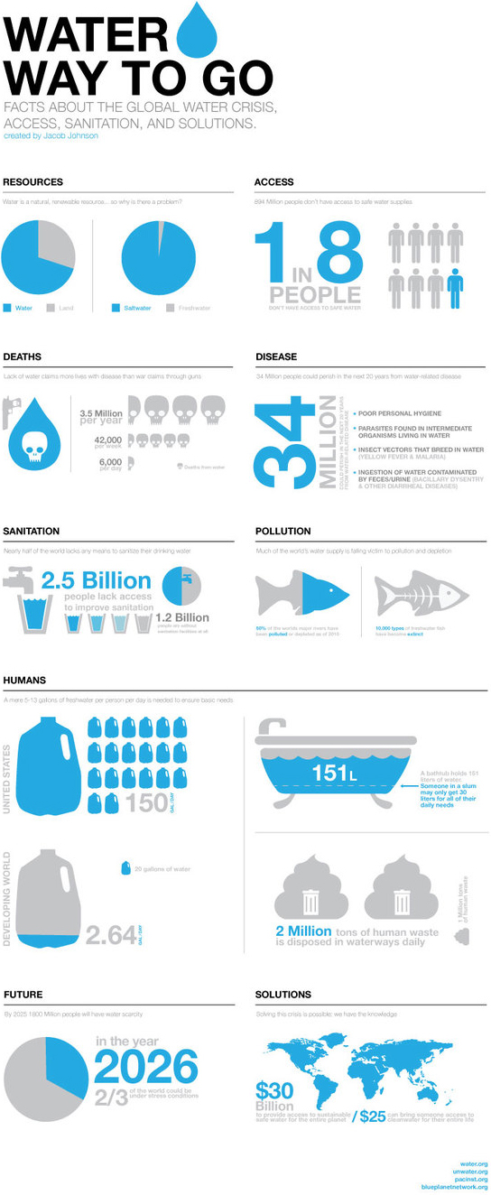
Information about water shortage:
Here is the most compelling and informational poster about water shortage ever

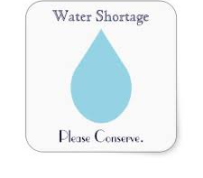

Here is a poster for a movie that is probably really bad, but at least they hired a good graphic designer…

- While nearly 70 percent of the world is covered by water, only 2.5 percent of it is fresh. Just 1 percent of our freshwater is easily accessible, with much of it trapped in glaciers and snowfields. In essence, only 0.007 percent of the planet's water is available to fuel and feed its 6.8 billion people.
- According to the United Nations, water use has grown at more than twice the rate of population increase in the last century. By 2025, an estimated 1.8 billion people will live in areas plagued by water scarcity, with two-thirds of the world's population living in water-stressed regions as a result of use, growth, and climate change.
- 4.2 billion people now get water through a piped connection; 2.4 billion access water through other improved sources including public taps, protected wells and boreholes.
- 663 million people rely on unimproved sources, including 159 million dependent on surface water.
- Globally, at least 1.8 billion people use a drinking-water source contaminated with feces.
- Contaminated water can transmit diseases such diarrhea, cholera, dysentery, typhoid and polio. Contaminated drinking-water is estimated to cause 502 000 diarrheal deaths each year.
- By 2025, half of the world’s population will be living in water-stressed areas.
- In low- and middle-income countries, 38% of health care facilities lack any water source, 19% do not have improved sanitation and 35% lack water and soap for hand washing.

Each bunk will be given a bucket of materials:
- 1 bucket
- ½ pool noodle
- 1 roll of duct tape
- more

In Israel specifically, there is a large problem having to do with water shortage. A company in Israel has invented an innovative new way to water plants called Drip Irrigation. This has helped the country save several million gallons of water. It is often used on kipputzim.

With the materials that they have, along with anything else that they can find that may be helpful (example: maybe a toilet paper roll or a clothes hanger will come in handy!) they have to build a pipe that will allow for as much water as possible to get into the bucket at the end. When they think they are ready, we will pour one gallon of water into the pipe and measure how much of it gets all the way through. The team with the most efficient pipe wins.

There are some requirements, however (gotta keep it interesting, ya know?), which are as follows:
- The pipe must be at least 10 feel long, and each foot has to have the name of one of the 10 plagues. (#judaism)
- One part of the pipe must be at least 4 feel tall or taller
- You must use at least 5 different materials in making your pipe. Tape does not count as one of these materials.

Here is a list of the materials that every team will get
- 2 pieces of pool noodle
- Bucket
- Duct tape
- Cups
- Scissors
- Trash bags
- Straws

Location: Café Ramah
Time: 12-1:30

What’s up spuds! I’m Mr. Potato head. I’m Andy’s trusty food shaped toy. A few things about me: my arms, legs, and face can come off my body… but hey I’m just living my life. I know its weird, but I love eating food… Not potatoes… that would be non POTAT-riotic. Along with eating food, I love making food. I feel so fortunate for never having to worry about where my next meal is coming from, and I think you should all too. So I’m asking you all to help me bake cookies to donate to a local homeless shelter. This way I will get to show you how much I love cooking, and we can help some people less fortunate than ourselves! Don’t worry, we will also be eating cookies too!

2 Groups will join together to make each batch.
- Thomas/Rachel and Micah
- Jake and Sally
- Yaira and Miriam
- Yael and Nicole

They will make the cookies together. Counselors PLEASE make sure that everyone who wants a job gets a job. Don’t just leave it up to them to assign tasks among themselves. There are already too many cooks in the kitchen (lol) for this one so please facilitate and make things easier. We also need clean up to happen, so make sure you assign those jobs as well. You can talk about favorite foods or something with the campers that are not doing a task.

Here’s the recipe:

- 2 cups of flour
- ½ cup white sugar
- 1 cup brown sugar
- 3 cups oats
- 1 ¼ teaspoon baking powder
- 1 ¼ teaspoon baking soda
- 1 ¼ cup oil
- 2 ½ teaspoon of vanilla extract
- Some raisins (add at the end… you’ll see how much you need)

In a large bowl, mix together all of the wet ingredients (oil, vanilla, water apple sauce)

Add the dry ingredients (not the raisins), a little bit at a time, until you’re done adding. If the dough is too mushy, you can add a little big more flour

Add the raisins at the end. Yay raisins!

Put wax paper down on a baking sheet. You should be able to fit 54 cookies on each sheet (6 across and 9 down). Cookie dough balls should be about the size of a nose if noses were spherical

(Cookies bake at 350 degrees for about 10 minutes)

Herbivores vs. Carnivores
Location: Migrash

Yo yo yo! What’s up my main dinosaurs? My name is Rex. I’m Andy’s number one prehistoric toy. I’m a T-Rex. Do you have a black eye, because it looks like you were hit with a “big bang.” What does a triceratops sit on? (Its tricera-bottom!) What do you call a sleeping dinosaur? (A dino-snore!) What do you get when dinosaurs crash their cars?(Tyrannosaurus wrecks!).

A carnivore is a dinosaur that eats meat. A herbivore is a dinosaur that does not eat meat – a vegetarian dinosaur, if you will. Everyone starts out as a carnivore; however, one person from each group starts out as the herbivore. This game is very similar to sharks and minnows, where the carnivores are the minnows and the herbivores are the sharks. The herbivore’s job is to pick up grass from the migrash and throw it at the carnivores. Once a carnivore is hit with grass they turn into a herbivore and start fighting for that team. All of the carnivores MUST walk/ run like T-Rexes.

(We play a few rounds until interest drops, time ends, etc.)

Lunch = awkward dinosaurs meal

Everyone is referred to as Rex and eats weirdly with their arms. Dinosaur plates will be provided for pack out. Let’s all eat lunch together in the shade by 67 and make sure that no one leaves until their trash is picked up. At the end of lunch, bunks will begin to leave for Rondeau’s.

Location: Beit Am Bet

Each group will receive 2 pieces of fleece, and a few pairs of scissors. As a group, they will have to cut the fabric and turn it into a blanket. While they are cutting the blankets, the counselors should facilitate a conversation about community service that the kids are involved in at home, and things that they are interested in doing.

Hamm’s monologue:
Hi guys, I’m Hamm. I’m Andy’s beloved piggy bank. I act as a toy and a place to keep money. When I’m playing with woody, Buzz, and the rest of the gang I play many different characters, like “Evil Dr. Porkchop”. My favorite thing to do with the money I save up is to use it for tzedakah. It has been a few years since toy story 3 came out, so I’ve had a lot of free time on my hands. In my free time I have collected a lot of money and materials. Magshimim, I need your help to get the best use out of the money and materials. I have all of these pieces of fabric. I need you guys to split up into your groups and make the fabric into blankets, so that we can donate them to a local homeless shelter. This will be a lot of work, but it will be fun. Trust me, I’m an honest toy!

A few helpful hints for the discussion:
- Which is better? Giving 100$ to a cause because the Torah mandates tzadakkah, even though you really don’t want to, or donating 10$ because you are passionate about the cause?
- Talk about the community service projects that they are involved in at home. Some have done really cool bar/bat mitzvah projects!
- Talk about Maimonides 8 levels of tzadakkah:

  - [1] The greatest level, above which there is no greater, is to support a fellow Jew by endowing him with a gift or loan, or entering into a partnership with him, or finding employment for him, in order to strengthen his hand until he need no longer be dependent upon others . . .
  - [2] A lesser level of charity than this is to give to the poor without knowing to whom one gives, and without the recipient knowing from who he received. For this is performing a mitzvah solely for the sake of Heaven. This is like the “anonymous fund” that was in the Holy Temple [in Jerusalem]. There the righteous gave in secret, and the good poor profited in secret. Giving to a charity fund is similar to this mode of charity, though one should not contribute to a charity fund unless one knows that the person appointed over the fund is trustworthy and wise and a proper administrator, like Rabbi Chananyah ben Teradyon.
  - [3] A lesser level of charity than this is when one knows to whom one gives, but the recipient does not know his benefactor. The greatest sages used to walk about in secret and put coins in the doors of the poor. It is worthy and truly good to do this, if those who are responsible for distributing charity are not trustworthy.
  - [4] A lesser level of charity than this is when one does not know to whom one gives, but the poor person does know his benefactor. The greatest sages used to tie coins into their robes and throw them behind their backs, and the poor would come up and pick the coins out of their robes, so that they would not be ashamed.
  - [5] A lesser level than this is when one gives to the poor person directly into his hand, but gives before being asked.
  - [6] A lesser level than this is when one gives to the poor person after being asked.
  - [7] A lesser level than this is when one gives inadequately, but gives gladly and with a smile.
  - [8] A lesser level than this is when one gives unwillingly.

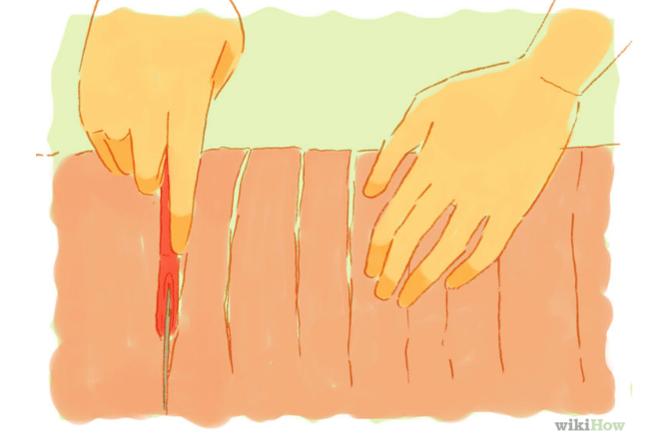
And here’s how to make the blanket:
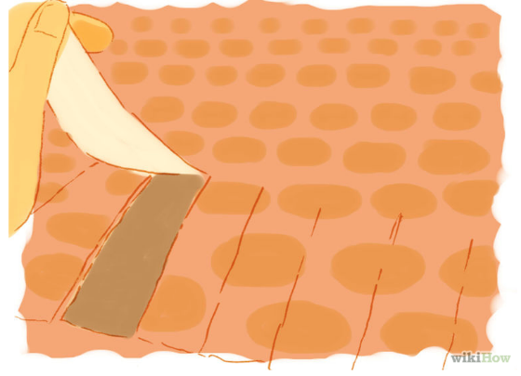
- Cut strips that are about 4 inches long around the perimeter of each piece of fleece. Make sure that you cut both pieces at the same time so that the strips line up! (You can cut the corners of if you want; don’t worry about them)
- Lay the pieces on top of each other and tie the strips together in a knot.

Buzz light year relay race
Location: Migrash

“Hi everyone, I am buzz light year. Right now you have all just joined the incredibly competitive intergalactic space academy. You will be split into teams. The winning team will be the only people to graduate. To Infiniti and beyond magshimim!!!

Now we get them into their teams. These will be their teams for the rest of the whole day, so they should remember at least who their counselor is. Teams are on a separate page of this packet

Next: Make the rocket, key, and slogan (15 minutes)
Then: Present to the rest of the edah (5 minutes)

“ATTENTION- EMERGENCY
Buzz LightYear’s father/enemy Zorg has threatened to destroy Woody and the rest of the gang. It is your job to work with your team to save Woody. If you can save Woody before any other team then you have proved yourself worthy of graduating from the space academy.

[EXPLAIN THE GAME TO THE CAMPERS]
Your task is an outer space apache race. As a team, you will be tested both physically and mentally. Zorg will try to break you, but if you act with bravery like me, Buzz, you will be able to defeat Zorg and save my friend woody.
One person will start out on earth, where they will lift off and begin the journey into space. They will then pass the green alien baton to three people, who will become a 3 headed alien and transport the baton to the next space cadet by walking as said 3-headed alien like so [give a demonstration of how to walk like a 3-headed alien]. The next space cadet will jump into the comet pit and search for the key to the rocket ship. Once they find the key they will hand it off to the next person, who will rev up the engines to the rocket ship with the key (don’t forget to pass on the baton!). 2 people will be piloting the rocket ship, and they will navigate through the “asteroid belt”. Once they get to the end, they will break Woody out from Zorg’s dungeon and free him.
When you are dine with your leg of the race, please sit down and wait.

Dear counselors,
This relay will work very much like an apache race. That means you need to split up the tasks among the campers and assign each task to one/two camper(s). Below is the description of each task and where the camper needs to begin and end their task. YOU MUST EXPLAIN EACH TASK TO YOUR GROPUS INDIVIDUALLY BEFORE THEY BEGIN THE RACE. YOU ARE RESPOSIBLE FOR COMMUNICATING THEIR EXACT JOB.

1 (Starting point of the race)
One (or 2 if you have 8 people in your group) space cadet must do spinny bat until we scream “3-2-1 lift off!” where they then run forward and grab a roll of toilet paper. They will hold onto the end of the roll and throw it because the migrash is space and we cant have any cadets flying around without any guidance. If the paper does not go far enough to get to the next person they have to walk on the toilet paper and throw it again. They do this because they are currently in space and don't want to get lost. Once they reach the next person they hand them the green alien.

2 (Still in the middle of the migrash… Josh will be standing there)
We now need 3 people to be the 3 headed alien. 2 people in bottom and 1 on top, so they can walk as a small pyramid, like Ben demonstrated. The three headed alien will fly through space for a bit and hand the baton off to the cadet by the ball pit.

3 (by the ball pit)
It is one persons job to dive into the ball pit and find a card board key. They then run this over to the 2 people that are in the team’s rocket, and hand them the key.

4 (by little house)
The key is supposed to "start" the rocket. 2 people need to be in the rocket; they will then run through the asteroid belt and go over benches. They have to be the first group to save woody.

