July 3rd, Yom “Wherever you go there’s always someone Jewish”
By: Natan Fandel and Maddy Pliskin
Outline:

Time | Activity | Location | Rain Location
9:00-9:45 | Breakfast | --
9:45-10:45 | T’fillot with Gal (Argentina) and top 10 Jewish countries | --
10:45-11:30 | Nikayon - riddle, go to countries | ---
11:30-1:45 | Russia Plan | Machaneh gimmel  Home base is back spot by old softball field
 |  | Ohel
1:45-3:00 | Lunch and Menucha | --
3:00-6:00 | Machazemer - confirmed w bogrim vaad yom meyuchad | BAG  3:00-3:30 just mag then mag/bog
4:00-5:00 | Ice Cream
6:30-7:30 | Free time | --
7:30-8:30 | Aruchat Erev | --
8:30-9:30 | Brazil and Fourth of July | BAB

T’filla
- Argentinian comes in to talk
- Top 10 jews around the world, make a poster board
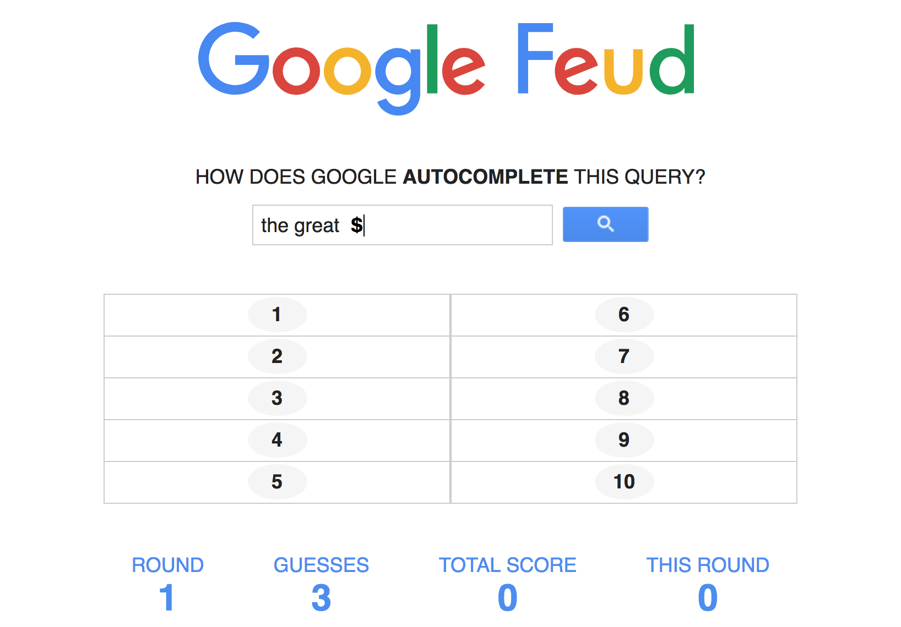
Nikayon to Lunch k’tzrif
Make it a competition of who finishes the fastest, then once they’re done they get a riddle to simulate the diaspora
  - Leads to france; each of them have to replicate certain tourist attractions and madrichot need to take pictures
  - Print them out and put them in the different locations
- Canada make the best lumberjack looking person and take a picture (flannel)
- UK make a video of the changing of the guards in any way you want
- Argentina - earthquake???????
- Germany build berlin wall and someone needs to knock it down,
  - Video must say “ mr gorbachev tear down that wall!”
- Australia - simulate a ride through the australian outback , touristy, and video
- AFTER, everyone meet in machaneh gimmel.

Russia (1.5 hours) (go to machaneh gimmel)
This kayitz alpayim v’chai Russia is hosting the FIFA world cup. In this event, soccer brings together many countries no matter their political relationships.
In this challenge, each tzrif, or country will compete in the world cup:
- For the first part of the challenge, each country needs to create their own national anthem (15 minutes)
  - Supplies: 4-8 pens, pieces of paper
- Next, each country needs to create a flag that includes their national symbols (20 minutes)
  - specific requirements will be distributed
  - Supplies: left over poles from programming, zip ties, markers, clothy paper for the flags PITA
    - Specific requirements: national bird, food, song, tree, flower, sport, motto, animal, instrument,
- Then each tzrif performs their national anthem and presents flag, must explain all symbols
- Scorpion soccer - natan do this write up

Brazil- after lunch and menucha
Mention before sending kids to lunch so that they can have time to find things
- Work as a tzrif
- Like a carnival (DECORATE, REALLY FUN MUSIC) - have tzevet members run stations - mask making, apple bobbing, face painting, milk jar ish throw (stack things in a pyramid, maybe even cups, hit them down),
  - lollipop tree game - get dum dums, prizes, spoon from chadar, 11 aliyah, connect four station

Alternative idea because we have to go to water slides at 12:00 on tzad aleph:
- 9:00- 9:45- Breakfast
- 9:45- 10:45- Tfillot (special Argentina program)
- 10:45-11:45- picture scavenger hunt
- 11:45- 12:00- getting ready for water slides
- 12:00- 1:00- Water slides on Tzad Aleph
- 1:00-1:45 packout lunch
- 1:45- 3:00 nikayon and menucha
- 3:00-4:15 mag machazemer practice
- 4:15-5:00 ice cream
- 5:00-6:00 mag bog machazemer practice
- 6:00-7:30 Peulah- Russia
- 7:30-8:15 dinner
- 8:15-9:15 Peulah- Brazil and America
- 9:15- 9:25- Free time
- 9:25- 10:05- Getting ready for bed
- 10:05- Lights out and Harga’a

Picture Scavenger Hunt 10:45 am -11:45 am
!!A competition of which tzrif makes the best Jewish world tour!! MADRICHIM: give chanichim riddles and tasks, and take pictures and videosss

France - say at the end of t’fillot
What am I?
I’m a country but I’m not Iceland
I have red, white and blue on my flag but I’m not the USA
I’m in Europe but I’m not the UK
I have a famous tower but I’m not Italy
I have my language spoken in many countries around the world but I’m not Spain

TASK: make the eiffel tower with yourselves and your surroundings and have the group madrich take a picture

Canada:
What am I?
I’m in the northern hemisphere but I’m not France
I have a Prime Minister but I’m not the UK
I’m one of the largest countries in the world but I’m not China
I have a red and white flag but I’m not Japan
I have many people who speak French but I’m not Rwanda

TASK: go to your tzrif and dress one chanich or chanicha as a lumberjack. ex) flannel, jeans, hiking boots

United Kingdom:
What am I?
I have a red and white flag but I’m not Japan
I have a Prime Minister but I’m not Canada
I’m a country in Europe but I’m not Switzerland
I have a commonly spoken language but I’m not France
I have a royal family but I’m not Denmark

TASK: There are guards on at all times at Buckingham Palace protecting the royal family and the palace itself. Every hour the guards change and for this task you need to re-enact a changing of the guards.

Germany- no riddle
TASK: you must make a video of the berlin wall being torn down, get creative. You must also include the line “mr gorbachev tear down this wall”

Austria
What am I?
I’m a country but I’m not Russia
I’m in the southern hemisphere but I’m not Argentina
I’m popular with surfers but I’m not South Africa
I’m surrounded by water but I’m not Madagascar
I’m sometimes called Oz but I don’t have anything to do with wizards

Task: simulate a ride through the australian outback with tourists and animals

